**IBAAN CENTRAL SCHOOL WEB PORTAL: LEVERAGING**

**DATA ANALYTICS AND DATABASE INTEGRATION**

**FOR ENHANCED PERFORMANCE**

A Capstone Project

Presented to the Faculty of

College of Informatics and Computing Sciences

BATANGAS STATE UNIVERSITY

The National Engineering University

Batangas City

In a Partial Fulfillment

of the Requirements for the Degree

Bachelor of Science in Information Technology

Business Analytics

By:

Dimaano, Jann Angelo C.

Dumara-og, Ken Laurence M.

Sabundo, Regina Cheley P.

Ms. Jeleen M. Mangubat

Adviser

December 2024

# **APPROVAL SHEET**

This capstone project entitled “Ibaan Central School Web Portal: Leveraging Data Analytics and Database Integration for Enhanced Performance”, prepared and submitted by Dimaano, Jann Angelo C., Dumara-og, Ken Laurence M., and Sabundo, Regina Cheley P., in partial fulfillment of the requirements for the degree Bachelor of Science in Information Technology with specialization track in Business Analytics, has been examined and is recommended for acceptance and approval for oral examination.

Ms. Jeleen M. Mangubat

Adviser

Approved by the Committee on Oral Examination with a grade of ________

Mr. Jefferson I. Cañada

Chair, Defense Panel

Mr. Raymond Kit M. Rodriguez Mr. Jerome M. Fabregar

Panel Member Panel Member

Accepted and approved in partial fulfillment of the requirements for the degree Bachelor of Science in Information Technology with specialization track in Business Analytics.

**________________** Dr. Princess Marie B. Melo

Date College Dean

# **DEDICATION**

This work is a sum of all efforts and countless sacrifices and is humbly dedicated to the parents of the researchers who have always been there supporting them no matter the circumstance. To Almighty God who has been the guiding light, granting the researchers the will-power and strength to persevere throughout the journey of this study.

# **ACKNOWLEDGEMENTS**

The researchers would like to express their thanks and heartfelt appreciation to the important persons whose assistance in any form were beyond useful in pursuit of the study.

To Dr. Alberto M. De Chavez, the Principal of Ibaan Central School, for allowing their school to be the study’s respective client and giving permission to access the necessary data for the study.

To Ms. Valentina Guerra, the Guidance Counselor of Ibaan Central School for being heaven-sent, assisting the researchers in the approval of the study and for providing necessary information they need.

To Ms. Jeleen M. Mangubat, their capstone adviser who gave her time, support, and invaluable insights ensuring the accomplishment of the study.

To their family who never fails to show support and encouragement which continuously inspires them to give their very best.

Most importantly, to their friends who have been the pillars of their mental health, being present in every laughter and every moment of melancholy.

# **TABLE OF CONTENTS**

**APPROVAL SHEET** ii

**DEDICATION** iii

**ACKNOWLEDGEMENTS** iv

**TABLE OF CONTENTS** v

**LIST OF TABLES** vii

**LIST OF FIGURES** viii

**ABSTRACT** ix

**INTRODUCTION** 1

1.1 Background of the Study 1

1.2 Purpose and Description 6

1.3 Objectives of the Study 8

1.4 Scope and Limitations 9

1.5 Definition of Terms 10

**2 REVIEW OF RELATED SYSTEMS/STUDIES** 14

2.1 Technical Background 14

2.2 Related Studies 26

2.3 Synthesis 80

2.4 Conceptual Framework 81

**3 DESIGN AND METHODOLOGY** 84

3.1 Project Concepts 84

3.2 Development Model 85

3.3 Requirements Analysis 86

3.4 System Design 91

3.4.1 Software Requirements Specification 99

3.4.2 Hardware and Software Requirements 103

3.4.3 Database Design 106

3.4.4 Trade-off and Multiple Attributes 109

3.5 Development 111

3.5.1 Software Development Tools 111

3.5.2 Hardware Development Tools 112

3.6 Testing and Evaluation 113

3.6.1 Testing Tools and Methodologies 115

3.7 Deployment 116

3.7.1 Sustainability and Maintenance Plan 117

3.7.2 Risk Management Plan 117

3.8 Sampling Method 125

3.9 Statistical Approach 126

**4 RESULTS AND DISCUSSION** 128

**5 SUMMARY, CONCLUSIONS, AND RECOMMENDATIONS** 139

5.1 Summary 139

5.2 Conclusions 141

5.3 Recommendations 143

**BIBLIOGRAPHY** 145

**APPENDICES** 160

**APPENDIX A: TEST RESULTS** 160

**APPENDIX B: SCHEDULE AND TIMELINE** 177

**APPENDIX C: RELEVANT SOURCE CODE** 178

**APPENDIX D: PROJECT ROLES AND RESPONSIBILITIES** 240

**APPENDIX E: BIONOTE** 242

# 

# **LIST OF TABLES**

**Table 3-1.** Hardware Requirements **104**

**Table 3-2.** Software Requirements **105**

**Table 3-3.** Trade-off and Multiple Attributes **109**

**Table 3-4.** Software Development Tools **111**

**Table 3-5.** Hardware Development Tools **113**

**Table 3-6.** Identified Risks  **119**

**Table 3-7.** Risk Assessment Matrix  **121**

**Table 3-8.** Evaluated Risks  **122**

**Table 3-9.** Risk Solution  **123**

**Table A-1.** Efficiency Testing Results  **160**

**Table A-2.** Reliability Testing Results  **162**

**Table A-3.** Functionality Testing Test Cases  **166**

**Table A-4.** Flexibility Testing Results  **173**

**Table D-1.** Roles and Responsibilities **240**

# **LIST OF FIGURES**

**Figure 2-1.**Conceptual Framework  **82**

**Figure 3-1.** Agile Methodology  **85**

**Figure 3-2.** Fish bone Analysis **88**

**Figure 3-3.** System Boundary  **90**

**Figure 3-4.** Use Case **91**

**Figure 3-5.** Context Diagram **93**

**Figure 3-6.** Level 0 Diagram **95**

**Figure 3-7.** Sequence Diagram **98**

**Figure 3-8.** Entity Relationship Diagram (ERD) **107**

**Figure 3-9.** Risk Management Process **118**

**Figure 4-1.** Enrollment **129**

**Figure 4-2.** Pending Section **130**

**Figure 4-3.** Student Record **131**

**Figure 4-4.** Parent Portal **132**

**Figure 4-5.** Analytics Dashboard  **135**

**[Figure A-1.](#_1ljsd9k)**Load Testing Result  **[164](#_1ljsd9k)**

**[Figure A-2.](#_1ljsd9k)**Functionality Testing Result  **[171](#_1ljsd9k)**

**[Figure A-3.](#_1ljsd9k)**Flexibility Testing Login  **[175](#_1ljsd9k)**

**[Figure A-4.](#_1ljsd9k)**Flexibility Testing Homepage  **[175](#_1ljsd9k)**

**[Figure B-1.](#_1ljsd9k)**Gantt Chart **[177](#_1ljsd9k)**

# **ABSTRACT**

Ibaan Central School, situated in Ibaan, Batangas, was experiencing difficulties in their operations due to the lack of a centralized platform wherein all stakeholders may interact. The institution's primary challenges are the tedious processing of enrollment, the disorganized storage of crucial information, and the lack of data-driven insights concerning students' academic performance. With the rise of academically-aligned systems, a web-based portal for the school is created which leverages prescriptive analytics and have an integrated database supporting the school’s operations. The web-based portal offers a platform of enrollment to assist the guidance, a centralized hub that makes all important documents easy to retrieve and transfer, and a visualization and interpretation of the student performance for the guidance and principal to keep track of the students’ performance. The web system was developed using JavaScript and PHP as its programming languages together with Bootstrap Framework. The user interface was constructed with the help of Figma and coded in HTML and CSS. MySQL and XAMPP was be used for database services and hosting was employed by Hostinger.

# **INTRODUCTION**

This chapter contains the overview of the content of the study and the motivations of the researchers which pushed them to conduct the study. This is for the readers to see and understand the flow of the study.

**1.1 Background of the Study**

The field of education, specifically, learning institutions are constantly seeking ways that may enhance their operations and overall experience for their broad community of stakeholders. Full online learning systems and learning management systems (LMS) have been utilized by education practitioners as a platform that reinforces the learning process through an inclusive learning environment for academic progress (Bradley, 2021). Another kind of academic advancement involving technology is the development of student information systems. A successful student information system (SIS) makes the students more productive and improves their workflow of academic services (Al-Hunaiyyan, 2021). The very existence of LMS and SIS goes to show that systems or applications aiding the academic experience of all the users have been proved beneficial in terms of study progress and boosting operation of the learning institutions.

The popularized concept of Portals has been around since 1997. This was first famously used in different business-to-business and business-to-consumer applications that allows individuals to automatically filter information from the web through a search engine while being customizable for automatic search of specific information unique to the user. Today, web portals have evolved to serve a variety of purposes including fostering collaboration and modernizing school administrations.

Currently, Ibaan Central School has a population of 175 kindergarten, 198 grade 1, 212 grade 2, 207 grade 3, 164 grade 4, 239 grade 5, 205 grade 6, 186 Alternative Learning System (ALS), and 96 Special Needs Education (SNED) students with a total of 1682 students. On the other hand, there are 51 teachers, 48 of which are female and 2 are male. For the longest time, this school has been the center of all schools within the district and has been the avenue for academic and non-academic contests with respect to the fact that it is located in Poblacion Road, Ibaan, Batangas, the center of Ibaan and also has the biggest campus and most number of rooms within the district. Ibaan Central School is also known to be one of the most inclusive elementary schools in Ibaan as they offer SNED and ALS program that caters students with special needs. However, despite being the most advanced school in the district, Ibaan Central School had no existing online system and stored and processed students’ data manually through a paper-based system.

During the retrieval of student documents, the guidance counselor had to manually go through the pile of papers in the office’s shelves and inspect them one by one. The total school population being written in a notebook posed a risk of losing useful data when unexpected events like natural disasters or a minor misplacement happens. In terms of the distribution of grades, even though the teachers use Microsoft Excel, there was still a need for multiple hard drives for backup. For the school’s enrollment system, they have three ways to register; face-to-face enrollment, enrollment through google forms, and barangay enrollment wherein student requirements are left in a box across different barangays within the municipality of Ibaan. This traditional process was often time-consuming and inefficient since it required significant time and effort from the staff involved. Manual data entry from these processes was also prone to errors like data duplication and typographical errors which may potentially affect the student record and enrollment statistics. The vast amount of student data was also left unutilized by the school leaving them to miss out on opportunities in improving the performance of their students.

Ibaan Central School is no exception to the rapid advancements in technology as they acknowledge the need to centralize their operations by integrating the school’s database into a single functioning system. With the uprising of the mentioned challenges, the researchers developed a web portal addressing these issues by exploring the development of a web-based school portal that leverages data analytics and database integration to improve the school’s day-to-day operations, help the users in their school experience, and enable real-time tracking of student academic progress. This study also places emphasis on United Nation Sustainable Development Goal (SDG) 4, “Quality Education” as it generally eases the administrative processes of the school and offers a hub for transparent academic information supporting the students and most especially features prescriptive analytics and graph interpretation which can be utilized to have a better understanding on the academic performance of the student and boost it further.

Through a system that has a centralized database and features prescriptive analytics, this study aims to address the important issues that was raised by the client and discussed below.

The protracted enrollment procedures has been a long-term problem sincethe previous system of enrollment of Ibaan Central School involves three different processes. The first one being the face-to-face enrollment wherein parents are expected to bring the physical copy of requirements and do all the processes within the school vicinity. The second involves filling up google forms for registration before passing the requirements in person. The third process is passing the requirements in boxes that are left across different barangays in the municipality. These boxes are collected at the end of the day. While having these different flexible options for registration, the enrollment process remained inconvenient as files are handled, stored, and retrieved manually. With that mentioned, the processes themselves were very vulnerable to inaccuracies which may contribute to frustration and future conflicts, hence the need for an automated enrollment system.

The disorganization of essential information management with respect to the fact thatessential information such as announcements, schedules, academic resources, and grades were distributed in a scattered manner which may result in misinformation and confusion to the parents. Typically, the school administered the aforementioned information to the parents online through social media platforms, specifically, Facebook groups and Messenger group conversations. However, social media platforms are often not targeted and are not necessarily exclusive for academic use. There was also a tendency for the parents to overlook some announcements since notifications are mixed up with personal matters of engagement as well as a risk to fake posts. Moreover, the inconvenience of having to go through different platforms may impact the communication between the school and the parents.

The lack of data-driven insights on academic performance. As a competitive institution, Ibaan Central School puts great value on their students’ scholarly excellence. The lack of visualization and interpretation on the calculated grades lead to a limited understanding of the students’ weaknesses. Through access to data-driven interpretations, the guidance and principal are alarmed on the scores of the students and are able to see how much improvement on the scores must the students make in order to achieve a higher outcome.

Together, these difficulties highlighted the need for a centralized system combined with analytics to boost communication, administrative procedures, the sharing of information, and academic performance.

## **1.2 Purpose and Description**

The study, Ibaan Central School Web Portal: Leveraging Data Analytics and Database Integration for Enhanced Performance, represents a significant step forward in leveraging technology enhancing the processes of the school. This has significant implications in meeting the growing demand for a streamlined hub for all of the users within the school. By integrating both data analytics and database system, the portal gives an interpretation on the quarterly grades of the students for the principal and the guidance to understand and see how well the students are performing while also enhancing administrative processes through offering a platform for enrollment and document upload and retrieval.

This study is beneficial to the students because they can have access to different certificates rewarded to them for their achievements and academic materials such as modules which can be downloaded from the parent’s portal for easier studying. In addition, they also stay informed about different school activities and urgent announcements. More importantly, the project is also beneficial to their parents because they can also keep track of the grades of their children and see what current school activities they are up to. It also offers them convenience in checking the class schedules of their children for better planning.

On the side of the administrative body, the study is helpful to the teachers since they would not have to manually write down the information and grades of their students making their job less troubling and more time-efficient. This also minimizes the possibility of errors in data like data duplication. The turn-over of student records to their next class adviser has also been easier since the records do not have to be physically transferred. More importantly, it benefits the guidance counselor as it makes the enrollment process less of a burden since it is aided by the system. Similar to the teachers, the guidance would also not have to do manual data entry which makes them less prone to errors and keep the records accurate at all times. The delivery of announcements and school calendar has also been more convenient for the Project Development Officer (PDO) as the system can direct it to all of the users of the school portal instantly. For the principal, the prescriptive analytics together with the interpretations of the chart provide an idea on how well the students are doing academically. Announcement dissemination has also been more targeted, efficient, and convenient.

Finally, this study is helpful to the field of information technology as it can be used as a reliable reading material and reference to gain understanding for those who seek to continue and improve this study and for those who plan on conducting a study which is likely similar and related to this one.

## **1.3 Objectives of the Study**

The main objective of this project is to create a web-based portal that shall provide a streamlined online platform for teachers, parents, guidance, PDO, and principal to conveniently access information and manage administrative processes within the school. To meet this goal, the system ought to achieve the following objectives:

1. To offer a platform for enrollment processing;
2. To develop a system that provides assistance to parents in managing their children’s activities;
   1. Have a module dedicated for announcements of the upcoming events, activities, and suspensions;
   2. Have a section dedicated for academic materials, class schedules, e-grades, and e-certificates;
3. To integrate prescriptive analytics in the principal and guidance’s dashboard for students’ academic performance;
   1. Provide a visualization of the students’ quarterly academic performance;
   2. Provide a recommendation on what subject the class must focus on.

## **1.4 Scope and Limitations**

The system’s purpose is to provide a school portal that can be accessed online. Its features include an enrollment processing system for the guidance and the parents. The parent’s portal has a section for announcements, and a display of the full class schedules of their child. They can also access e-grades, e-certificates, and e-materials. The principal’s portal has an incorporated prescriptive analytics.

The primary focus of the study is the development and optimization of incorporating data analytics and database integration in the web portal to improve overall performance, user experience, and performance-understanding capabilities of the students. This study delves into prescriptive analytics that includes data collection, processing, and visualization.

The project focuses on developing a web portal rather than developing applications or digital platforms. It is solely focused on prescriptive analytics so it does not provide trend analysis and other specialized areas of analytics that are out of the range and domain of prescriptive analytics. The web portal does not offer a feature of uploading assignments, seat works, or exams and grading them. It also does not process any transaction involving fees as the school is public and abides the to the DepEd order “No Collection Policy”. It also does not have a notification feature upon the upload of announcements or any material as it is web-based and most parents do not open their emails frequently. The system also does not have built-in messaging mechanism between the stakeholders due to the time constraint of the project. Moreover, this addresses data handling but does not cover the specific hardware or any infrastructure required to support deployment.

The students do not have a portal of their own due to the learnability of the portal and the potential risk of lack of technological literacy. Parent portal is administered instead so the students can still have access to information and modules that shall be uploaded by their teachers. Students under ALS and SNED program is also not a part of the academic evaluation since they adopt a different curriculum.

## **1.5 Definition of Terms**

The following terminologies give a brief idea to the readers the operational definition or what meaning the terms have in the project.

**Academic Portal.** Is the avenue or hub in a form where academic data is managed which the stakeholders have access to and is the point where all modules interact. This operates as an integrator and serves as a line of communication between campus academic communities. An academic portal is designed to support academic programs by effectively managing academic data (Istan et al., 2020).

In the study, the academic portal is the solution to the client’s concerns and is also the main system that was developed. It is a digital platform intended to operate as the focal point for interactions between all the stakeholders involved in the institution. This offers services for the users online and provides access to a range of functionalities unique to the user but overall enhances performance and operations of the academic institution.

**Bugs.** Is defined as not only the by-product of the lines of codes that where modified in the attempt of fixing it but is also brought about by many things such as a change in external API. These are errors that need identifying and fixing for the system to behave as it is expected (Rodrıguez-Perez, et al., 2020).

In the context of the study, bugs are the errors caused by coding mistakes, unforeseen user input, or component integration errors leading the portal to behave in an unintended manner. This is inevitable in the development process of the web portal which requires debugging to patch system malfunction.

**Data Analytics.** Is described as the methods used to analyze, process, find and reveal critical connections, uncover patterns, and insights from massive amounts of data from many sources. With the emergence of big data, paved the way for numerous advancements for technological forecasting. Over the years, data analytics has been an effective instrument in achieving business growth (Lee, 2021).

In the study, data analytics is the broad term which covers educational analytics. Included in this is the process of extracting meaningful insights from raw data of students to generate a visualization, identify a pattern, and come up with a recommendation for an easier interpretation. Data analytics handles the big data and is responsible for processing the numeric grades of the students.

**Prescriptive Analytics.** Is the type of analytics capable of generating proactive decisions. This is a stepping stone for optimized decision. It has two levels of human intervention, decision support which provides recommendations and the decision automation which is mainly the implementation of the prescribed actions (Lepenioti, et al, 2020).

In the study, Prescriptive Analytics is the specific analytical approach used as the process in treating data to generate a recommendation for the users who have access to the analytical dashboard. Prescriptive analytics is responsible in making a suggestion to the Principal and Guidance on what particular subject must the class focus upon in order to improve their general average for the specific subject.

**Student Information System.** Is the most common information system in academic institutions which incurs application software purposely designed to management student data. It transforms educational tactics comprehending school practices relative to the system information for improved communication to be achieved (Javier, 2019).

In the study, the concept of Student Information System was adapted in the retrieval major student information. This allows the Guidance and the Principal to access, update, and manage information in a more structured manner. Additionally, upload and download of sensitive student documents can be easily accessed by the parents whenever in need.

# **2 REVIEW OF RELATED SYSTEMS/STUDIES**

This chapter summarizes the discussion about existing systems and studies related to the topic being investigated. This chapter identifies potential gaps for innovation and improvement, thereby assisting the researchers as they build their research design.

## **2.1 Technical Background**

This particular section contains an in-depth discussion of the technical concepts and principles relevant to the development of the web portal. This contains not only the programming language and tools, but also the methodologies that the study used as a support for the development process.

**JavaScript**

JavaScript is a programming language widely used in developing web pages. It allows the developers to implement complex features like displaying real-time content updates, interactive maps, animated 2D and 3D graphics, and so on. JavaScript is typically referred to as the third layer in developing standard web technology in conjunction with HTML and CSS. In 2020, JavaScript has been considered as the world’s most broadly deployed programming language with over billions of pages embed or load source code written in JavaScript programming language (Wirfs-Brock & Eich, 2020).

In the conducted study, JavaScript was used the primary programming language as it offers versatility in developing the web-based portal. The client-side functionality which includes dynamic and interactive features on the elements inside the interface was taken into consideration. In addition, JavaScript has various libraries, frameworks, and built-in components offered which suits the development of web portal. Moreover, the minimized memory usage made possible by JS ensures that the system runs smoothly satisfying the user’s experience on the web portal.

**PHP** PHP is one of the most frequently used programming languages, extensively used as scripting languages in the creation of web-based applications due to its learnability, ease of use, and flexibility. This programming language is compatible across different platforms and also supports SQL. Moreover, PHP is a server-side scripting language which is commonly used in developing dynamic and interactive web pages (Laaziri et al, 2019).

In the study, PHP was optimized due to the ease of integration with the database and the wide web-support it offers. The processing of bulk data from the student registration alone requires a stable database integration for a seamless generation, storage, manipulation, and generating reports and since PHP easily integrates with relational databases, it makes it an ideal choice. Moreover, the hosting process is less complicated and does not require additional configuration as PHP is already supported by majority of hosting platforms, especially hostinger.

**PHPSpreadsheet**

PhpSpreadsheet is a library fully written in PHP which enables developers to be able to read and write various types of files including Excel, PDF, CSV, LibreOffice, and more. This makes the creation of files downloaded by the users on simulation pages or in data properties pages possible (Vieira, 2022).

Through PHPSpreadsheet, it is possible for spreadsheets to be created which includes the common capabilities that Excel has such as creating graphs and diagrams, and calculating averages. It is also capable of cell-styling, data importation, and offers improved performance with newer PHP versions (Halupecki, 2023).

Since the development used PHP programming language and PHPSpreadsheet is already a built-in component of it, this was used to fetch and handle spreadsheet data programmatically with consideration to the fact that the teachers use Excel spreadsheet in compiling and calculating grades. Moreover, this eradicates the need for manual handling and formatting of the structure of the data to generate a visualization for the Principal and Guidance dashboard.

**MySQL**

MySQL is an open-source relational database management system (RDBMS) used by Software as a Service over the cloud which can be used to create and manage databases as well as their contents. Currently, it is the most known database management system for hosting service providers garnering more than ten million installations. It has its pros and cons in terms of security, performance, usability, and reliability. MySQL has over 10 million installations making it the most popular RDBMS over the cloud that can withhold up to more than millions of records which is why it is used by many organizations and companies for storing their data online. The retrieval time of data from millions of records takes about thirty seconds or more which is primarily influenced by metrics like large images, texts, computer resources, and complexities affecting the page loading (Dawodi et al., 2019).

In the development of the web portal, MySQL was selected as its RDBMS considering the fact that it is reliable, quick, and easy to use, making it an ideal choice for the web project. Since MySQL is also open-source, this makes a great deal for the client and the developers to avoid financial burden of spending a big amount on other database. Its scalability and ability to manage thousands of concurrent users while handling the increased traffic also makes it a good option since the records of the students are stored over the years which requires big storage.

**jQuery**

jQuery is a remarkable JavaScript Library compatible with CSS3 and a variety of browsers whose core idea is write less, do more. This feature makes it easy to handle HTML to achieve event handling, animation effects, and puts a great advantage in keeping the user’s HTML page code and HTML content separation without the need to insert bulks of JS to call commands but only the definition of the ID is required. Its syntax design allows the development to be more convenient such as the operation of the document object, production of animation effects, event processing, and many more. Additionally, jQuery provides API allowing the developers to insert plug-ins and its modular approach makes it easy for the developers to develop powerful static or dynamic web pages. More importantly, this library is free and open-source (Feng, 2019).

To minimize development efforts, jQuery was used in the development of the portal. This was particularly used in the display of the student grades as it a dynamic content which updates whenever the grades are added making the update of the content real-time excluding the need to reload the site. Since the portal will be accessed in different devices, jQuery’s capability of ensuring uniformity across all browsers makes it a safe option to ensure responsiveness. Most importantly, it was applied in the creation of the school calendar and enrollment form.

**XAMPP**

XAMPP is a free to download PHP package that can be used to assist with the creation of PHP-based software. The X in the name XAMPP signifies support to four operating systems, namely, Apache, MySQL, PHP, and Perl. Furthermore, it merges multiple software products into a single package. XAMPP is commonly used in conjunction with MySQL to create a more user-friendly interface for database applications. Through XAMPP, MySQL database-based applications’ operations have an easier interface as the tools it is equipped with are complete and are already set to meet the needs of the database design (Awaliah et al., 2022).

In the study, XAMPP was used due to its great compatibility with MySQL and PHP which allowed queries to be done locally before deploying making it safe and isolated. Moreover, the setup of this is not complicated and is convenient to the developers.

**Bootstrap**

Bootstrap is a well-established set of tools for web application development as well as creation of user interfaces using HTML, CSS, and JavaScript. This framework provides built-in classes which can be used when creating elements and forms. Along with its most popular feature which is its responsive grid system, Bootstrap uses a dynamic CSS style language that enables extensive CSS capabilities including a wider range of colors being managed by the creator and being able to create nested columns and variables (Levashenko et al, 2023).

Bootstrap was adapted to the system due to the visual appeal of its pre-designed components which saves time for the frontend development. The quick integration of common components like buttons, forms, and dropdowns made the development process simple. Moreover, the consistency of the layout throughout all browsing devices was made possible by Bootstrap which was especially needed on the interactive school calendar and e-grades.

**Chart JS**

Chart JS provides an open-source HTML 5 charts together with a concise documentation. This also enables personalization of charts to cater user needs and requirements. Additionally, Chart JS is typically used to create an interactive web including features such as dashboards and data analysis. It is used when a system aims to provide data visualization from raw data as it is flexible for chart customization making it an ideal choice. Chart JS can be implemented in prototyping 3d models placed together with Firebase to come up with a dashboard. Further enhancements can also be made since developers can look into more advanced chart functions and plugins already provided free by Chart JS developers and community (Shalaby, et al, 2022).

In the study, Chart JS was applied in the quarterly grades visualization visible in the Principal and Guidance portal. Clear and understandable format of the graph, proper filters, hovering to see the scores in numeric form was made possible through Chart JS. This also makes it easy to focus on specific aspect of the visualized data for the Principal and Guidance. Moreover, it is a built-in library for JavaScript already making it convenient to access instead of downloading other libraries.

**Agile Methodology**

Agile Methodology refers to rapid, active, and dynamic software development with an iterative strategy for keeping up with the fast-paced changing development environment. This methodology breaks down the project into smaller tasks and is focused on iteration. This methodology allows adjustments to be made easily without causing significant disruption to the project timeline (Sinha & Das 2021).

Using agile methods gives the developer and the client the opportunity to have a more open and flexible model on the project and product that is under development compared to when applying the conventional way of developing software. Furthermore, this methodology helps the developers plan their work while assisting managers at the same time to achieve the desired result in terms of collaboration (Ozkan & Mishra, 2019).

The use of agile methodology offered advantages in flexibility to adapt to changing requirements and fostered strong collaboration among the developers and the client. By processing continuous feedback, the model ensured that user needs were met. Through this, the process remained transparent and minimized the risk throughout.

**Visual Studio Code**

Visual Studio (VS) Code is a compacted integrated development environment (IDE) developed by Microsoft that can be downloaded for free for both private and commercial use. VS Code's main feature is extension support, which allows users to add languages, debuggers, and tools to their own installation. Aside from conventional extensions provided by Microsoft, there are numerous other extensions available in the VS Code Extension Marketplace contributed by third-party organizations and individual developers. This IDE is accessible, providing cross-platform services. It can run on various operating systems like Windows, macOS, Linux, and on most available hardware in the market with a user interface identical to the aforementioned. Additionally, it has a small download and disk footprint, and supports multi-languages which makes it ideal for student use (Tan et al., 2023).

In the conducted study, Visual Studio Code was used as the main coding environment of the developers due to the familiarity to work around this IDE and due to its compatibility with the chosen programming language for development. In addition, VS Code has the extensions necessary for the development, debugging support, AI assistance features, and collaboration features that was ideal since the project had two developers.

**Figma**

Figma is a popular application for UI/UX design prototyping that allows teams to interact with one another regarding design of the system under development. Figma is a revolutionary cloud-based platform that lets designers directly ideate, create a layout, and collaborate with the programmers working the software project. Users can utilize it to link and prototype up their designs to produce a working app prototype that is easily shareable with key stakeholders and can be quickly moved to the next stage of the app creation procedure (Dal Ponte et al., 2023).

Figma was used as the tool in developing the initial design of the web portal. This was the most ideal tool as it is cloud-based and offers collaboration so anyone with access can make the necessary alterations when needed. Moreover, the simplicity of the of the application and the reusable components and styles provided a wide-range of options to fully come up with the best output. The linking of screens provided a good simulation of the flow of the system ensured the end product is meets the user experience standards.

**Sustainable Development Goal 4**

SDG 4 expresses the goal to ensure an inclusive and equitable quality education and promote a long-lasting learning opportunity for everyone. It comprises seven targets and its first 3 primary targets include for all children and adults to have access to quality education throughout primary and secondary level to technical and university level. Target 4.5 tackles the dissemination of educational access across a range of demographics, taking into account the needs of people with impairments, disabilities, and those who belong in indigenous groups (Unterhalter, 2019).

The study falls under SDG 4 as it improves the operations of the school including the enrollment process and the announcement dissemination. More importantly, the focal point of the study is the integration of prescriptive analytics which is used as to pin point the subjects which the students struggle on for the Principal and Guidance to know which subject must they focus on improving. This improves the academic performance of the students and also builds a good reputation for the school.

**Prescriptive Analytics**

Prior to making any decisions, prescriptive analytics undertakes the attempt to list all potential future decisions. This type of analytics not only forecasts future events but also explains why and how problems arise. This is the most advanced analytics because of its capability to provide potential recommendations based on actions and produce more accurate forecasts. Prescriptive analytics helps users find the best possible course of action from several options to solve the issue the particular institution is facing (Poornima & Pushpalatha, 2020).

In the study, prescriptive analytics was applied in the student quarterly performance seen in the portal of the Principal and Guidance. This approach was implemented to be able to generate the recommendation string found below the data visualization. By pre-processing, the normalized grades uploaded by the teacher and applying prescriptive analytics, an analysis of the grades are provided. Clustering of the underperforming students are also listed to indicate the need for extra support.

## **2.2 Related Studies**

There are several studies done by other researchers which are useful to the present study. Reviewing previous studies is necessary as it proves the current study’s validity. Presented below are the local and foreign studies that contain relevant information to the present study.

**Local Study**

With today’s parents being busier than ever, online is the convenient and efficient way to process their kid’s enrollment. The convenience and the ease of submitting the paperwork online does not only benefit the parents but the students and administrators as well. In this study, the functionality and credibility of the paperless enrolment system of Central Philippines State University – San Carlos Campus was evaluated. The system was coded through the use of Visual Studio Code and used XAMPP for their database. As for the programming language, the system was built using PHP and Javascript to ensure the online platform’s functionality and accuracy. Meanwhile, the study’s system process model included four entities, the registrar who encodes the student details and grades, the admin who receives the encoded information by the registrar and also manages the user logs, the accounting office who are the only ones given access to view the enrollment statistics and student details and also encode the payments and student record, and lastly the students who has a view-only access to their grades. After conducting a comprehensive survey among students, the study concluded that the present enrolment system of Central Philippines State University – San Carlos Campus indeed has good performance and approved the further use of the present enrolment system (Hayagan, 2022).

This study proves the need for an online enrollment system especially most processes nowadays are done online for convenience. The present study used the same IDE, programming languages, and database as this study. The same approach was implemented in the development of the web portal whereas the Guidance inputs the student data.

On an assessment of the online enrollment system of Nueva Ecija University of Science and Technology, information was extracted from the primary users of the online platform itself. Through the use of a modified survey questionnaire created through Google Forms, one thousand eighty-seven students participated in the survey. The questionnaire mainly includes functionality, reliability, usability, efficiency, maintainability, and portability of the enrolment system as its main quality parameters for the assessment. Results show that students are very much satisfied with the system as it serves its purpose. The students also commended the capability of the system to work across different internet browsers. However, further updating and enhancement must be done to improve the students’ perception on the system’s efficiency (Mina et al., 2021).

From this study, the quality standards were adapted to ensure the success of the web-based portal. Through this, user satisfaction is guaranteed with respect to the same motivation of enhancing the processes and improving the user perception to the system.

Student Information Systems (SIS) are one of the most common systems implemented in different schools in the Philippines. SIS have the capability to input student scores, build student schedules, track their attendance, and manage other academic-related files and data of the students within the institution. The use of SIS is also a big help to the administrator whenever data piles up. HEEDS, or Higher Education Enrolment Decision Support System, is a type of SIS that has been providing support in registration, assessment, and grade monitoring of students in Cagayan State University. Moreover, this system has been known to provision knowledge to assist top-level management in their decision making. There is more to HEEDS than enrollment and file management; this system is also expected to support the decision of the university’s registrar and all their colleges. HEEDS was developed by Mr. Ricolindo L. Carino using PHP and MySQL. The study used a descriptive research design as their approach in evaluating the usability of HEEDS.

In this study, the mentioned system was evaluated using the ISO 9126 software quality characteristics as a guide. The findings show that the strengths perceived by the students includes accessibility, schedules were a click away, and accounts were secured. The deans and the program chairs on the other hand found the intelligent decision support mechanism, easy monitoring of data, readily available reports, and access-restricted accounts remarkable. Nonetheless, the system also has its key problems. Majority of the students encountered issues in online payment, saying that the system was poorly designed, and there was an inconsistency alongside the e-grades compared to the physical grade sheets. The study suggested an enhancement in terms of the HEEDS’s bandwidth, a more user-friendly and less-confusing enrolment process, clearer error messages or notifications, and faster statistical report generation for immediate decision-making.

Overall, HEEDS, together with its key feature, decision support system, was very helpful to the institution. The assessment results show that HEEDS is generally accepted to the community. The stakeholders generally agree that the system is beneficial to them and that it conforms to the user’s need and general satisfaction (Javier, 2019).

This study highlights the need of SIS which was also aligned to the developed portal for Ibaan Central School to ease the storage and retrieval of student data. The reviewed study vouches PHP and MySQL database as best suited development tools for a school system which was adapted to this conducted study. The approach to developing features like access to e-grades and enrollment was used as reference.

Paper enrollment forms are once again acknowledged as a gap making the process of admission inefficient especially in the digital era. This study recognizes this issue and addresses it through an evaluation of the existing platform of Mapua University. The study placed emphasis on a good UI/UX design for the system to be highly usable. Using a quantitative approach and an online survey as a method for data collection, the researchers included 40 students to participate in the study. The study’s methodology applied the FURPS Quality Model encapsulating Functionality, Usability, Reliability, Performance, and Supportability. These were the quality characteristics used for the basis in the study. It was found that the majority were not satisfied with the existing platform and the respondents also commented that it needed further improvement on the overall design, usability, and functionality. It was concluded that the revamped FURPS Quality Model was a viable one in drawing out the analysis (Villafuerte, 2023).

Similar to the reviewed research above, this study also used a quantitative approach in ensuring that the system meets the user needs and standards. The same data collection method in the form of online survey was done to evaluate the quality standards the system must uphold.

In today’s evolution of e-learning technologies, members of academic institutions are no longer confined to brick-and-mortar classrooms, rather, they start to embrace novel strategies to shift towards effective e-learning. Part of the e-learning technologies which has been on the rise is the concept of learning analytics. Learning analytics focuses on the processing of learning data and also employs predictive and prescriptive analytics altogether in order to project a system that provides decision support. The study focused on the impact of the iLearn Portal of Cagayan State University on their student’s academic performance. The conceptual framework of the study involved were the socio-demographic characteristics of the students and their respectful perception on iLearn Portal. In assessing the raw data, the study had set Usefulness, Ease of Use, Ease of Learning, and Satisfaction as the quality determiners. As for the paper’s methodology, the researcher used Rapid Miner in treating the data. Rapid Miner was also used to carry out the simple linear regression analysis. Simple linear regression examines the association between the established independent variables. A total of seventy-seven students studying in College of Information and Computing Sciences, Cagayan State University – Gonzaga Campus answered and gave their feedback through a questionnaire which had undergone an assessment for reliability and validity. Results show that iLearn Portal plays a vital role in improving the students’ academic performance. Findings also confirmed that the students must have a positive view or perception towards the portal and e-learning itself in order for their academic performance to flourish (Maramag & Palaoag, 2019).

This highlights the need for innovation in academic institutions which is the primary goal of the study at hand. Although the study applied a different methodology and statistical approach, this was listed in the consideration of what approach is best suited for the development of the web-based portal.

To evaluate the efficiency and effectiveness of the enrollment system of University of the Immaculate Conception in Davao, the study had 365 respondents from nine different college programs. Three personnel, one registrar’s office representative, one cashier, and one coordinator were also interviewed. Gathering tool utilized was questionnaires validated by experts. Variables effectivity and efficiency were the quality standards evaluated through a t-test and analysis of variance. It was later found that the users perceive the enrollment system to be averagely efficient. This is due to different factors like lack of familiarity with the curriculum and inaccuracy in the encoding section at the end of the cashier office. Similarly, the system was perceived as averagely effective. The research came to a conclusion that one malfunction of a single component can snowball to the efficiency of the following systems. The efficiency and effectiveness of the system is dependent on the quality of its subsystems (Sagarino et al., 2019).

The results of this study which includes familiarity and essence of accuracy in data entry was considered in ensuring that the developed web portal succeeds in meeting the user needs. It given a great amount of attention to make sure that the results do not encounter malfunction especially in data entry and data keeping which is a very sensitive portion of the enrollment section.

Meanwhile, discussed in the study by Sanchez, et. al., was the predicting of a student's performance through learning analytics. The platform NeuroK was the chosen e-learning platform to gather data from. NeuroK has a total of 29 features. 698 students were the subject of the study as they were the ones who were the subjects to different experiments with different types of classifiers in a cross-validation framework in order to identify the most effective predictive model. Records were compiled in a database and were subjected to exhaustive analysis. This will produce a result of pass or fail in the course. The study proceeded to discuss that from a statistical standpoint, the learning analytics study's accuracy ratings ranged from 0.9255 to 0.9986, and its AUCs from 0.9575 to 0.9999 to both of the scenarios. These numbers are relatively close to the reference studies which happen to have 0.754 to 0.953 accuracy range. It was concluded that the best predictive model was the RF model or Random Forest Algorithm with 7 features (Sanchez et al., 2022).

In the evaluation of the online student’s grading system of Laguna State Polytechnic University, a descriptive research design was adopted. The researchers evaluated the system and its interface according to ISO 9126 and observed the buttons, themes, labels, and other visual objects. Through the stratified sampling, 132 BSIT students with an age range of 18 to 23 years old were selected to answer an online survey through google forms. The data gathered was analyzed and it was concluded that the online grading system of LSPU was feasible and performs its functions correctly (Justo, 2023).

Even though this study used a different research design model, sampling and followed different metrics, the same data gathering tools were applied which was also used to the present study. The results of this was taken in consideration with respect to the fact that it has the same function of uploading online grades in the platform.

COVID-19 pandemic has brought the people difficulties, especially to universities. Since there was a pandemic, students were not able to go to school and process their enrollment. Since then, the enrollment process in Faith-Based University in Silang Cavite has become entirely automated. A validated questionnaire was used to assess the online enrollment process and an interview protocol was prepared to generate in-depth information about the enrollment process from the students 1st to 4th year students of the university. The result revealed that the online enrollment system itself is very convenient. Comments indicated that the system was responsive and well-accommodating. However, there are still minor issues encountered with the enrollment process such as backlogs and bugs hence the need for enhancement, such a workforce, for faster transactions and approvals (Bizamare et. al, 2022).

Stressing the need for an online enrollment system, especially after the pandemic has hit which started motivating institutions to do their transactions online, this study was used as reference in developing a responsive and accommodating enrollment system for the web-based portal. The issues encountered in this study as well as its recommendations were thoroughly reviewed and applied.

The vitality of a good record management system to academic institutions is truly undeniable so they must put an increased effort to attain a centralized record management system that could cater to the needs of the school’s clientele. This study assesses the level of satisfaction of the users with the Enhanced Basic Education Information System and Learner Information System. Quantitative Method with the use of revised perception questionnaire which was priorly validated was used in the data gathering and processing of the study. The numerical data were treated using the Spearman’s rho statistical test and results show that personnel perform well when they find the data processes of the system fully-functioning. Information literacy also plays a crucial role in using the information systems. The study suggests that the coordinator provides a copy of the user manual that serves as a guide for class advisers. They also suggest that the school forms a partnership with a stable ISP as connectivity plays a big role in the functionality of the system (Lopez & Lorejo, 2023).

The quantitative approach for validating the data from the user was adapted in the study at hand. Numerical data was also collected from the users. However, the study used Spearman’s rho as its statistical test, different from the present study which used descriptive statistics. This also served as a reminder to check whether the client has a stable internet for the web-based portal to function well.

**Foreign Study**

Web-tools are meant for a collaborative and interactive-centered learning environment which is intended for long term use hence the need to strategically select an online tool. They utilized Salmons’ 5 stage model for their conceptual framework or system design wherein four separate logins for four separate users were utilized. From the result of their observation of the teachers’ comfortability in using Web-based tools, the learning curves of the teachers tend to bend as they progress through the different phases of observation. Regardless of the outcome that there are many factors contributing to the teachers not being fully literate in using web-based tools, it is worth putting focus on better staff training and providing manuals for the system and not solely relying on the teachers’ background knowledge when navigating around the web-based information system (Schatenstein & Purushothaman 2022).

This study was a great reference material in understanding the impact of learning curves which also has implications for the analytics of the web portal. The identified factors such as literacy in web-based tools, staff training, manuals, and general background knowledge was taken into consideration in the study.

Educational Institutions who are known for their good academic results are actively introducing educational analytics as means for monitoring and evaluating educational activities. The use of learning analytics in recent years has piqued the interest of many Arab researchers because of its capability to open numerous possibilities of predicting the quality of student learning. Based on this prediction, institutions are able to identify shortcomings which can be eliminated and other steps to influence the group of students who have higher risk of failure or not completing the course can be made. However, applying learning analytics to predict student performance may require further examination. For this study, the application Moodle used Inspire Analytics as a plugin. The process of the data mining involved a clustering of the bulk data as they get categorized whether quantitative, qualitative, or social. This allows a better classification and a more accurate algorithm for the prediction of academic performance. The study’s model is based on the number of passed or failed quizzes, the number of messages sent or read on the forum, total time spent on assignment, quizzes, and forum, and final grade received by the student in the course. Results from the model are the parameters for the analytics. All in all, through educational analytics, the accumulated large amount of information can help analyze student behavior and help teachers identify possible student error, making it easier for the top management to create a progress-oriented training course which can stimulate students’ interest not only on grades but in increasing personal potential as well (Zhang et al., 2020).

This material was used as reference in comprehending predictive models delving into educational analytics. This also gave a grasp on handling bulk student data through an algorithm that classifies it making it arranged. Additionally, it aligns with the goals of the present study which is to pin point the weakness of the classes and to take action to foster growth.

On the side of the application of analytics, the study placed emphasis on the great potential of predictive analytics in the field of education. The research on predictive analytics has evolved through the years due to its implication on providing valuable and intuitive feedback that could potentially assist educators. One of the great potentials of this particular analytics is an early warning system for future academic outcomes. With the involvement of machine learning, the study aimed to create a model that can predict the students’ final grades based on historical academic performance. Using a dataset gathered from 489 participating students of ICT Department of North-western Malaysia Polytechnic, the study was able to create a comparison of performance. The methodology for the proposed predictive analytics model consisted of four parent supervised algorithms. The process begins with the collection of raw data which then undergoes data pre-processing as preparation for the selection of machine learning algorithms. In these steps, irrelevant information was filtered out. The study applied the WrapperSubsetEval technique to filter out relevant information from the dataset. This section also divided the student’s individual grades into five classes, “Extremely Excellent”, “Excellent'', “Good”, “Passed”, and “Failed”. The data are now subjected to WEKA where basically a ten cross-fold validation is used and at the same time implement the four supervised algorithms as the prediction’s basis. Once this is all done, the results are presented using a visualization technique which can view the pattern of the student’s academic performance. Through the predictive model, the study was able to pinpoint J48 as a promising technique. Through this knowledge, the institution can find a good reason to improve student information in courses with low scores. Generally, the predictive analytics model developed had a positive impact on the institution's early warning system (Bujang et al., 2021).

This material gave an idea how analytics is integrated to a system. The study followed the same flow of steps of data processing. It also gave an idea on what good technique can be used in order to come up with an accurate output.

The university under study declared the need to identify itself in the internet space. To do this, they applied the latest methods of attracting target audience, monitored the continual content quality of the portal, and took into consideration the demands of the educational service buyers. The study evaluated the portal which consisted of an online counseling module, a module of educational programs, module teaching materials, a separate module for educational institutions, a dean's module, a learning analysis module, an online conferencing module, and a test assignment module. All these modules are connected through the internet portal. Several approaches were proposed for improvement but in general, the academic portal increased the level of competitiveness of higher education institutions as educational services providers (Stativko, 2019).

Although this material presents different modules and features from the developed web, this was used as a reference material in understanding how to connect the modules to ensure that the actions from one user which has output will reflect to other users it was designed to reflect on.

Learning analytics dashboards are steadily gaining popularity among learners. For concept, the study mentioned three streams of research that lies within educational analytics. Learning analytics itself which is responsible for optimizing teaching and learning. Educational Data Mining which seeks to build methods for exploring educational data which will be used to understand the students better. Lastly, Academic Analytics which draws insight from educational data to resolve academic-related issues such as retention. These three streams intersect at various groups and can somehow be grouped under the same broad umbrella as Educational Data Science. The study also mentioned the need for the dashboard to possess a great degree of comprehending the human visual cortex perception in order to optimally use the rightful visual representation best fitted for the data being presented. The dashboard creator must also be mindful of the positioning, color contrast, size, shape, and orientation. To evaluate the existing learning academics dashboard, the researchers followed the PRISMA Framework which is an approach requiring a definition of the inclusion and exclusions together with search parameters. After finding out that the dashboard needs further improvement, the study proposed a new model which applies descriptive, predictive, and prescriptive components all at once. This makes it extra challenging as prescriptive analytics is the most sophisticated form of analytics. The proposed model also converted the black-box predictive model into a glass-box, human interpretable model providing learners better transparency on data. These three components were distributed across three separate panels. Through this, the learners were able to see how far their scores are from the class mean and can also inspect how distant their scores deviate from their fellow learners of the same class. The distribution of class scores can also be visible through box-and-whisker plots. Consequently, the next panel displays the next component which provides the estimation of the student’s score on the upcoming assignment or exam estimating the risk for meeting the course’s learning outcomes (Susnjak et al., 2022).

Prisma Framework was reviewed to see if it fits in the development of the web-based portal. Inspection of scores was also applied in the study albeit the fact that this material used a predictive model. The display of the visualization was used as reference as well.

Research was carried out to determine the status of the Ministry of National Education information systems. This tests the systems’ interoperability and identifies the gaps that need to be filled. The study used qualitative research methods and data were gathered among participants consisting of instructors, assistant principals, and school principals working in 9 different high schools in Sisli, Besiktas, and Kagithane districts of Istanbul through a semi-structured interview. Data gathered from this was later on analyzed through a content analysis method where responses were categorized in themes and sub-themes. Two recurring themes persisted, namely Inter-Organizational Interoperability and Intra-Organizational Interoperability. Both had two more sub-themes under them which provided greater detail explaining the themes. These two themes are said to be impossible to overlap to one another. The study’s findings stated that some of the data of the students from their basic information, demographic, to their academic progress, scores, and sports they participate in which were entered in primary education were unexpectedly transported to the separate system of secondary education. This occurrence prevents the teachers and administrators from coming up with comprehensive information about their students, hence minimizing the benefits of having a system. Final discussion of the study said that MoNE information systems do provide interoperability features however the full potential of the central E EMIS was not properly explored and some aspects of the MoNE needs further development (Boz & Simsek, 2022).

In the context of parental involvement on a student's academic performance, this study highlights the implications of the engagement of family members on a student's portal. Analytical datasets were created by the researchers which includes the whole population of the grade nine students for each year in the span of five years. The dataset plus the parental portal engagement that was determined through a close monitoring of logins in parent portal were used as the variables in determining the relationship between portal login and student failure. This was tested through hierarchical logistic regression. Results were then analyzed through hierarchical linear model analyses. The study suggests that indeed parent engagement on the student portal affects their performance. However, there might be underlying factors and barriers on why the parents do not use the portal as much as problems with setting up their account and difficulty in navigating the system. But with sufficient guidance and instructions, the parents were able to see the value in the system and were enthusiastic about using it as a tool to monitor and help their children with their academics. In conclusion, one can posit a plausible theory which suggests that parents being informed about their children’s grades or unfinished works could urge them to encourage their children more and provide them support (Iver et al., 2021).

This material highlighted the need for parental involvement to boost the academic performance of their children which is similar to the concept of why parent portal was administered for the present study. In this material, the technique of login monitoring was adapted for the testing of the system to see if it can handle loads of requests and to see whether the parents do engage on the system. To engagements were ample, the development of a user-friendly interface that is easy to navigate was held as priority.

In parallel with technological advancements, trends like online learning have been earning success prosperously in higher education. Together with this is the application of learning analytics tools which is widely used by researchers to build a standardized and measurable course of actions about student performance. This study particularly investigates whether LMS activities predict the academic performance of 511 physical education teachers taking up pedagogical online education via LMS. Student Information System provided the end-of-semester academic performance scores while the LMS was the main source of student tracking report. The study used correlational and hierarchical linear regression as the basic analysis to identify the relationship between the variables. Moreover, it also used Pearson correlation analysis to have an insight between the activity scores of the participants and their academic achievement score in the training courses they were taking. Hierarchical linear regression on the other hand was used to determine the extent to which the score on activity of the participants predicted their academic performance. The study insinuates that each online learning activity significantly predicted academic performance scores. It also concluded that the LMS does possess the predictive power that gives the users a general idea on how they are doing in their academics. Using this knowledge as a foundation, the study discovered that learning activities in the LMS significantly predicted academic performance. The results shows an analytical association between academic accomplishment and LMS activities in online pedagogical instruction (Işıkgöz, 2024).

This study validates the notion of the uprising of LMS and school systems and the positive impact it brings in academic institutions in terms of improving the academic performance of all classes. This provided knowledge in building the system’s structure in its analytics. Moreover, it presented ideas on what potential statistical approach can be used.

The concept of learning analytics continues to become a mainstay for higher education as it offers countless benefits in academic institutions. However, data to which insights are derived from are very sensitive and it is critical for institutions to develop learning analytic programs that recognize the importance of data privacy. This research studies how privacy is addressed across the school’s platform of information system. The data gathering method involved an interview with system administrator, faculty members, and company representative. The study employed Westin’s Privacy Framework which shows the four states of privacy particularly Solitude, Intimacy, Anonymity, and Reserve. It is followed by the four functions of privacy which are Personal Autonomy, Emotional Release, Self-evaluation, and Limited and Protected Communication. With these concepts in mind, the study can have an idea on how well the institution addresses privacy principles. The findings appeared to be unexpected as it stated that the institution had minimal understanding regarding the privacy concerns related to learning analytics. Nevertheless, researchers recommended for the institution to enforce stronger policies and procedures which can help them move forward with learning analytics without sacrificing security and privacy (Francis, 2023).

The impact of big data in higher education due to the surge in data from various educational platforms and systems was discussed. This provides a comprehensive review of big educational data across five key areas: research overview, data sources, data collection and mining, technological aspects, and data analytics approaches, while addressing social and technological challenges in leveraging big data for education. The survey consists of five main sections: The initial part offers an overview and classification of Big education research, mapping out the field comprehensively and summarizing the paper's scope. The second part delves into various data sources from educational platforms contributing to Big education data. The third section discusses data collection, data mining, and databases. The fourth section explores technological aspects, detailing Big data platforms such as Hadoop, Spark, Samza and tools used for managing Big education data. Lastly, the fifth part explores diverse data analytics approaches for Big education data, going beyond traditional learning analysis in higher education. This encompasses predictive analytics, various types of learning analytics and examples of this are collaborative, behavioral, personal, and assessment, recommendation systems, graph analytics, visual analytics, immersive learning, and more. The concluding part of the paper addresses social and technological challenges posed by Big data in education, illustrated by an example of employing graph-based analytics in a cross-institution learning analytics scenario (Li-Minn Ang et al., 2020).

A study on monitoring academic performance which applied learning analytics recognized the importance of the areas of Data Mining, Analytics, Big Data and Ontologies when applied in academic context, more specifically in enhancing student performance. Systematic literature review was conducted as means to identify relevant materials which are related to the research issue. It was then grouped into three main phases; Planning, Execution, and Reporting. Kitchenham and Charters' guidelines were adopted to direct the data into extraction methods which were later tabulated to depict general information. The study made use of regression analysis, a statistical method utilized in classification analysis to confirm the existence of a correlation between dependent and independent variables. Furthermore, a statistical technique for processing data, clustering, which seeks to investigate the data by producing hypotheses and aiding in prediction processes, was also used. The study suggests that there is a significant increase in the number of studies, revealing a growing interest in this area of research, and also identifying a trend: in recommending Virtual Learning Objects and in predicting the success or failure of student learning. These efforts are motivated by the desire to improve understanding of the use of analytical techniques that can assist in the processing of educational data and the deepening of methods that allow students to monitor their educational progress in order to foster learning (Costa et al., 2019).

The two materials were used as reference on how to transform big data into narrowed down visualizations in the form of graphs. The phases used in this study was also adapted in the progression of the present study. The same technique of clustering to come up with an organized results and to further monitor the educational progress was also applied.

An investigation was made on how data mining models can utilize student data to predict their academic performance and diagnose the risk of failing. In this study, the Open University Learning Analytics (OULA) dataset is designed by a standard query language (SQL) database. The course files, student information, and student registration were included in the personal details of the student, the outcome, and details about the course. The evaluation of student’s evaluation results and data are kept in evaluations and student evaluation data files. Click totals and online interaction types among students are included in the studentVLE and VLE databases. Classification Decision Tree, Random Forest, and K-nearest neighbors were used to build the data mining model. Findings indicate that the Decision Tree Model had a higher bias. Still, Visualization of data can be done through the use of decision trees. Furthermore, these findings clearly demonstrate that the system for early detection and associated research have to incorporate the "week 0" data to forecast student final scores or performance on an assignment. Lastly, this research demonstrated that the caliber of the data itself is the most crucial element in data mining models and indeed through the prediction model, academic success was able to be foreseen (Xu, 2023).

In the study, the same database was used as it was vouched by this material to be viable for handling thousands of records. Models from this material were also evaluated to see if it fits the system even though this material focuses on predictive analutics to forecast student final scores.

Despite the increasing interest in the use of learning analytics among academes, there is a scarcity of research in this field. In this study, an exploration on how learning management systems together with learning analytics was done. The research design included using a mixed-sampling approach and a blend of qualitative and quantitative data gathering, as well as a range of data kinds throughout the analysis stage, in accordance with Dick's system model suggestion. There were a total number of 128 participants who answered a Likert-type questionnaire. Their responses were evaluated through Kruskal-Wallis test and another non-parametric test called Dunn test. Results showed that the widespread use of GCs brings limited functionality. These limitations can be filled by learning analytics applications. Moreover, the results demonstrated the potential of leveraging learning analytics tools and data from achievement-based grading rubrics to give concrete examples of how formative assessment may impact students' growth in self-reliant learning. While the job site has produced some significant preliminary results, more investigation is required (García-Senín et al., 2022).

In the quantitative paper, the effect of using an academic portal was evaluated. The study conceptualized academic portal as an information system gathering and managing academic data administration which is an application that strongly provides support for academic institutions. By using a quantitative approach where facts were derived from numerical data, the researchers mainly evaluated the lecturer performance which significantly affects the learning. From the results of the distributed questionnaire whose result were statistically processed through a Likert scale and regression analysis, it was evident that there was a need to increase the services of the academic portal as it was only used for limited functions and lacks complex features making the lecturers lazy to access the portal (Istan et al., 2020).

Similarly, this material developed an academic portal while using a quantitative approach. It also has the same functionalities which gathers and manages academic data. The same approach was applied to the present study which is distribution of questionnaires even though it gathers and measures different data.

Data-driven decision-making plays a crucial role in HEIs to improve academic performance and support sustainable development. HEIs must utilize data analytics tools, including educational data mining, learning analytics, and business intelligence, to gain insights and knowledge from educational data. The tools mentioned can help HEIs’ leadership monitor and improve student enrolment campaigns, track student performance, evaluate academic staff, and make data-driven decisions. Data analysis and decision support tools make it easier for universities to deal with one of the most frequent obstacles continuously faced in the decision-making process – the selection of human resources. He also stated that the process is significant for any HEI and determines its future stability and development. HEIs’ managers can apply the tools to identify and differentiate candidates' personal and professional qualities (Gaftandzhieva et al., 2023).

This material gave a grasp on the analytics tools which can help gain insight and present educational data in an orderly manner. The tools’ importance was highlighted in the performance tracking and generating data-driven decisions similar to the present study. The obstacles faced in this material was reviewed as well to make sure that the study at hand avoids encountering them ensuring that the system succeeds in meeting its standards.

**Related System**

Systems done by other researchers which are similar to the web portal that this study aims to develop are reviewed in this section. This is necessary as previously developed systems can be used as a standard to which the researchers can benchmark from. Moreover, the researchers can learn from other researchers’ mistakes and be able to avoid them. Presented below are the local and foreign systems that contain relevant information to the present study.

**Local System**

In the 2021 study conducted by Grepon, the issues the school was facing is similar to the present study’s problem. He stated that the most commonly encountered issue by the school was its enrollment process. The enrollment of the students typically ranges 2-3 weeks because the admission, storage, and processing of student files are done manually. He also mentioned that the retrieval of data is another concern for the school. To address this issue, Grepon developed a Java environment and a web-based platform using the agile approach. He used agile as its adaptive nature is suited for speedy and flexible projects. The system has two focuses, one being the school transactions like enrollment, assessment, and printing of reports, and the other for the different user roles to interact with the web system. The project assigned three users with different levels of privileges namely, the super admin, the staff, and the instructors. In addition, the system also generates reports that are the basis for decision-making for current and future advancements and innovations (Grepon et al., 2021).

In the study, agile methodology was adapted which is similar to this one. This study also mentions the speed and flexibility the methodology offers which is best suited for developing the web portal. The system reviewed had similar functions which are the enrollment, assessment, and generation of reports used as grounds for decision-making. This also validates that web-system can provide solutions concerning the different processes in academic institutions.

Academic institutions are thinking of ways to avoid the slow process of enrolment at the start of the academic year most especially in public schools. A web-based enrollment system for a public junior high school in Cavite, Philippines was developed in response to the rising problem. The outcomes demonstrate that the user's criteria were satisfied and the comprehensive assessment suggests that the system is helpful and efficient in meeting the demands of the school (Mayo et al., 2022).

This material mentioned that majority of public schools struggle especially in processing enrollment which also highlights the need for a platform to do it online. To solve this, the automation of enrollment was done which is also a component of the web-portal. Its results indicated that the system was helpful to meet the growing demands of the school.

Similarly, Eastern Visayas State University – Tanauan Campus experiences the same problem. The long-standing “paper and pen” method of handling student records in their enrolment system, the “pakikisiksik” culture of Filipinos in document storage, and more related issues has been bungling their enrolment every semester which pushed the stakeholders to raise this concern and compelled them to deploy a new system. The system was much needed considering the increasing number of enrollees that constantly adds burden to the registration staff. As for the research methodology, the system incorporated four modules; the Registration Module, wherein the registrar encodes all student data, the Enrolment module, which formally enrolls the student to their respective courses, the Assessment Module, where accounts of learners are created, and lastly, the Cashiering Module which computes the balance and manages the student’s payment. In conclusion, the enrolment system for Eastern Visayas State University – Tanauan Campus minimized human-error and maximized the number of students served per day making the university’s transactions easier, faster, and reliable (Campos, 2019).

The old process being paper-based was the same issue encountered by the present study. This material also highlighted the need for an enrollment system to lessen the burden to staffs. The registration module of this study was reviewed to see its flow and to see how it impacted the university. Although the system used Incremental Development Model, it still gave an insight in selecting the best methodology as it was also listed as the potential methodology for the study. The study at hand adapted PHP as programming language and MySQL as database for the enrolment and other files that are uploaded in the portal similar to this material. Furthermore, the use of Ajax was also utilized in fetching data.

Due to the inevitable increasing number of enrollees of Aklan State University – Kalibo Campus and their current system not being able to cater the large amount of data, the researchers were motivated to develop a web-based information system portal with SMS support. The study used an IPO paradigm for its conceptual framework. The input includes the inquiry of the users and the submission of their grades. The process involves the main development of the system. Lastly, the output must deliver a fully-functioning system that can assist the university in its operations. To evaluate the proposed system, ISO 9126 criteria which includes the system’s functionality, reliability, usability, efficiency, maintainability, and portability, was used as the criteria for quality characteristics. For their methodology, the researchers used the spiral model which consists of five phases; planning, risk analysis, engineering, construction and release, and system evaluation. The phases being iterated helps the researchers understand and solve issues better. With the help of five IT specialists, three hundred students, and twenty faculty members who participated in the test case and group testing, the researchers were able to produce an evaluation of the system. The results of the evaluation were further studied through a software called Statistical Package for Social Sciences. Here, the mean and the standard deviation was extracted. These two measures of central tendency gave better insight to the researchers on the effectiveness of the system developed. In summary, the system achieved its primary goals which implies that it is functioning correctly and therefore met the ISO 9126 criteria for software quality (Clarin & Lumauag, 2019).

In this material, the conceptual framework was thoroughly reviewed and was partially applied to the present study as its input and output matches. The information management system’s concept of fetching student data was also applied to the study whereas the registration ID was used to retrieve all student data stored. This fits as a key identifier as it is unique to every user. In the study, the LRN number was used. The use of spiral model was not applied in the current study however, its iterating phases to deal with the problems was adapted. The data gathering instruments used to gather data from respondents were applied as well in the form of survey questionnaires. Lastly, the statistical treatment used in this study was descriptive statistics which focused on the central tendency of the numeric data was applied to the study whereas the mean was used to determine the level of overall effectiveness of the system.

Computer-based information systems have been widely implemented in schools throughout the world because of its potential in improving the decision-making process. In this study, an integrated school management system utilizing a centralized database was developed as an attempt to unify all offices and streamline their operations. The study falls under the descriptive-qualitative research as it was not only aimed to develop a system but also assess its usability and acceptability to its stakeholders. The researchers quoted, “Building a School Management System (SMS) needs a strong foundation like finding the right components and analyzing existing frameworks for improvement”. So the study carefully identified fitting components and methodologies. The system introduces features like enrollment, assessment, report generation, and decision support module. On the other hand, the development process followed the Agile AWE Model as it was a good model in developing web platforms while supporting the quick-paced development of multi-systems. On a more technical side, the study used 3-tier architecture which breaks down all the tools used in the development. The first tier states that the chosen database server is MySQL as it has a great edge in enforcing referential integrity. The second tier states that the modules were created using PHP codes. The third and final tier states that the interface presentation was based on HTML. Fifteen separate modules were created which were based on the different offices in the school. For the evaluation part, the Technology Acceptance Model was used to assess the respondent’s answer on the system’s effectiveness. Alongside with this is the System Usability Scale which was used to assess the respondent’s answer on the system’s level of acceptability. The conclusion of the study affirms that database integration truly enhances the quality of service (Balcita & Palaoag, 2020).

The methodology of this study was considered as the best suited for the development of the web-based portal considering that it needs constant communication with the client and there was limited time for the development. This study validates the use of agile methodology. Additionally, it features enrollment assessment, report generation, and applies analytics for decision support which is similar to the developed system. It also used MySQL as the database server and the system was coded using PHP. Its frontend was coded using HTML which was also adapted to the study due to familiarity around the markup language.

Automation is imperative for public schools in the Philippines in order to deliver good quality service towards stakeholders most especially in terms of document management. In the study conducted, it was mentioned that despite the rise of Electronic Class Record system which enabled calculation of grades abiding DepEd guidelines, its features remained limited when it comes to capturing learners’ performance and creating analyses. Furthermore, student, faculty, and administrators generating ginormous data which should be stored safely and should be accessible upon request adds more reason to the need for a centralized document management system. In response to this, the researchers developed a school record and forms-online management system (SRF-OMaS) to aid the school in their enrollment process and data management procedures. For the software development process, the study used the iterative development approach. This approach falls under Rapid Application Development. The iterative model begins with planning and proceeds with the succeeding three phases; analysis, design, implementation. This first batch of processes produces a version 1 of the system. These processes are repeated to create a version 2 and a version 3 or final version. Alongside with this, the study used the ADDIE model which was composed of five phases including analysis, design, development, implementation, and evaluation. The study identified Microsoft Visual Studio 2019, MySQL/MySQL Server, Adobe Photoshop CS6 as their software requirements. On the other hand, the device must have Intel 1.8 GHz Quad Core, 2GB RAM, 20-50 GB hard disk storage, Video Card that supports at least 720p display as the study’s set hardware requirements. Participants were gathered to partake in a survey which reviews the system. The survey was based on e ISO/IEC 25010 as the primary standard in evaluating the acceptability of the application. Results showed that every component module under the component test was successful. In addition to this, the preceding standards, Functional Suitability, Usability, Reliability, Maintainability, and Portability were found very much acceptable. By undergoing tests and evaluations using ISO/IEC 25010 standards, it is found that the SRF-OMaS achieved its goal to provide the school with a centralized and cost-effective records and forms management (Ronquillo et al., 2022).

The study used the ISO version as the reviewed material above. It adapted similar stadards for evaluating the acceptability of the portal. Moreover, the use of MySQL database is further empowered by this material as it acknowledges its potential in handling student data. Lastly, the level 0 diagram of the material was reviewed as it was applicable in the flow of the student records and in providing the performance summary.

The workload of the school registrar of STI College Laoag has become tedious owing to the fact that the increase of the number of the students was persistent. Issuing of grades, release of other student-related data, major discrepancy on reports about student grade and tuition fees were the main concerns of the university. This became the motivation of the researcher to develop iSercan, a web - based student information system. The aim of the study was to develop iSercan, an online system serving as a portal for students and their parents/guardians. This system provides easy and accurate access to student data, alleviating administrative burdens and enhancing communication between the school management and stakeholders. The researchers applied Rapid Application Development or RAD as its methodology since this methodology’s emphasis is mostly placed on end-user involvement during the development process. For this website they use HTML, CSS, Bootstrap and JavaScript as their front end and for the backend and databases are PHP and MySQL. Findings were depicted through a Likert scale where it showed that respondents were satisfied with the modules of pre-registration and tuition fee advising module (Acoba, 2019).

For this study, the methodology was not adapted rather, the software development tools were applied. This vouches the use of HTML, CSS, Bootstrap Framework, and JavaScript in building a web-based portal similar to iSercan. These tools play a crucial role in ensuring that the interface of the portal is user-friendly while remaining functional to increase engagement and ensure that users can work around the portal without being lost due to a bad graphical user interface design.

Regardless of the fact that several universities in Davao City have adapted to the introduced concept of automated grading machines which deals with multiple-choice questions, it is still not efficient and as comprehensive as there is a lack of integration between these technologies. This research addresses the challenges faced by the existing educational grading system which includes time-consuming manual grade recording, disorganized assessment format of activities by the same course, and more. E-Grado portal was developed to develop an innovative grading system and to streamline grade processing and standardize assessment activities in the College of Engineering. The study leveraged PHP, MySQL, and WAMP Server. Moreover, the development of the portal was divided into three phases with Phase 1 being the preparation and gathering of data, the Phase 2 being the construction, and lastly, Phase 3 which is the pilot testing. Each phase is broken down into smaller bits of work. Due to the need to be compatible with the hardware in use, the study opted to apply PHP with Javascript and Laravel as its framework. Once the development was done and so was the implementation, e-Grado was evaluated by the admin, the professors, college dean, and 30 students in order to gain feedback on the perceived usefulness, ease of use, design, content, and security. By the end of the study, e-Grado held a great potential as its features were useful to the college of engineering (Lorilla, 2023).

This material was helpful in exploring what software development tools are best suited for the web portal. As it leveraged JavaScript, PHP, and MySQL, it vouches that these tools are effective. The approach in uploading the online grades was thoroughly reviewed to see how they integrated the modules. Additionally, it gave a grasp on what testing procedures are available and whether it is suitable for the web-based portal.

Practically, every school must have its web-based school information and publication system. This serves as a virtual gathering pub for the members making up the school community to view and exchange any information pertinent to the academe. This pushed the researcher to develop a web-based portal that can perform many functions including sharing of relevant links and materials from the teachers to the students, use of chat rooms for academic-related conversations, and more. The created system was used by Lal-lo National High School to serve the purpose of delivering dependable school-affiliated information to all the involved stakeholders. The iterative waterfall software methodology which consisted of several processes, namely the gathering of requirements, design, implementation, verification, as well as maintenance, was used in the software development. Meanwhile, to test the system, 126 teaching and non-teaching staff, 350 students of the said school, 70 parents, and 12 IT specialists participated in a survey which used ISO 25010:2011 as the standard in evaluating the wholeness of the software quality. Findings revealed that the system was valuable and effective. The system was functioning accordingly while catering users concurrently accessing the web portal (Caratiquit, 2021).

Similar to the previously reviewed study, this material highlights the use of ISO 25010 as the basis for evaluating the software quality. ISO 25010 was also applied in the current study to ensure that the non-functional requirements are satisfied. Moreover, the sampling and data gathering instruments in this study were also referenced.

Baggao North Central School Computer-Based Record Management System was deployed to modernize the administrative tasks of the school ensuring a smooth-running system. The system keeps track of learners’ records and generates reports from them which was useful when further decisions were needed. Design Science Research Framework was applied in the data gathering of the study. This study improves knowledge on science and technology addressing issues using innovative technology. Moreover, its versatility makes it convenient to use across different fields. Meanwhile, the project model depicts an authorized staff who will enter student details into the registration. These details are taken into the system’s database and are compiled and arranged in order to create the students list. The data will go to a promotion before finally having a generated report. The Student Registration section collects the most common data needed when registering like the LRN, learner’s personal information, and their parent’s information. The hardware used in the study includes a personal computer with minimum of 4GB of Random Access Memory (RAM), 64 Bit of Video Graphics Adapter (VGA), monitor, keyboard and mouse. On the other hand, the software used are as follows; Microsoft Windows 11 or 10 Operating System, XAMPP, Crystal Report, Java Development Kit and MySQL Connector. When installing the system, the researcher employed the Direct Changeover software migration approach. Overall, Baggao North Central School's record-keeping system has proven to be effective in enhancing the accessibility and arrangement of educational data. With its easy-to-use interface and extensive capabilities, it has aided in the ease of administrative tasks. It has enhanced beyond the educational and organizational effectiveness. Moreover, the system has offered a precise and safe means of keeping track of crucial data. Additionally, the technology has made it simpler to retrieve student records, which grants productivity to staff members in the school (Uy et al., 2023).

This study gave an insight on what are the minimum software and hardware requirements to be able to develop a fully functioning web-portal without experiencing issues on the end of the developers. This also presented the use of XAMPP and MySQL as a single central database proving its effectivity in storing and tracking crucial student data.

Using the Rational Unified Process as its software development methodology, a Web-based Information Management System was developed in light of the need to improve the efficiency of the activities of the school offices. It was programmed using Programmers Notepad 2, PHP, XAMPP 1.7.3, and MySQL. Through a context diagram, the study outlined three users; the registrar, principal, and faculty. Overall, the system garnered an average rating of 4.3 which suggests that it is ready to be utilized to perform basic functions aiding operations in the school (Despabiladeras & Sarmiento, 2023).

In the system, XAMPP and MySQL was used as recommended by this reviewed material. The context diagram was also essential to understand the flow of data between the teacher, guidance, and principal. The same ISO version which is 25010 was also followed by this study and the present study. Moreover, the use of the LRN as the primary key was also suggested by this study. The data flow diagrams of the different modules per user gave an idea on how the data moves. Lastly, it also specified the resources used for the development of the web-based information management system which was used as referenced by this study.

**Foreign System**

Priyadarshini College of Engineering Staff/Student Portal provides a simple interface for the students and faculty members. This system can be used by scholastic institutes for record storage of their students. Its main objective is to minimize the consumption of time whenever the college handles their records. Moreover, they procure a more convenient means to not only automate all functionalities of the university, but also procure full functional reports to the university’s top management with the smallest details about any phases of the college still present. To ensure their data’s integrity and consistency, the proposed methodology stated that all data used were at least once validated from the college before being entered in their database. The concept of the methodology of the study begins with a landing page, then a login page will prompt for users who already have an existing account, unregistered users may register by filling out personal information through a form. Accounts are verified and once they are inside the web portal, the homepage will display the workshop, paper publication, placement wing, alumni management, student forum and events, and photo gallery. From there on, the user may proceed to navigate their way depending on what purpose they seek from the portal. In conclusion, the web-based system helps all the stakeholders to get required information without delay. On top of that, it aids the management in making decisions through examining the years of huddled data in the repository (Raut et al., 2019).

This study indicated the double validation of student data to ensure that it is accurate and consistent. Similar to the developed web-portal, this study did not automate all the processes of the school but only the necessary functionalities which is mainly student information storage. This information is gathered through filling up a form which was also applied to the present study.

LADA, or Learning Analytics Dashboard for Advisers, a dashboard that supports comparative and predictive analysis, was a system developed to help students make better decisions. This work specifically focused on learning analytics technique which was used to aid in academic advising through a detailed insight of relevant data and a prediction model. In designing the system, the developers used a user-centered approach and applied clustering technique as well in handling the student raw score. LADA was then implemented with the use of a client-server architecture using Meteor Framework. Its final output is a web application that provides a prediction of academic risk of the students. In the system’s model, the chance of success visualization updates each time data was entered or removed from the database. The system was able to find out that through analyzing the interaction of the participants with LADA, the researchers were able to compare it with the traditional method using quantitative measures as the basis. Overall, LADA was considered as an appealing tool to the users. It was a good indicator of student performance as the prediction feature enables the experts to try different combinations of courses that would generate the lowest risk of failure (Gutiérrez, 2020).

The quantitative approach of this study was adapted in terms of doing a comparison between the traditional method and with the automated system present. The data collected from the survey was subjected to descriptive statistics focusing on the mean, median, mode, of the numeric data. The same approach was applied in evaluating the system.

In an Integrated Management System developed for SMP Negeri 9 Tapung, the researcher used a literacy methodology where phases can be carried out over and over again until the researcher gets their desired output. The application used text-based programming languages including HTML, CSS, JavaScript and PHP. MySQL was used as the system’s database and database management system. For the research’s approach, qualitative data were taken through interviews, analyses, and secondary data sources. More specifically, the data collection involved an observation, interview, and document review. The proposed new system offered enhancement in security by enforcing a login form. Additionally, this offered a computerized system that simplified the teacher’s duties in terms of enforcing disciplinary actions and improving student character in school. The IS also improved the data management of the learners (Yahya & Wijoyo, 2020).

This reviewed study was a strong reference material in terms of the software development tools. Similarly, the use of HTML, CSS, JavaScript, PHP was used as well as MySQL which perfectly mirrors the tools used in the present study. As these languages were vouched, it was chosen to be applied in the development of the portal.

It was stated that the enrollment in Peru decreased from 8,024,672 to 7,834,543 as an aftermath of the pandemic that occurred back in 2019. The researchers proposed a mobile application prototype that is adaptable to any school in Perú in order to facilitate the registration process of parents for their children due to the global crisis. The proposal of the research will help students to enroll successfully using mobile applications. The proposed project streamlined student registration and academic management by providing easy access to personal data, school monitoring such as grades, attendance, courses, schedules, and payments for registered students. Scrum methodology was used as a framework under agile software development. Agile Scrum defines three roles; the master, the owner, and the development team each of which plays a different role. Since the application being developed is mobile-based, the IDE used for the development was Android Studio, meanwhile the database manager used was Microsoft SQL Server. In designing and wire framing, the research team employed Balsamiq Mockup Tools to develop the project’s prototype. Four incrementing modules were developed which delivered the functions of the application. This study resulted in the school greatly benefiting from minimizing the amount of time and as a result made schools more competitive, both for the parents and for the students who make life progress in spite of challenges (Delgado et al., 2020).

The agile methodology was used in this study as well. This paper focused on the enrollment system which is a module of the web portal. However, since this is developed mostly for mobile users, the study did not use the same IDE. The explanation of the interaction of the four modules was helpful in conceptualizing the modules for the web portal.

Educational decision-making optimizes the learning outcomes and student success. It encompasses decisions related to curriculum design, teaching methodologies, resource allocation, student support services, and overall organizational development. This conducted study emphasizes the overall architecture of the system for learning data visualization that the researchers designed and developed to extend the possibilities of an LMS used at the University of Rijeka. In addition, the developed extension of the present LMS will depict reports on the progress of its development. The approach chosen for implementing the learning data visualization system includes utilizing a MySQL relational database management system (RDBMS), Apache HTTP server, the Phalcon framework, and integrating Chart.js for data visualization. For a better idea on the study’s framework, Phalcon framework was defined as an open-source full-stack PHP framework which developers use to provide lowest overhead in apps that use MVC architectural pattern. This architectural pattern divides the system into three logical components. Since the study highlights data visualization, the researchers came up with modules which are the Interface, Authentication module, Data Entry module, Data Selection module, Data Analysis module, Analysis Record module, and Data visualization module (Kovačić et al., 2023).

The study had a data visualization module which was also applied in the present study. The explanation of the architectural pattern of the components helped in better understanding on how the components interact. In terms of library, the use of ChartJS was also used in this study for the visualization. Moreover, the use of MySQL database was vouched and then applied to the present study.

In the development of a web-based aggregate information portal, software requirements included XAMPP Server, MySQL, Wordpress version 4.2.1, Really Simple Syndication (RSS), and Browser which can be Google Chrome, Safari, Internet Explorer, and so on. The project used MySQL as its backend database and database management system due to its convenience and compatibility to different operating systems. Moreover, for the interactivity, PHP was used as it has strong capabilities to generate dynamic web pages. The project did not follow a specific methodology but instead created a methodology of their own which involves seven steps; (1) Information Gathering; (2) Planning; (3) Design; (4) Development; (5) Testing and Delivery; (6) Maintenance. The portal was named Kaseremulticoncept and its process of construction had three phases; Architecture, Development, and Staging (Bayem et al., 2021).

This study indicated the use of XAMPP, MySQL and PHP which was also used in the development of the web-based portal. The description of the powerful capabilities offered by PHP especially when developing web pages was taken into consideration for choosing this language. Moreover, the proof that it operates in various browsers lead to the final decision of using this PHP programming language.

The study that was set in Indonesia faces a similar problem to the present study. Processes in the boarding school were carried out online, but not optimally. The process of storing data involves the use of Microsoft Excel and are all carried out by the single operator of the school. As a solution to this problem, a website that functions as a medium which stores and delivers information, and a platform for registration was proposed. XP or Extreme Programming Method was used in the development. This is a methodology in software engineering which also falls under the Agile Software Development Methodology and is generally considered as a lightweight method promoting flexibility and cost-efficiency which is extremely helpful to small teams. For website development, CodeIgniter Framework with PHP programming language was used by the researchers. This framework, which uses the Model, View, Controller (MVC) paradigm, encourages quick execution which is highly suited for the chosen methodology. There are four phases in the Extreme Programming approach which are Planning, Design, Coding, and Testing. The portal utilized PHP and MySQL as well for better viewing and filtering of data. According to the research's outcome, this portal can effectively register new students, add information about teachers' and students' activities, display data, and print data in a form report. The adoption of the system has been beneficial for both registering new students and recording school events as it was able to provide additional services, like the ability to create accounts for newly registered students (Hidayasari et al., 2023).

The present study used this material as basis in the approach of the development. The phases of the study were looked into and through various alterations, some portion of the phasing was adapted. More importantly, the use of PHP and MySQL was also backed up with this paper.

An analytics dashboard which integrates the four types of analytics (descriptive, predictive, diagnostic, and prescriptive) was proposed as an extension to the most widely used LMS, Moodle. It was mentioned that the development of a dashboard which displays accurate and timely data was relevant as it provides insight and eventually improves the learning process as a whole. Upon the development of the dashboard, the researchers used three analytics dashboard. Piwik Analytics for comparative tables containing reports. Blocks: Progress Bar as a tool to track the progression of the students. Blocks: Analytics Graph which displays the distribution of the hits of the course content visualized through a line graph. Meanwhile, the Moodle LMS, the analytics dashboard, and the users were the only three primary entities included in the analytics dashboard's system model. Data visualization is automatically created from the data by the learning analytics dashboard's back-end infrastructure after the data has been uploaded. The learning analytics dashboard was created by using a web application utilizing Python and Dash framework because these two specialize in data visualization. Finally, the end product was a scrollable web-based analytics dashboard providing an overview of a student's performance in a specific course which can be accessed using any browser of choice (Xin & Singh, 2021).

This study was helpful in selecting what best graph to use to display the quarterly academic performance of the students. To avoid confusing the Principal and the Guidance, it was opted to use the simplest graph which displays the data effectively. This was also used as reference material to the design of the analytical dashboard as it introduced tools to track the progression of the students’ performance.

A renowned elementary school at SDN 14, Pontianak City was struggling with efficiently disseminating crucial information. The school relies on group chats, WhatsApp in particular, in announcing school-related events which poses obstacles in reaching a broader audience. This was the primary motivator of the researcher to propose a web-based school information system which aims to seamlessly distribute comprehensive and accurate school-related information to stakeholders, as well as alleviate the hassle in processing services by leveraging new information technologies. The methodology adopted the Waterfall method. The initial stage of the project development was the analysis of user needs. This was done in order to identify and cater the features that will be necessary for the stakeholders. This also establishes a strong communication between the developer and the users. The data collected in this phase lays a strong foundation during the designing phase of the website. The design stage on the other hand used modeling techniques to create a thorough and coherent blueprint that directs the project's subsequent development and implementation phases. For the development proper, the website was constructed through PHP and HTML and the database used was MySQL. For the local hosting environment, XAMPP web server was applied. In order to test and verify if the system functions at optimal level, black box testing was carried out. Through an effective design of the interface where users can easily navigate their way around, proper backend construction, testing the functions, and revising, the project was able to conclude that it was able to effectively achieve its goal achieving a 100% rate of success (Asrin & Utami, 2023).

Similar to the previously reviewed studies, this system used the same programming language, scripting language, database server, and web server. These are also found and adapted to the developed system. This paper served as a reference material backing up the use of such development tools especially the system developed is web-based.

Due to the high demand for enhancing the processes of the school, an automated admission based on a web platform for the college was proposed by this study. The system overcomes the paper-work and replaces it with digital work instead. The development team of the system used HTML and CSS as markup languages for the design of the web page. They referred to the seventh edition of Sava which contains java features as java was used for the programming proper. The enrollee’s eligibility is verified first before proceeding with the application. Features of this system also include viewing of fees, viewing status, and a report section for the admin page. The proposed and developed tool in the form of a web page which aimed to automate the application process in the university was found verified for its’ correctness and completeness (Kulkarni et al., 2022).

Record management has a big impact in the school administration as it is part of their responsibility. Due to the lack of streamlined or standardized process for capturing, processing and storing student’s information resulting in records not being centralized, instances like loss of information and academic programmes not being well-executed were inevitable. This has become the primary motivator of the researchers to develop a record management system. The operations on data involved querying, inserting, deleting, updating, appending, and processing. The architecture of the system follows a semi-autonomous homogeneous distributed database management wherein data is distributed to multiple sites performing local transactions and query operations on a local level but relies on a central server. The designed system has 4 actors, namely, the administrator, the course lecturer, the student, and the level coordinator, each of which performs different tasks. MySQL was used to normalize the database tables. HTML5, CSS3, and JavaScript were used in the creation of the front-end interface, while the back-end features are driven by the server-side programming language PHP. In summary, the developed system centralized the database of the offices of the school providing a stress-free and speedy processing of the processes. Moreover, through enforced data integrity, occurrence of data redundancy was minimized (Afolabi et al., 2021).

The specific versions of the software development tools which includes HTML5, CSS3, JavaScript, PHP, and MySQL was mentioned in these studies. Furthermore, these studies were helpful in creating the database design as it mapped all the users and specified their tasks. It was also a great material reviewed to get a grasp on what operations were possibly applicable for each user’s functionalities.

To fill the gap within the Electronic Record Management System, a new model on the record management of the school was developed. The need for archive management to provide people the transparency and accountability of the institution was apparently one of the main issues. The database design begins with the scanning of files which are later uploaded into the digital archives and into the database. These materials undergo a classification system called Eight Education National Standards in Indonesia where they are divided and categorized. Through a change in the present system which alters the management strategy as well as the ERM tools, the system model developed was proven to be effective (Oktarina et al., 2023).

A Learning Analytic work was conducted in the University of Colombo School of Computing in Sri Lanka. This investigates and develops the Technology-Enhanced Learning Analytic Dashboard System (TELA). The researchers first gathered information through two separate surveys from third-year and fourth-year students before proceeding to the development as those insights gathered will be helpful in determining the needs and the features the end users expect out of the system. The research was based on the Design Science Research Process which involves 5 steps; Awareness, Suggestion, Development, Evaluation, and Conclusion. The interaction between student information, activities, and learning materials was visualized through Access Analytics Module. The visualized data include progress bar, resource access count, daily action count, daily online time, time spent from SCORM material, quiz marks with class average, student’s current status, quiz marks with class highest marks, quiz time, and question time. Based on the results obtained through the study, the TELA system was able to provide valuable insights which can be used in improving the performance of the students. Moreover, it was proven that the TELA system can improve the motivation, grades, and engagement of the students (Jayashanka et al., 2022).

In the study, this material was used as reference as the Access Analytics Module was reviewed enabling the creation of the visualization. Moreover, it helped on deciding which was the most graph to use for displaying the quarterly grades of the students. However, for this case, they used a progress bar as the study measured numerous data which does not match the present study’s goal which was isolated into the students’ quarterly grades only.

To bridge the gap between learners facing issues, facilities, and other university communities, a web portal was proposed. The school sought to expand its opportunities, so it leveraged technology. Prior to the development, user requirement analysis was carried out and it was discovered that information accessibility is the primary problem for the learners. It followed the Web Development Life Cycle (WDLC) Methodology as it adheres to the Web Content Accessibility Guidelines (WCAG). This methodology consisted of five phases: planning, analysis, design, development, and testing. The portal was named MyAbility web portal and was built using software development tools such as phpMyAdmin, XAMPP, MySQL, HTML, and JavaScript. Moreover, the study followed the five principles which are inclusivity, accessibility, equity, flexibility, and equivalence (Hamzah et al., 2021).

In the study, the use of phpMyAdmin, XAMPP, MySQL, HTML, and JavaScript was used as well. These tools were vouched by this paper as effective tools in developing web pages. This goes to show that these software development tools are a popular choice when it comes to web development as these tools complement one another in creating a dynamic and interactive web app.

Rapid Application Development was the methodology adopted in the development of Selangor Matriculation College Information Announcement and Notification System. The system was developed due to the growing need of a fixed platform that shall deliver program information, events, or extracurricular activities since the present method was found to be ineffective. This web-based system makes access to information and announcements more convenient to the students. The web-based system was developed through a variety of programming languages including HTML, CSS, and PHP. The system is also equipped with security features as it mandates password validation and encryption by using password hashing. The system was tested and validated through the participation of students who took the initiative to ensure that it was functioning correctly and met the set requirements. As a result, 88.2% of the participants agreed to the narrative that the UI of the system is comprehensible and 64.7% said that performing basic functions was an easy task. In conclusion, SMC-IANS successfully distribute the program’s information to the students (Kamarozaman et al., 2023).

This material mentioned the use of HTML and CSS as primary markup languages for the frontend development. This was adapted to the study was it was promoted by multiple studies as well as its simplicity. Similar to the reasoning of previously reviewed studies, the use of PHP for the backend has always been a popular choice for web development as it suits JavaScript and MySQL. These development tools are applied in the study as the main tools in developing the web-based portal as it requires user interaction and real-time display of data visualization.

## **2.3 Synthesis**

The materials that were cited have problems falling under the same theme, the need for a system in educational institutions. Generally, the studies emphasized the necessity of improving and automating school systems in order to leverage the vast amounts of data that has been collected and to enhance the procedures in order to support the stakeholders' experiences and optimize their operations at the institution. The studies and systems provide a comprehensive idea to which the present study can be based on.

In Acoba’s iSercan application, he used the Bootstrap framework which is also be adopted in the present study. The selection of the methodologies of cited studies had different considerations such as time constraint and structure. However, the typically used methodological approaches were Waterfall and Agile.

Evident in the related systems is the use of HTML, CSS, JavaScript, and PHP as the most effective building blocks of a web-based applications. For the database, the typically used and stood out the most is MySQL and XAMPP. The systems followed different editions of ISO in evaluating the software quality standards. The present study followed ISO 25010 which was also used by Despabiladeras and Sarmiento in 2023. In addition, the systems employed diagnostic, predictive, and descriptive analytics to develop a system centered around prescriptive analytics. For the data gathering, online survey was done as the main data gathering instrument to collect user feedback which was referenced to Justo in 2023 and other relevant studies. The quantitative approach in data treatment was adapted from Villafuerte, Lopez and Lorejo, and more studies and used descriptive statistics for interpretation.

## **2.4 Conceptual Framework**

The conceptual framework provides the design which displays the inputs and components making up the system which also shows the relationship and how it interacts to produce the output of the system.

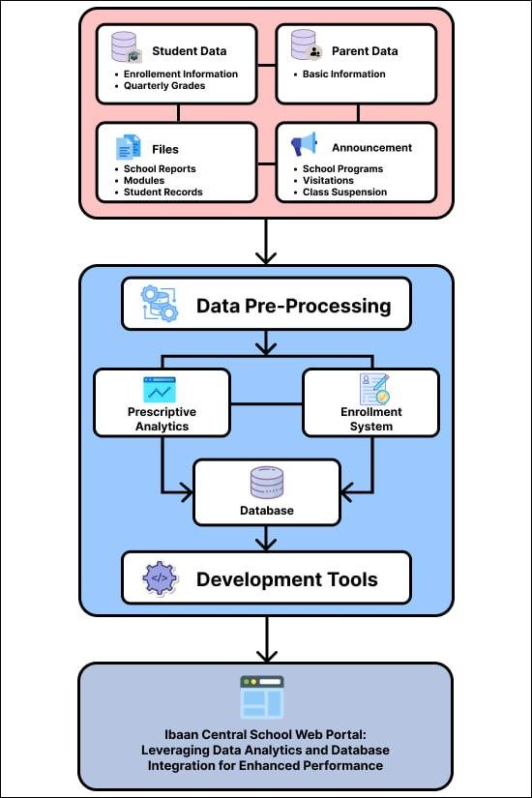

**Figure 2-1.** Conceptual Framework

Figure 2-1 shows the Input-Process-Output of the developed web system. The input includes all the data that are entered within the system. This includes the prerequisites for registration which includes both parent and student data. The quarterly grades also fall under student data. Meanwhile, different types of announcements and essential school files are also entered in the system by the principal, guidance, and PDO.

Prior to interacting with the tools, these data are pre-processed. The data then proceeds to a series of processes depending on their type. The quarterly grades interact with the prescriptive analytics, while the student and parent enrollment prerequisites interact with the enrollment system. After this, the data are stored in the school’s database for efficient storage and easier retrieval before it finally interacts with the development tools.

The output of the web system is the fully-functioning Ibaan Central School Web Portal: Leveraging Data Analytics and Database Integration for Enhanced Performance that is able to perform all its functionalities and is capable of processing the data correctly.

# **3 DESIGN AND METHODOLOGY**

## **3.1 Project Concepts**

The web-based portal developed a platform making essential academic information easily accessed online by the student’s parents, the teachers, the guidance, the PDO, and the school principal. The school portal serves as a main hub for school announcements, informing students and their parents of the scheduled upcoming events and activities. The guidance can administer enrollment and registration for students who do not have existing records in the school’s database yet through the help of a module that assists the enrollment process.

The use of data analytics as a tool to glean insightful information has gained traction in different academic institutions over the years. This project implemented data analytics tools to create a dashboard reflecting the academic performance of the students in the principal and guidance’s portal. This dashboard provides a visualization of the quarterly grades of the students by section in their different subjects through bar graphs. Additionally, the dashboard applied prescriptive analytics that identifies and recommends what academic task the class must focus on to improve their likelihood of achieving a higher average. By carefully analyzing the results, the school principal and guidance counselor can identify subjects and academic tasks on which the students struggle and excel.

## **3.2 Development Model**

The project used Agile Methodology as the development approach in developing the system. By breaking down the project into smaller tasks and working in short, focused iterations, this level of collaboration ensured that the developers and stakeholders were on the same page and that any issues or roadblocks were addressed promptly. As requirements and priorities may change during the development stage, agile methodology allows for adjustments to be made easily without causing significant disruption to the project timeline. Furthermore, this methodology supports continuous feedback and improvement allowing the development to adjust according to the preference of the client.

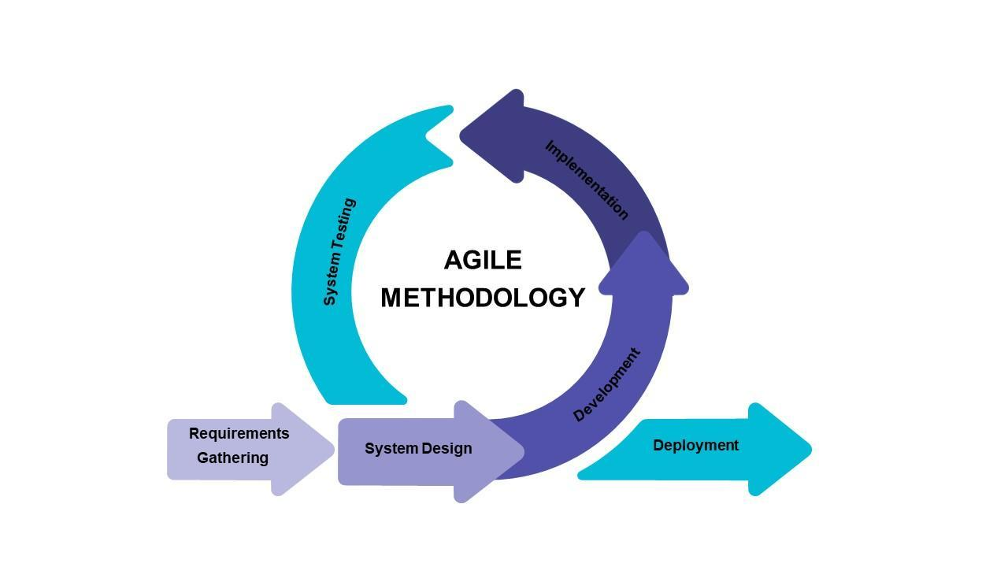

**Figure 3-1.** Agile Methodology

Visible in Figure 3-1 are the iterating processes within the methodology. This maps the overall sequence of the process flow of the project. It began with the gathering of the necessary requirements which includes all the data, software, and hardware requirements. This was followed by the designing of the system and its interface. The designing maps the processes and identifies the functionalities the system offers before proceeding to the development process which includes the coding, connecting of the database, and the whole building of the system involving both front end and back end. After those stages, the system is implemented next and tested for further revisions. For the testing process, the web portal was evaluated following the ISO/IEC 25010 before finally being deployed. However, these stages of the agile lifecycle can vary depending on the team’s preference.

## **3.3 Requirements Analysis**

In previous years, Ibaan Central School did not have a web-system with an integrated database, instead the school used different means and platforms in carrying out tasks. For the student record file storage, the physical copies of records were compiled in portfolios which were alphabetically arranged in shelves inside the Guidance office. This way, browsing and retrieving was somehow still systematic. The registration and enrollment were processed through a mixed-method of paper and computer whereas filling out google forms was an option for enrollment but there was also the physical registration done in the school premise and the barangay-box enrollment.

The grades of the students were calculated in an excel spreadsheet which contains the assignments, seat works, quizzes, summative exam, and periodical exams. The sheet has a fixed formula following DepEd’s established curriculum. The distribution of grades on the other hand was done through physically distributing the report cards during what is called “card-giving day”. While it might cause inconvenience like long lines, traffic buildup, and severe heat intolerance, on the positive end, this also gives the teachers an opportunity to have a talk with the parents on how their children are behaving and performing in the school. This also gave the parents a chance to meet their co-parents. In the matter of information and details on event announcements and class suspensions, these are shared via Facebook and Messenger, the two most popular social media networks. This may be in the form of a message or post.

**Fish Bone Analysis**

A fish bone diagram represents the brainstormed root causes of the problems of a main problem. This is important to see the root causes of the problem and see what exact causes contribute to the bigger problem. These are categorized into categories that illustrate a reflection of the problem statement. Most importantly, fish bone diagram helped in creating a systematic analysis leading to a comprehensive and efficient problem-solving process.

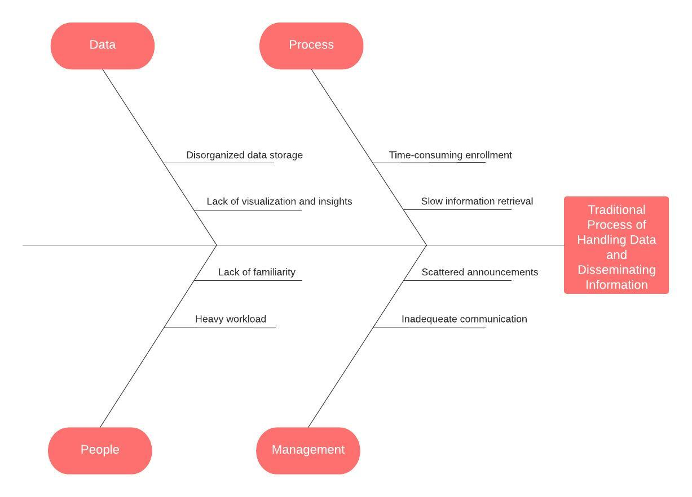

**Figure 3-2.** Fishbone Analysis

The main problem is the traditional process of handling data and disseminating information in the previous system of the school. Sub problems which make up the main problem were nitpicked, this includes Data, Process, People, and Management. These issues were the primary reasons why the system was necessary for its users.

Under the data is the disorganized data storage and lack of visualization and insights. In the old system of the school, sensitive records were stored in different places such as notebooks, folders, hard drives, and cloud storage proving the need for a centralized database. The school also did not take advantage of these data to its maximum potential leading to missed opportunities in improving.

For the process, the enrollment and registration of students usually took a painstakingly long time, this was due to the manual processing of requirements. Moreover, the guidance counselor consumed a long time when retrieving files, the student or parents may need as she had to go through a pile of documents stored in the shelves of her office.

Meanwhile, the sub problems under the management include scattered announcements and inadequate communication. Event announcements, class cancellations, and other school-related information were usually broadcasted through Facebook and Messenger as it has been the primary platforms that connect the stakeholders.

On the other hand, under the people category are the lack of familiarity and heavy workload. Since the old system of the school is paper-based, big adjustments had to be made as most users lack familiarity with the technology. Moreover, the guidance counselor faced a lot of paper-work as the distribution of workload left it heavy on her end.

The Ibaan Central School Web Portal is huge help in organizing and streamlining administrative processes by following a structured work-flow and automating processes.

**System Boundary**

Figure 3-3 illustrates the boundaries of the system along with the distribution of tasks among all the users utilizing the system.

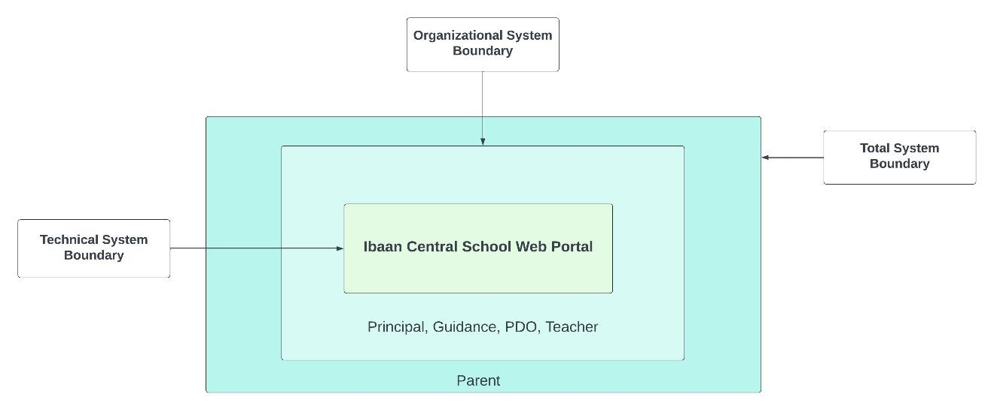**Figure 3-3.** System Boundary

Three boundaries were identified; Technical System Boundary, Organizational Boundary, and Total System Boundary. The center of the figure shows the Ibaan Central School Web portal that falls under Technical System Boundary. Inside the next layer, organizational boundary, are the members of the organizational structure and are working under the institution which are the school principal, guidance counselor, PDO, and teachers. They are the ones who have access to exclusive administrative information and administrative processes involving handling student data and sensitive school records. Meanwhile, the parents belong to the total system boundary as they are external entities whose only involvement in the system are their children. Access is only given to parents for files and information aligned to their role.

## **3.4 System Design**

Based on the defined requirements and system details, the system's design offers detailed information. This section demonstrates how the system operates and what features the stakeholders may access.

**Use Case Diagram**

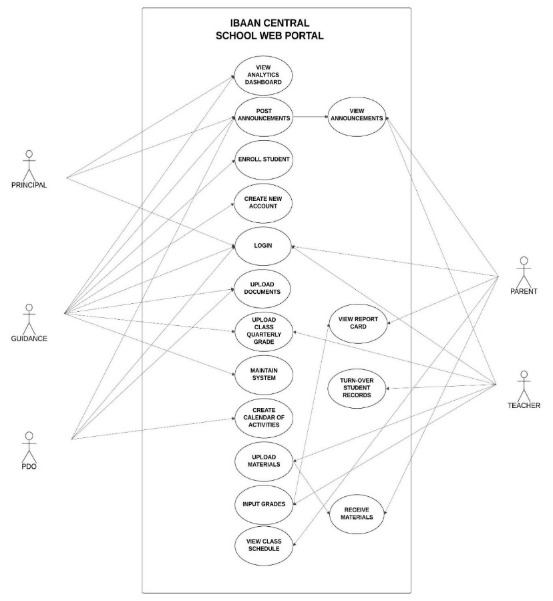This identifies the interactions between the identified actors of the web-based school portal. Use Case Diagram shows what actions they are limited to.

**Figure 3-4.** Use Case

All of the actors in the system are required to login before being directed to their homepage. The first actor in the web-based portal is the principal who upon login, can have access to features including creating an announcement, viewing the dashboard which reflects the quarterly performance of the students by year, section, and subject. Lastly, the principal can also view the output of the prescriptive analytics which is a recommendation of which academic task deserves more attention based on the quarterly grades. Similar to the functions the principal has access to, the guidance also has the ability to make announcements and view the dashboard. The guidance is the personnel responsible for uploading the compiled quarterly grades of all the students which is the data necessary to create the dashboard. The guidance can process enrollments for cases of new enrollees or transferees. Moreover, the guidance is also the personnel responsible for maintaining the system and creating a new account for newly registered parents. Another acting entity within the system is the Project Development Officer (PDO) who is responsible for notifying the school in school events, uploading school files, and creating the school calendar. Teachers are the ones to input the grades of their students and as well as upload academic-related materials. They also receive announcements from the principal and the guidance. The teacher is also responsible for the turnover of the previous student record to the upcoming class adviser of the student for the next academic year. This sums up the administrative actors.

The parents, on the other hand, can view the announcements created by the principal and the guidance. They can also view the uploads of the teachers containing the e-grades and school materials.

**Context Diagram**

The Context Diagram identifies where the data originates from and where it is taken to. This also visualizes how the external entities interact with the system.

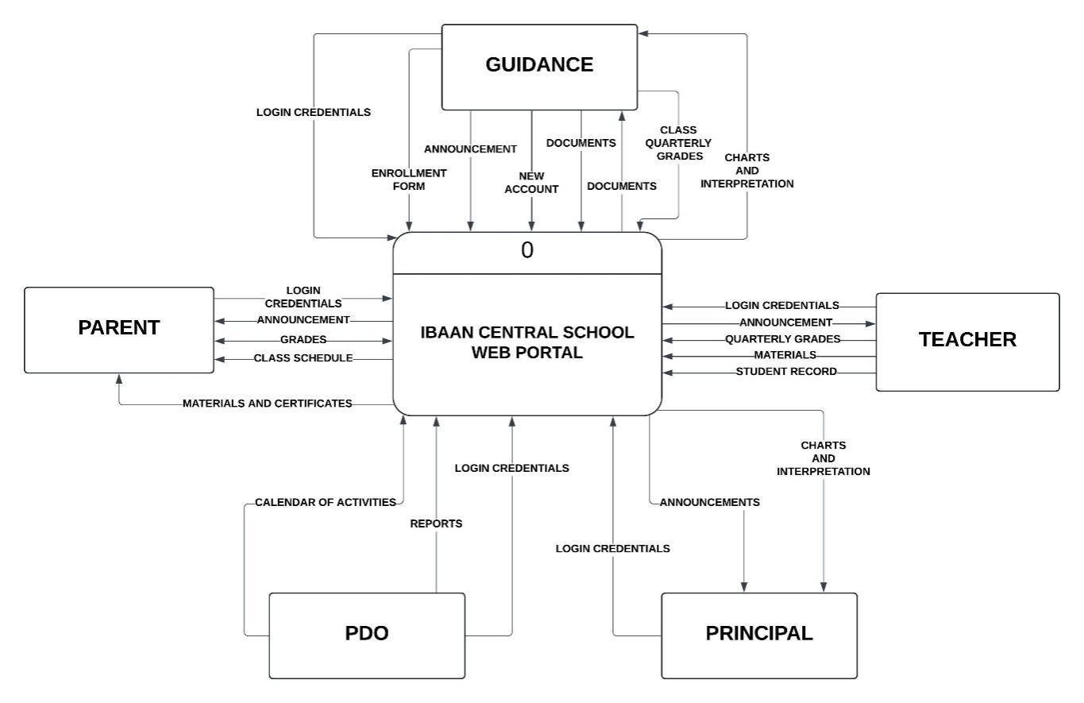

**Figure 3-5.** Context Diagram

The web-based portal consists of five users, the principal, the guidance, the PDO, the teacher, and the parent. Prior to being taken to their homepage, each user must log in first.

The flow of the announcements begins with either the principal, guidance, or PDO who inputs the announcement into the system. These are received and reflected in the parent’s portal. For the quarterly grades, it begins with the subject teachers uploading the grades to the portal. This is received by the parents. All the uploaded sheet of grades is compiled in the guidance’s portal where it is uploaded to create the dashboard. The dashboard calculates the mean of the grades of the students and displays the charts in the guidance and principal’s portal. For the teaching materials and certificates, the teacher uploads it and is received by the parents.

Students who already have existing records in the system can be enrolled by their previous class adviser by turning over their records. For new enrollees who do not have previous records in the school, a form shall be filled out and e-copies of scans of PSA birth certificate and progress report card (if available) shall be passed. If a parent opts to enroll their child under the SNED program, medical assessment will also be required.

**Level 0 Diagram**

Level 0 Diagram provides a bird’s-eye view to the system. It does not only illustrate the entities and how they interact with the system, but also provides an in depth view of the ingoing and outgoing data from users to data stores to the system. This is a detailed breakdown of the context diagram showing the exact flow of data and the data store where the specific data are stored on.

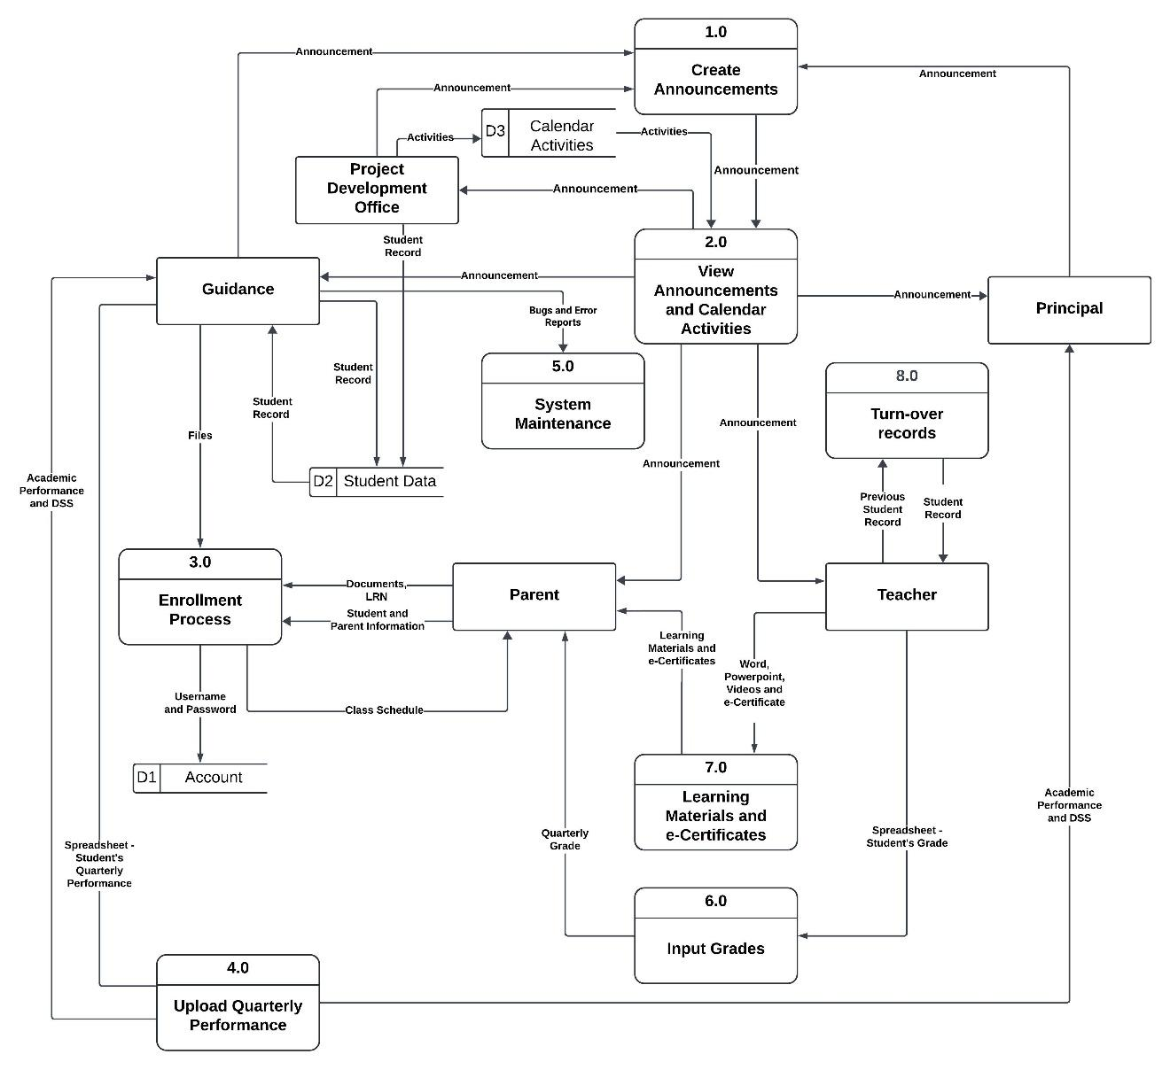

**Figure 3-6.** Level 0

Figure 3-6 shows all the entities in the system along with a detailed outline of the processes of the functionalities they have access to. The first process takes place after the login and is all about creating an announcement which is only exclusive to the principal, the guidance, and the PDO. Along with the announcements is the creation of a school calendar by the PDO. The school calendar basically maps all the planned activities placed in their tentative dates throughout the school year. Once the announcement and calendar of activities has been made and uploaded, these are viewable and are reflected on everyone’s portal including the teacher and the parent.

The third process involves the upload of learning materials and e-certificates. This process is done by the teacher who can basically upload files of varying format into the system before it is received by the parents. This process is followed by the enrollment.

The enrollment process requires the guidance to process the registration of new enrollees and transferees. The guidance uploads the student record into the student data store where it is permanently stored. They are also the ones to assign new accounts to students and parents which will be stored in the account data store, separate from the student data store. The next process is also part of the enrollment but is specifically only done for students who plan to go to the same school in the next school year. The turn-over of records is done by the previous class adviser wherein student records are transported to the next class adviser of the student. This can only be done to students who have pre-existing records in the school’s database.

The next process involves inputting the grades of the students which is done by the teacher. These grades are reflected into the parent’s portal. After completing all the grades, the spreadsheet that contains the broken down scores of all the academic tasks and the quarterly grade is compiled by the guidance before being uploaded to the system. This process generates a numerical data report in the form of a dashboard providing graphs and lists of top and bottom 10 students per subject, accessed by the guidance and the school principal. However, the dashboard only provide visualization on the quarterly grades. The last and final process in the diagram is the system maintenance which can be performed by the guidance.

**Sequence Diagram**

Sequence Diagram depicts how the end users interact with the system. In this diagram, the procedures performed are arranged sequentially.

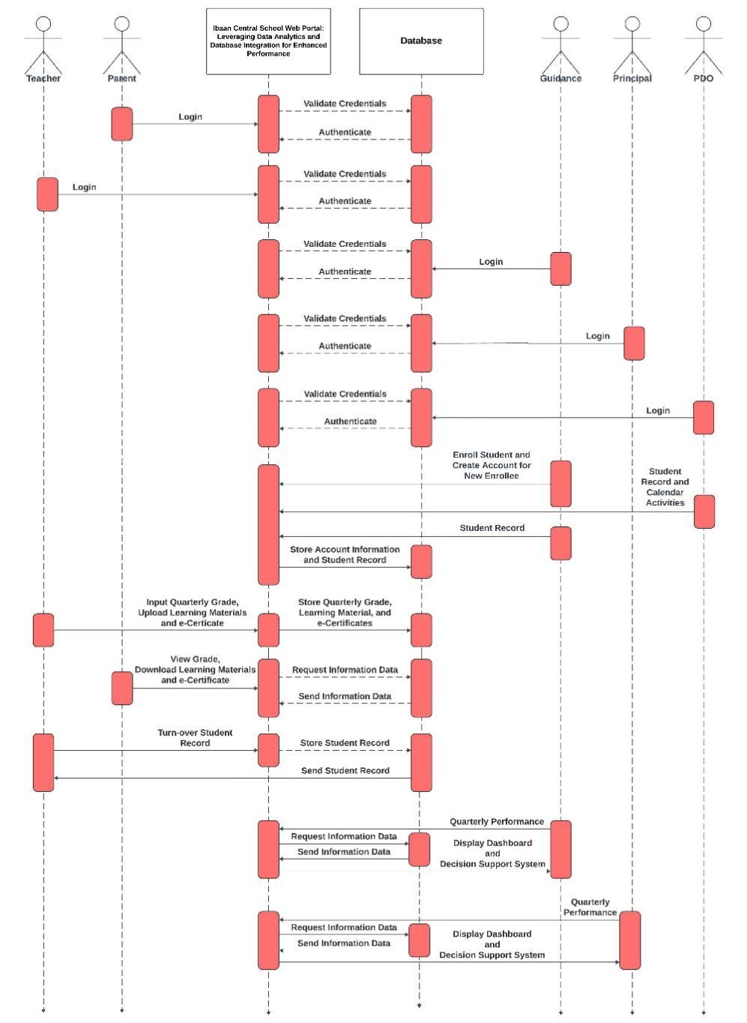

**Figure 3-7.** Sequence Diagram

Figure 3-5 outlines the actions performed by each of the users in the system. It begins with the login where the entered credentials are verified first from the database before proceeding to the authentication. Once the teacher has logged in, grades can now be placed and stored in the database. The parent on the other hand may view the announcements and download materials. The guidance can perform a multitude of functions such as enrolling the students and providing accounts for newly registered parents whose children do not have former records. The guidance also uploads the quarterly performance which is stored in the database before finally being reflected into the guidance’s own portal as well as the principal’s.

The principal and the PDO, on the other hand, may now create announcements, however the principal can view the analytical dashboard while the PDO cannot and the PDO can upload the calendar of activities while the principal cannot.

### **3.4.1 Software Requirements Specification**

When it comes to the intricate process of making software come to life, precisely defined prerequisites are one of the vital foundations. Knowing the precise parameters of the program is just as important as knowing the hardware requirements for the actual platform. Knowledge about this leads to a well-crafted set of software requirements that act as a guide for the features and functionalities of the program.

*3.4.1.1 Functional Requirements*

Functional requirements dictate the behavior of the system as well as its features that make it useful for the end users. This outlines what functions are the system able to execute for it to be able to meet the needs of the stakeholders. Here is a list of the basic functionalities that determine what the system is expected to do.

1. **Principal**

1.1 The principal can post an announcement.

1.2 The principal can view and filter the academic performance dashboard.

1. **Guidance**

2.1 The guidance can post an announcement.

2.2 The guidance can enroll students.

2.3 The guidance can create a new account for newly registered parents.

2.4 The guidance can upload the spreadsheet containing the quarterly performance of students

2.5 The guidance can view and filter the academic performance dashboard.

2.6 The Guidance can upload and retrieve student documents in the database.

2.6 The guidance can maintain the system.

1. **Project Development Officer (PDO)**

3.1 The Project Development Officer can post an announcement.

3.2 The Project Development Officer can upload school reports in the database.

3.3 The Project Development Officer can create the school’s calendar of activities.

1. **Teacher**

4.1 The teacher can view announcements.

4.2 The teacher can upload the excel sheet containing the students’ quarterly grade.

4.3 The teacher can upload teaching materials and e-certificates in varying file formats (Word, PowerPoint, Videos).

4.4 The teacher can turn-over the records of the previous student to the next class adviser.

1. **Parent**

5.1 The parent can view announcements.

5.2 The parent can view their child’s schedule.

5.3 The parent can view their child’s quarterly grades.

5.4 The parent can download the teaching materials and e-certificates.

*3.4.1.2 Non-Functional Requirements*

Non Functional requirements define what qualities must the system have. This highlights the criteria of the quality of the system.

1. **Accessibility**

1.1. The system is accessed only by the exclusive members of Ibaan Central School.

1.2. The system is accessible anytime and anywhere so long as there is internet connection.

1. **Efficiency**

2.1. The system’s load time and refresh time is quick.

2.2. The system completes the task within an acceptable time frame for the users without sacrificing the quality of the output.

1. **Reliability**

3.1. The system can process big loads of requests, manages errors and avoids long periods of down-time upon occurrence.

3.2 Consistent and accurate information is provided.

1. **Usability**

4.1 The system is user-friendly and not overwhelming

4.2 The buttons are functioning well and shall direct the users to where they want.

1. **Flexibility**

5.1 The system fits any screen resolution.

5.2 The system adapts well to all devices without losing functionality.

### **3.4.2 Hardware and Software Requirements**

This section provides a list of minimum hardware and software requirements and the versions and specifications that the system requires the end users in order for it to operate accordingly.

|  |  |  |  |  |
| --- | --- | --- | --- | --- |
|  | **Table 3-1.** Hardware Requirements | |  |  |
|  | **Requirement** | **Tool** | **Version** | **Minimum** **Requirement** |
|  | Device  Wi-fi | Laptop/PC  Smartphone  Any ISP | Base and Future Version  Base and Future Version  Base Internet Plan | 64 bit  Processor: 2.6 GHz  RAM: 4 GB  Storage: 128 GB  Processor: 1 GHz  RAM: 1 GB  Storage: 8 GB  Bandwidth: 10 Mbps |

Table 3-1 shows the hardware necessities the users must possess to utilize the web portal at its optimum level. The user can access the portal with either a laptop, pc, or smartphone. The laptop must at least have 64 bit and 2.6 GHz for its processor. The minimum RAM is 4 GB while the minimum storage is 128 GB. For the smartphone it is compatible with any processor as long as it has 1 GHz or higher. The RAM required is 1 GB and the storage must have a minimum of 8 GB.

The portal is web-based meaning for users to access it, there must be a stable internet connection. There is no limit on what ISP the web portal is accessed from as long as its bandwidth is within the minimum of 10 Mbps.

|  |  |  |  |  |
| --- | --- | --- | --- | --- |
|  | **Table 3-2.** Software Requirements | |  |  |
|  | **Requirement** | **Tool** | **Version** | **Minimum** **Requirement** |
|  | Operating System  Browser | Windows  MacOS  Android  iOs  Google Chrome  Microsoft Edge  Mozilla Firefox | Base  Base  Base  Base  Present and Future Version  Present and Future Version  Present and Future Version | 32-64 Bit  32-64 Bit  32-64 Bit  32-64 Bit  Standard  Standard  Standard |

Table 3-2 shows the software necessities the users must possess in order to utilize the web portal at its optimum level. The web portal works on different operating systems including Windows, MacOS, Android, and iOs with a minimum bit ranging 32-64. The operating system should at least have the base version which supports the browser. However, it is highly suggested to have the latest version to avoid potential issues with incompatibility. The second requirement is a browser which the portal is accessed and opened from. Compatible browsers include the latest versions of Google Chrome, Microsoft Edge, and Mozilla Firefox.

### **3.4.3 Database Design**

The database design gives an overview of the backend of the system. This shows the relationship of entities interacting in the database. In order to visualize this, entities, primary keys, and foreign keys must be identified. More importantly, this ensures that data are arranged logically and is responsible for eliminating redundancy.

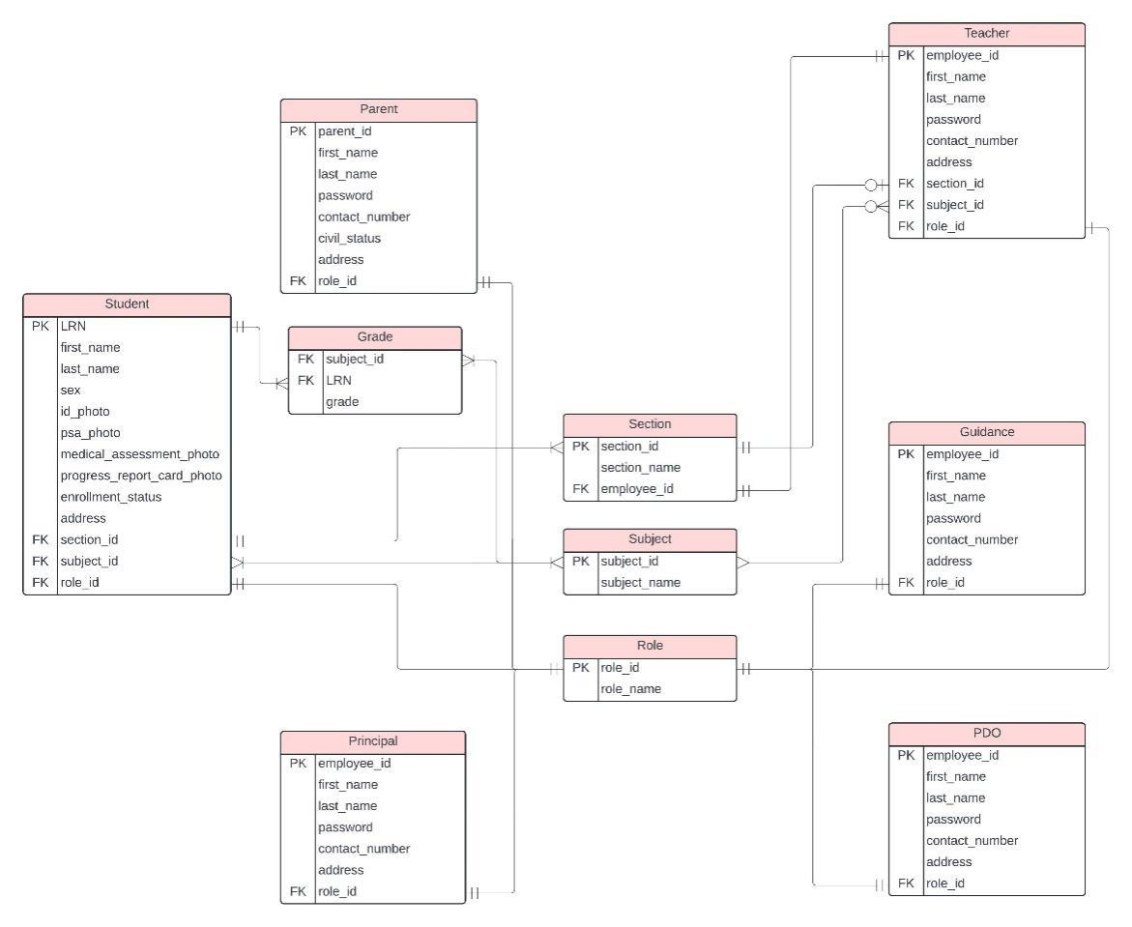

**Figure 3-8.** Entity Relationship Diagram (ERD)

Figure 3-8 shows the entity relationship of each table in the web portal. The tables are referenced from the users of the system which includes the Parent, Principal, Guidance, PDO, and Teacher. Despite not being a user of the system, Student has its own separate table as it is necessary to isolate all their included records from the rest.

The parent table contains attributes which are necessary for recording personal information. Its primary key is the parent_id and and role_id referenced to the Role table to identify that the user is a parent.

The teacher table contains similar personal information attributes. The primary key for this table is the employee_id. Similar to the parent table, it also contains role_id to identify that the user is a teacher. Attributes like section_id and subject_id are also present here as it shows what section the teacher is handling as well as the subject the teacher is teaching.

The guidance table has the same set of personal information attributes as the two first tables. The primary key for this is the employee_id. On the other hand, the principal table and the PDO table are identical to the guidance table, having the same set of attributes.

The student table is the most complex table in the ERD. The primary key used here is the Learner’s Reference Number (LRN) as it is unique to every student. Similarly, the same set of personal information attributes are present in this table. The files uploaded upon enrollment are also stored and arranged here. Photos or scans of PSA, progress report card, and medical assessment for SNED students are also within this table. Foreign keys connected to other tables are section_id, subject_id, and role_id.

The section table has section_id as its primary key which helps navigate the section name. This table also contains the employee_id of the teacher who handles the section. The subject table shows the name of the subjects. Lastly is the role table which verifies what role the user plays in the academic institution or the system.

### **3.4.4 Trade-off and Multiple Attributes**

The Trade-Off and Multiple Attributes phase evaluates advantages and disadvantages of the software development tools that the researchers initially considered using. Through this, the researchers can select the best suited option for the development of the web portal.

|  |  |  |  |  |
| --- | --- | --- | --- | --- |
|  | **Table 3-3.** Trade-off and Multiple Attributes | | |  |
|  | **Design** | **Coding** | **Database** | **Web-Hosting** |
|  | A  B | Visual Studio Code, Javascript, PHP  Pycharm, Python | MySQL  MongoDB | Hostinger  HostGator |

Table 3-3 presents the set of software utilities that were taken into consideration. Design A utilizes Visual Studio as the IDE for programming as it offers many extensions and features tailored for JavaScript. This is followed by the use of JavaScript and PHP as the primary programming languages. Design A uses the open-source database, MySQL, as it is known for its fast query execution and cross-platform compatibility. Hostinger is used for the hosting as the subscription deal matches the demand of the study in terms of features and duration.

Design B on the other hand utilizes Python programming language. To match this, the IDE used in parallel is Pycharm as it offers a wide variety of features, extensions, and frameworks that work best with Python. The database opted to be used is MongoDB as it offers a great query language which specifically supports CRUD functions.

The researchers went with Design A due to a variety of reasons. JavaScript with PHP was chosen over Python because of the dynamic interactivity it offers for the web portal and the familiarity of the researchers with the programming language itself. Although Python is still a top-notch language, JavaScript with PHP has better browser compatibility. On the other hand, MySQL was chosen over MongoDB as it outperforms MongoDB. Moreover, it is far more suitable for web-based platform development which uses JavaScript and PHP. Lastly, Hostinger was selected as the provider of the domain and hosting given that it has affordable plan rates making it the most accessible for the development which has a limited budget constraint.

## **3.5 Development**

This is the kick off which deals with the identification of the output of the system as well as the definition of the hardware and software requirements.

### **3.5.1 Software Development Tools**

This section defines the specifications for the software requirements and development tools necessary for the development of the web portal.

|  |  |  |  |
| --- | --- | --- | --- |
|  | **Table 3-4**. Software Development Tools | |  |
|  | **Requirement** | **Software Tool** | **Minimum** **Requirements** |
|  | UI/UX Design Tool  IDE  Programming Languages  Framework  DBMS  Web Server  Domain | Figma  Visual Studio Code  HTML, CSS, JavaScript, PHP  Bootstrap  MySQL  XAMPP  Hostinger | Base Version  Visual Studio Code 1.88  HTML 5, CSS 3, JavaScript ECMAScript 6, PHP 8.2  Bootstrap 5  MySQL 8.0  XAMPP 8.2.12  Business Pack |

The user interface design prototype was done through the application Figma and was coded in Visual Studio Code 1.88. The Bootstrap 5 extension was downloaded from the site getbootstrap before setting it up in the chosen IDE. The system was developed using HTML 5, CSS 3, and JavaScript ECMAScript 6 for the front end and PHP 8.2 as the programming language for the back end as these are the most suitable for web-based systems. The most updated version of the tools was selected to ensure that all features can be accessed. XAMPP was used for the server, and for the database, MySQL was used. The business pack in hostinger was purchased, providing a 1-year subscription and granting the system unlimited free SSL, unlimited bandwidth, and a domain. However, it has a limit of twenty-five (25) thousand users visiting monthly.

### **3.5.2 Hardware Development Tools**

This section defines the specifications for hardware requirements as well as the development tools that are selected for the development of the web portal.

|  |  |  |  |
| --- | --- | --- | --- |
|  | **Table 3-5**. Hardware Development Tools | |  |
|  | **Requirement** | **Hardware Tool** | **Minimum** **Requirements** |
|  | Device  Wi-fi | Laptop/PC  Any ISP | Operating System: Windows 10-11 64 bit  Processor: 2.6 GHz  RAM: 4 GB  Storage: 128 GB  Bandwidth: 15-50 Mbps |

Table 3-5 provides a list of the necessary hardware and its respective requirements. The laptop or pc’s operating system was Windows 10-11 with 64 bit. Its processor is at least 2.6 GHz or faster. Its ram is at least 4 GB and must have a minimum of 128 GB (SSD) storage. The wifi bandwidth ranges around 25-50 Mbps.

## **3.6 Testing and Evaluation**

This phase of the development process entails the evaluation and testing of the web-based portal to check whether the system meets the set requirements ensuring quality and compliance of the system. This is done to guarantee that the system is performing on an optimum level by identifying potential bugs and errors.

To validate if the functionalities set are working as intended, the study ought to use ISO/IEC 25010 Software Quality Standard to assess whether the web portal satisfies the following qualities:

**Efficiency**

In order to measure the efficiency of the web portal, Apache Jmeter is used as the primary tool for the load test of concurrency testing. Through this, the speed, resource usage, and overall performance capacity of the portal is measured through a simulation indicating a sample of number of users.

**Reliability**

A reliable system must be able to handle errors ensuring the end users a safe browsing experience. To evaluate the reliability of the web-based portal, the researchers, upon deployment, carried out a survey where the results of the reliability is evaluated. The survey has questions whether the user experienced crashes or errors in the system.

**Functionality**

The software system is considered to be functional if the user requirements were met in terms of the main functions of the web portal and it successfully performs the tasks of the users. Moreover, all the core features must be working accordingly, delivering expected results under normal behavior. The testing procedure to ensure the system is functional was through a functionality testing with Selenium IDE and user feedback.

**Flexibility**

This quality standard also assesses the ability of the software system to be flexible including the accessibility across different devices. The testing procedure to measure the flexibility of the web-based portal was done through a series of UI Testing where the responsiveness of the portal in different screens and the response of buttons when clicked were evaluated assuring that it produced the expected output in real-time. Cross-browser testing was done to ensure that the portal functions with different web browsers.

### **3.6.1 Testing Tools and Methodologies**

* **Apache Jmeter**

Apache Jmeter was used as the primary testing software for performance and functional testing including response time, refresh speed, and maximum user load, all of which are critical for a good user experience.

* **Selenium IDE**

Selenium IDE was used to ensure that all the functions within the web portal remain functional upon being deployed. It also verifies that the features are working as expected through a series of simulations. Test cases demonstrating the tested functionalities are created and results were recorded.

* **Cross Browser Testing**

To test the flexibility of the web portal, cross browser testing was done. The portal was accessed through different browsers to see if it remains responsive and consistently works on different web browsers and operating systems.

* **User Feedback through Survey**

A questionnaire in google forms was distributed to the selected sample users to gather user feedback to evaluate their satisfaction on the performance of the web portal, mainly its efficiency, reliability, and flexibility.

## **3.7 Deployment**

After the web-portal has been tested and validity was proven, it proceeded to the deployment. Software deployment is the final phase of the process of web development. This is the phase where technological transfer occurs and the entirety of the website is made available to the end users. Installation, proper configuration, setting up, and launching are also done in this phase.

### **3.7.1 Sustainability and Maintenance Plan**

After the software has been deployed and transported to the end-users, user manuals were provided and discussed in detail for them to know how the system works and what functionalities it can perform. A face-to-face training is done by the researchers as part of the duties to be fulfilled as developers of the system.

The possibility of the occurrence of anomalies which may alter the modules and the overall process of the system are never ruled out, hence the need for a maintenance plan. The maintenance plan contains activities to be carried out by the guidance in the event of bugs and anomaly detection so that the system can go back to normal operating conditions. Following the maintenance operations, the guidance must have a documentation which outlines the encountered issue and the steps taken to resolve it. This will be beneficial in the future if the system encounters the same problem again.

### **3.7.2 Risk Management Plan**

A Risk Management Plan is an essential aspect in maintaining the system. It ensures that potential risks can be controlled, preventing and alleviating further damage to the system by having an action plan prepared when faced with unexpected conditions.

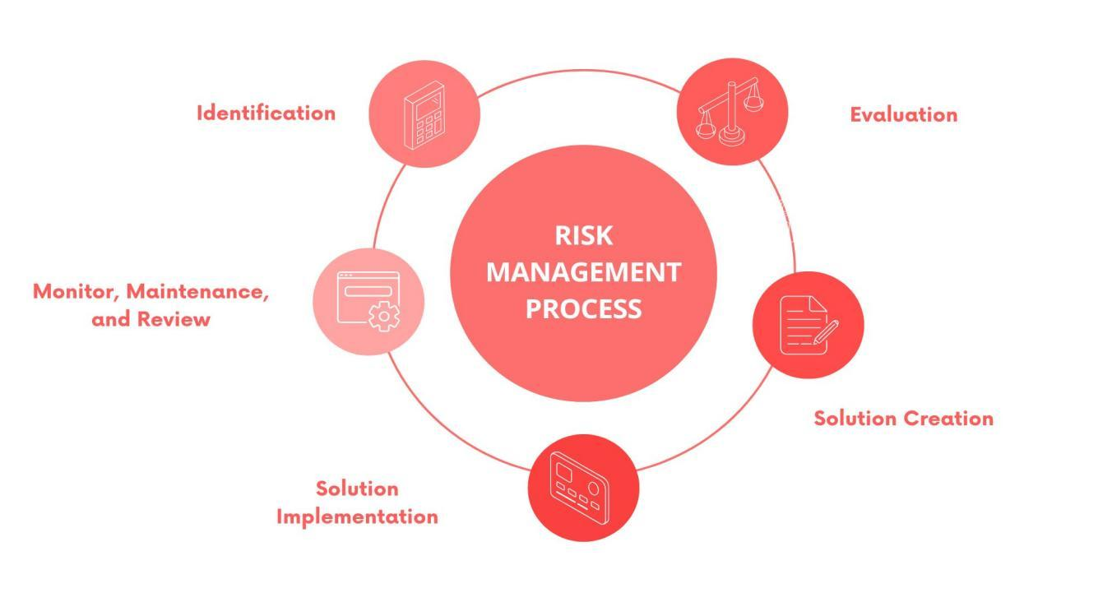

**Figure 3-9.** Risk Management Process

The Risk Management Process is made up of five crucial stages which must be implemented on the occurrence of detection of potential risks. These five stages must be followed chronologically.

**Identification**

The process begins with the identification of weak links and vulnerabilities through brainstorming. This can also be done by referencing relevant systems which present risks as well.

|  |  |  |
| --- | --- | --- |
|  | **Table 3-6**. Identified Risks |  |
|  | **Risk ID** | **Risk Name** |
|  | RID 001  RID 002  RID 003  RID 004  RID 005  RID 006 | Software Failure  Data Integrity, Inconsistency, and Breach Issues  Malware  Prolonged Downtime  Slow Performance  Human Error |

Table 3-6 lists the most commonly encountered risks in a web-based system. A total of 6 risks were identified and to it, a Risk ID is assigned for easy referencing.

RID 001: **Software Failure.** Unexpected crashing of the web portal may happen from time to time which may be caused by server overload, glitches, defects, minor to major coding mistakes, and configuration errors.

RID 002: **Data Integrity, Inconsistency, and Breach Issues.** This risk focuses on the data that are flowing and being processed in the system. This may lead to corruption and inaccurate display of records to the portal of the users.

RID 003: **Malware.** Exposure to malware is considered as another risk for the system. This can originate from infected files downloaded, external devices which already have malware, and more. This poses security risk to the users of the system.

RID 004: **Prolonged Downtime.** Downtime refers to the system not being accessible to its users. This may happen due to a couple of reasons including problems with the hosting, unexpected maintenance, and several attacks.

RID 005: **Slow Performance.** The performance of the system might get slow when network traffic causing latency occurs. Another reason for this is excessive incoming requests which the system cannot handle.

RID 006: **Human Error.** This is the most common and unavoidable risk in every system. Errors in data entry, login authentication, upload duplication, and forgetting to update the software are some of the examples of human error.

**Evaluation**

This phase assesses the acknowledged risks from the prior process and categorizes them according to their type. It also estimates the probability and severity of the risks. The evaluation of the likelihood of occurrence and the severity will be based on the provided Matrix referred to as Table 3-7 Risk Assessment Matrix.

**Table 3-7.** Risk Assessment Matrix

|  |  |  |  |  |  |
| --- | --- | --- | --- | --- | --- |
|  | | **SEVERITY** | | | |
| **ACCEPTABLE (1)** | **TOLERABLE**  **(2)** | **UNDESIRABLE**  **(3)** | **INTOLERABLE**  **(4)** |
| **PROBABILITY** | **IMPROBABLE**  **(1)** | Low | Medium | Medium | High |
| **POSSIBLE**  **(2)** | Low | Medium | High | Extreme |
| **PROBABLE**  **(3)** | Medium | High | High | Extreme |

Table 3-7 provides a rating scale of the probability and severity of the risks. The probability rating ranges 1-3, 1 being Improbable, 2 being Possible, and 3 being Probable. The higher the number, the higher the odds of the risk occurring. For the severity, the rating ranges from 1 to 4. 1 and 2 are on the lower side being labeled as Acceptable and Tolerable while 3 and 4 are on the higher side being labeled as Undesirable and Intolerable.

|  |  |  |  |  |
| --- | --- | --- | --- | --- |
|  | **Table 3-8**. Evaluated Risks | | |  |
|  | **Risk ID** | **Type** | **Probability** | **Severity** |
|  | RID 001  RID 002  RID 003  RID 004  RID 005  RID 006 | Technical  Security  Security  Operational  Operational  Operational | 2  2  1  2  3  3 | 3  4  4  3  3  2 |

Table 3-8 sorts the risks into their rightful categories. The risks may fall under Technical, Security, or Operational type. The risks are then evaluated based on the probability of it occurring and the severity of the impact it might make in the system.

**Solution Creation**

This section seeks to offer mitigation actions corresponding to the risks to minimize its impact on the system and operations of the school.

|  |  |  |
| --- | --- | --- |
|  | **Table 3-9**. Risk Solution |  |
|  | **Risk ID** | **Mitigation Approach** |
|  | RID 001  RID 002  RID 003  RID 004  RID 005  RID 006 | Debug  Carryout Database Maintenance  Apply patches and updates  Schedule Regular Maintenance  Employ Load Balancing  Hold training programs, employ strict role-based access control |

Table 3-9 offers the possible solutions to the risks. By creating potential feasible treatment, strategies are developed to minimize or fully eradicate the impact of the risk to the system.

**Solution Implementation**

The proposed solutions are now implemented to see if it is effective and if it solves the problems. To fix software failure, the guidance counselor must be ready to fix the bug by identifying, fixing by making software changes, testing and deploying.

When faced with the inconsistency, integrity issues, and data breach, the guidance counselor must first ensure that there is a backup of all the data before performing the database maintenance which may include clean ups and updates.

On the occurrence of malware detected upon the system, it must first be categorized and isolated so that it does not affect the rest of the system. A clean up must be performed which may require removing the detected malware. After this, patches and necessary updates can be applied.

To avoid long periods of downtime, regular system maintenance must be scheduled. To fix the slow performance caused by network traffic and excessive requests, load balancing must be done.

Lastly, to address human errors, the most effective way is to employ strict role-based access control and educate them about the system through meetings or training programs. This way they will know their way around the system and will most likely not commit errors as often.

Given the fact that these risks might have big implications to the system, it is essential to have a journal or documentation on the previous cases encountered. The documentation may include specific dates when it occurred, the case name, its description, and the measures taken to fix the risks.

**Monitor, Maintenance, and Review**

After the treatment has been implemented, regular review and analysis of the progress must be done. This is to track the effectiveness of the applied solutions, and to identify potential flaws and emerging hazards. Team meetings must be carried out to ensure full transparency and awareness.

### **3.8 Sampling Method**

To get the responses that verified the validity of the system of its compliance to the ISO 25010, the study applied Simple Random Sampling as the Sampling Method for the survey. This technique reduced the bias as the gathered feedback were collected from users who had equal odds of getting chosen. This ensured that the results reflected the views of the entire parent body.

Since the population of expected users revolves around 1000, the sample size was determined using the Slovin’s Formula:

n = N / (1 + Ne2)

* N (population size) = 1000
* e (margin of error) = 0.05

n = 1000 / (1 + 1000(0.05)2)

n = 286

A sample size of 286 users was extracted. The confidence rate of this sample is 95%. The sample size had different demographics, belonging from age brackets 30-40, 41-50, 51-60, 61-above. They also came from different barangays in Ibaan, Batangas. The 100 users received a survey in google forms comprising of validated questions which measures the set ISO quality standards the web-portal followed.

### **3.9 Statistical Approach**

The data gathered to assess the user satisfaction and acceptance went through an analysis to draw a conclusion whether it passes the set quality standards.

**Quantitative Analysis**

To have a better understanding on the perception of the user towards the web portal, the questions in the distributed questionnaire were designed to be answerable with “Strongly Agree”, “Agree”, “Disagree”, and “Strongly Disagree”. These answers have been converted to their equivalent scores of 4, 3, 2, and 1 for the data gathered to be numerical.

**Descriptive Statistics**

For the data summary, presentation, and interpretation, the statistical approach chosen was descriptive statistics mainly focused on the central tendency of the survey scores. The mean for each question were calculated before finally getting the composite mean which provides the overall result for the specific standard being measured.

# **4 RESULTS AND DISCUSSION**

In this section, the corresponding results of the developed school portal are reviewed and discussed. The Ibaan Central School Web Portal, a website that the researchers designed and developed, significantly streamlines the school's manual data handling procedures and enables a paperless enrollment system. This system links five particular user groups—Principal, Guidance, PDO, Parent, and Teacher—to access announcements and documents in a single platform through an integrated database. The implementation of a user-friendly interface brought convenience to the user groups upon using the developed system for their tasks. The web portal did not only enable the operations to be modernized, but also enhanced the school's communication to all of its stakeholders, empowered parental involvement in their children's academic life, and altogether created a collaborative and organized educational environment.

**Automation of Processes for Enrollment**

Aiding for a convenient enrollment processing, the developed system automated the enrollment process to minimize the paper-based operations in Ibaan Central School.

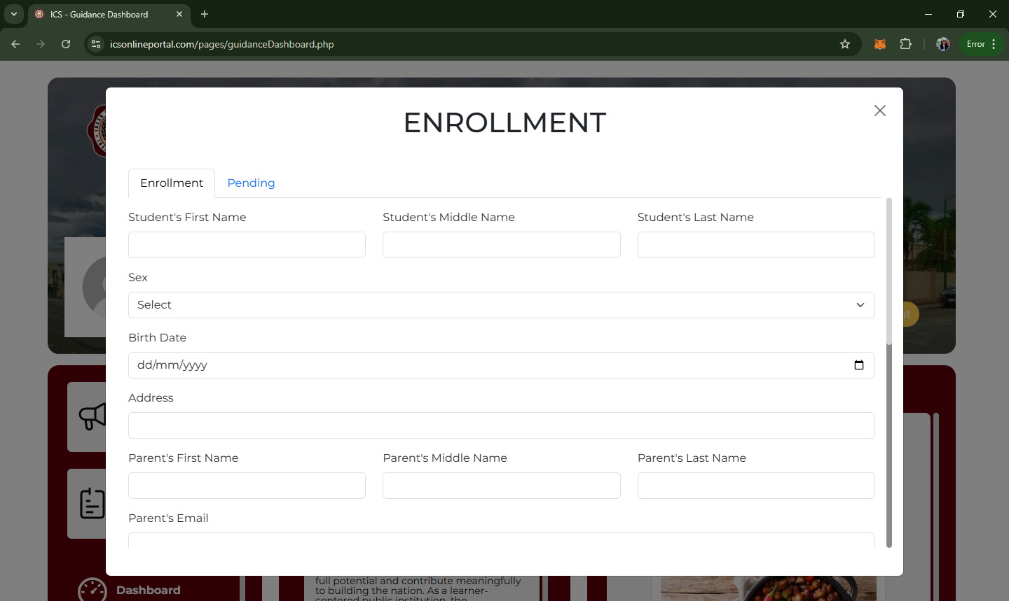

Figure 4-1. **Enrollment**

For the enrollment module to be created, HTML form from Bootstrap was used to a form that accepts the user input.All the fields in the form which includes the necessary student information must be filled up accordingly to proceed with the enrollment. Once it is complete, the data will be put in the student table in the database where the LRN field is at null state. The LRN is not readily available since it is directly issued by DepEd to schools once the enrollment phase of all the schools are finally over.

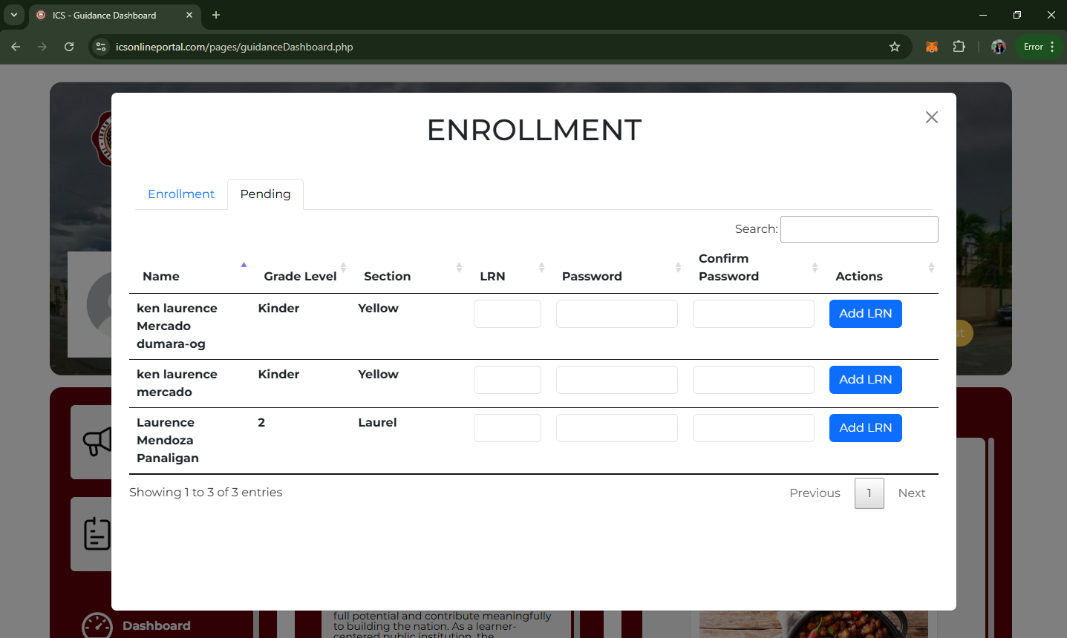Figure 4-2. **Pending Section**

The newly enrolled students will be placed in the pending section wherein the LRN is waited to be administered. Once the LRN has been provided the preceding fields will be filled out and then submitted and the student will be removed from the pending section. The submission also signals the creation of the portal account of the parent.

The built in library provided by JS called Data Table was used to access the built in function for searching instead of coding a search function manually. This also has a paging function which segments the list by pages so instead of listing all 1000 records in one go which does not fit the interface, there is a maximum number of entries then the proceeding entries can be accessed by clicking the arrow button.

This allows the guidance to quickly handle enrollees and enabled the storing of their information and documents in a structured manner through a single, centralized database. The student records are securely stored in a MySQL database in order for the data to be arranged, accurate and consistent throughout so it can easily be retrieved whenever it is needed.

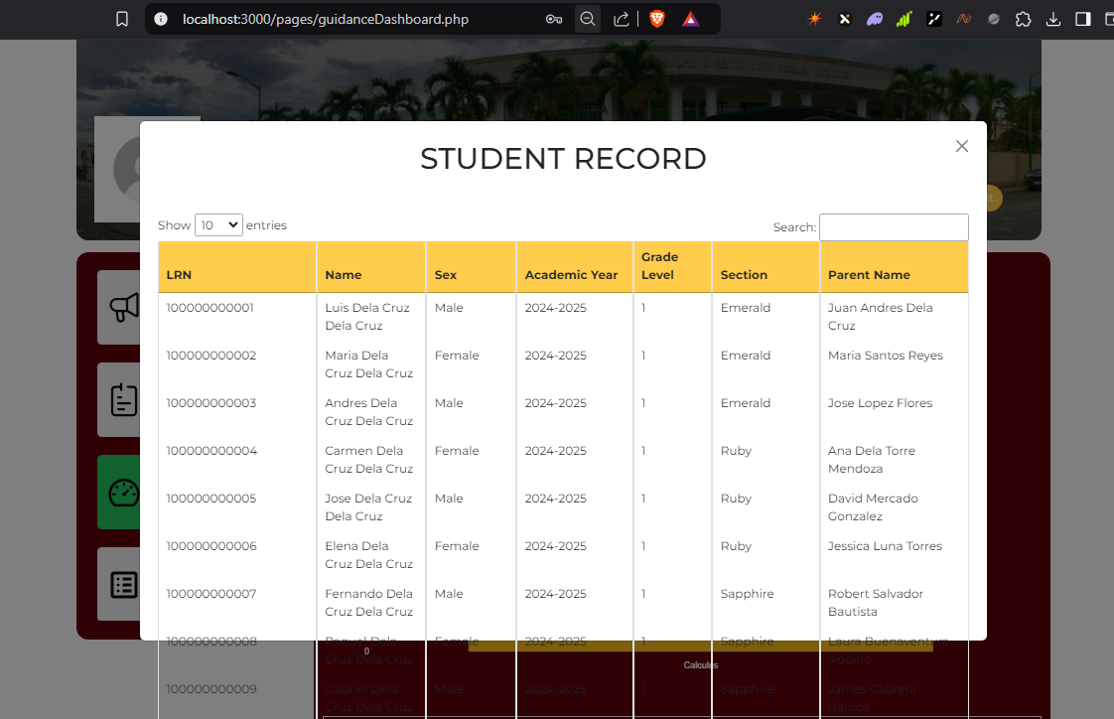Real-time access to student data enables the guidance to have access to student data at any time of the day. A modal box which contains a table of the records displays all the information of the enrolled students.

Figure 4-3. **Student Record**

The library Data Table was used to enable the filtering of entries. Meanwhile, all the student information is fetched from the database student_archives table. Access to updated data was made possible through the integration of MySQL Database and the Relational Database Management System that it comes along with. The grade level and academic year automatically increments upon turn over.

The successful replacement of the paper-based mechanism of data retrieval and implementation of the real-time access to data reduced labor hours and minimized human error in terms of data entry.

**Parental Involvement over Children’s Activities and Academic Progress**

One of the key users of the school web portal is the parents of the students who are responsible for keeping track of their children’s academic progress, school events and all materials that are uploaded to the portal.

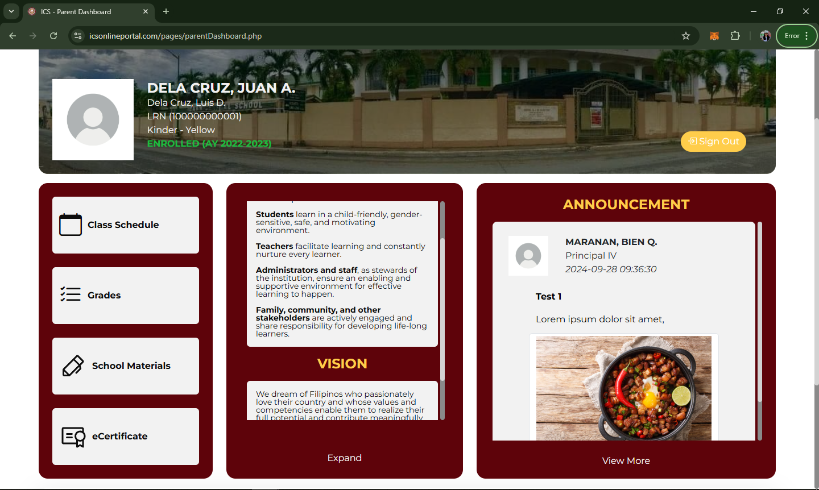

Figure 4-4. **Parent Portal**

Announcements are fetched from the user who created the announcement. The position of the personnel, description of the announcement, and files attached are all directed into the announcement table in the database. The announcement_file field accepts null values for scenarios that the announcements do not have attachments.

The creation of the class schedule was made possible through the installation and use of PHPSpreadsheet. If there is already an existing schedule, it will be inserted class_schedule_archive and will be deleted in the class_schedule table. Ajax library was used to create a request of data queried to the database. The query of list of grade level id is converted into an array and is returned as JSON. The result of the query fetches the grade level which generates the list that is refelected on the dropdown. The same approach applies for the section filtering but the result of the section will be based on the first filter. The algorithm when uploading a new schedule checks the section id to which the schedule was uploaded to. An object is then created for the loading of the excel file which is then converted into an array. Ajax was used to fetch the sections handled by the teacher from the teacher_section table before the excel file is attached and once submitted will reflect on the parent portal.

For the grades of the students, the averaging was done through a coded query which calculates the average grades of the students by quarter and LRN was used as referrence. When all the grades are completed from all four of the quarters, only then will the general average be generated. The school materials section was done through an SQL statement which was prepared to get all the list of sections handled by the teacher then the school material is attached and once submitted, another query inserts the file details to the school_materials table in the database before reflecting to the parent portal. Lastly, the same logic applies to the uploading of e-certificates but is isolated to the specifically selected student which is the end receiver of the e-certificate. Image format is the only format accepted in this section.

The output of all the mentioned functions are accessed in the parent portal as it is beneficial for transparency of the student’s activities and grades to the parents. Additionally, it is essential for the system to have a user-friendly UI/UX especially for parents who are not as techy to navigate the system effortlessly without facing unnecessary complications. With the use of software development tools shown in table 3-4, the researchers created a homepage for the parents to see all the materials, announcements, and grades of their children all in a single page.

The announcement, calendar, and access to academic resources or materials are all in modals. These have been set as modals to give emphasis on the displayed information on the screen and action the user must focus on. In the initial proposed UI, the modal box was semi-transparent and had a reduced opacity, however after the revision, it was changed into a solid color to prevent confusion for the user so that the main content has the emphasis it needs. Moreover, the materials uploaded by the teachers are downloadable for the students to have access to it offline.

**Implementation of Prescriptive Analytics for Student Academic Performance**

The principal and guidance portal has exclusive access to the analytics dashboard where the student performance is shown. This dashboard enables accurate monitoring of the quarterly grades through a representation of a bar graph and a list of top 10 and bottom 10 students.

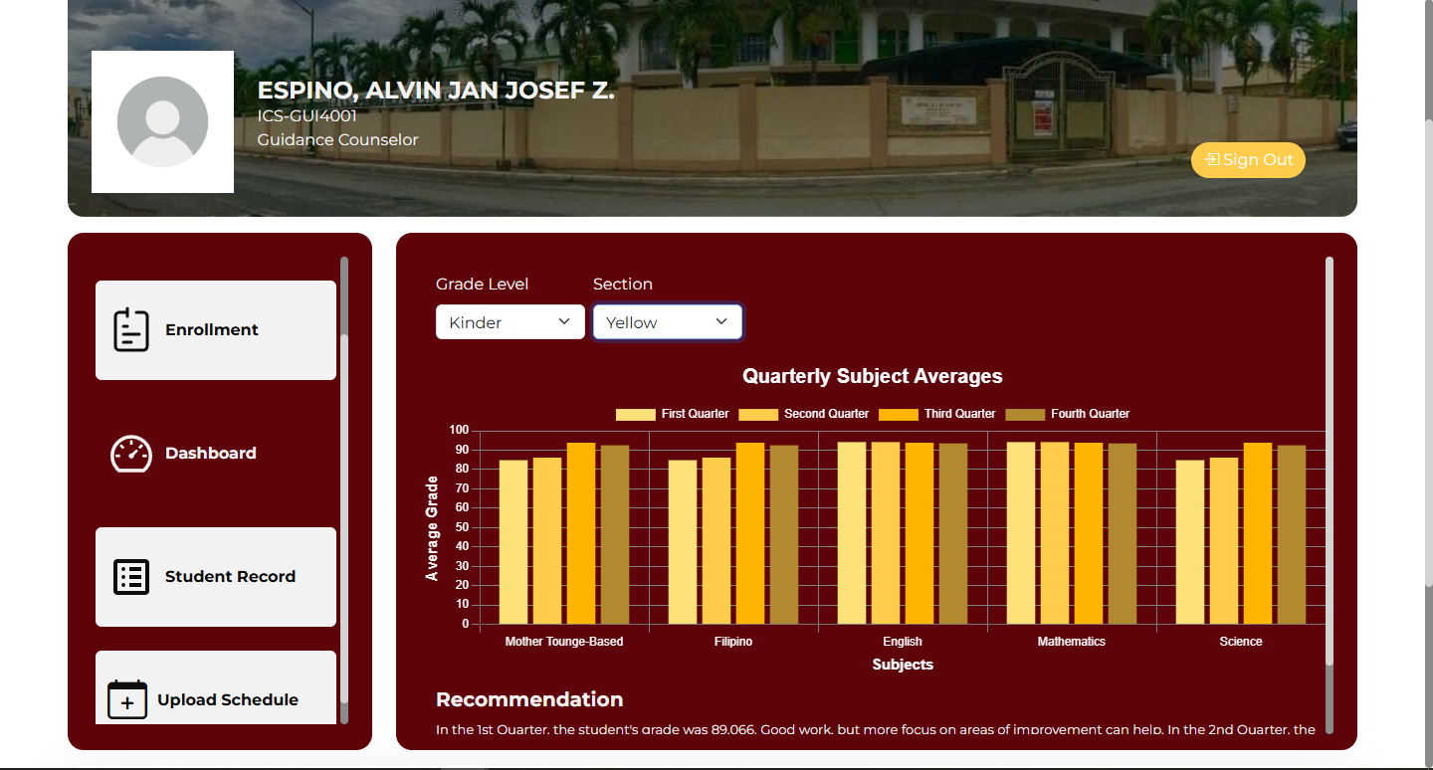

Figure 4-5. **Analytics Dashboard**

The analytics dashboard was achieved through the use of ChartJS which already has a provided layout of the chart. The data collected from the teacher which is the grades of the students they handle are used to generate the visualization. It was further customized by setting the colors of the bars into different variants of yellow. The four bars were done by declaring an object whose contents are arrayed. Inside the array, there are four dictionaries and in those dictionaries, the attributes including the label, data, background color, and border width are modified.

For better filtering, three drop-down menus were created which are the academic year, grade level, and section. A query is done then a SELECT DISTINCT SQL statement was used to return all the academic years. As for the grade level and section, Ajax was used to query is to fetch all the grade level which is then placed inside an array and returned as JSON. Using Ajax, grade level data was requested from fetchGradeLevel.php. The same approach was used for the section but the result for this is a list of the sections based on the grade level and not all the sections.

To get the average per quarter, a php function get_subject_average was created. A new object is assigned to hold the selected academic year and then an SQL statement which returns the subject id, subject name, and average of all four quarters is created based on the selected section and academic year and are placed in an array. Furthermore, a PHP file which gets the average per subject is created then a new object whose purpose is to hold the value of the selected section was made. Next is the calling of the get_subject_average function whose parameter us the created section id object. The result of this is then returned as JSON.

For the chart, a JS file responsible for updating the chart was created. Inside the same file, a function named updateChart which is set to accept a parameter that hold all the averages of all the four quarters was set. Inside the function is where the full structure of the chart with null values is found. This was followed by the creation of a new JS file named graphAnalytics where a function loadDefaultGraph is found. This is where the declaration of object that sets all the data to be null if the drop down menu has no selected values occurs.

A conditional statement that fetches all the average scores from first to fourth quarter is declared. The function .map() was used to fetch the subject name then another object was created to hold all the average grades of all the quarters and using updateChart function, the object created was assigned as parameter. For the recommendation string, showRecommendation() function was set to accept four parameters which are the four quarters. Since the data has already been fetched from the updateChart, the first to fourth quarter averages will already be reflected.

A new file recommendation.js was created and inside this is a function that calculates the average of all the averages per quarter. The function gradeRangeRecommendation whose purpose is to classify the grades was created and paired with a conditional statement that analyzes the grades and provides the recommendation for each quarter.

Lastly the list is of top ten best performing students below was done through a query that returns the name of students who had the highest grades within the subject selected on the filter. This is limited to ten. The same approach applies to the bottom list which provides the names of students who earned low grades.

By leveraging the data-driven insights from the student quarterly grades, prescriptive analytics to takes over and generates a statement on which subject the section must focus on. This is derived from the lowest scoring subject of the quarter. The successful application of the prescriptive analytics benefits the school in general as it identifies the specific subject which the students struggle in. This leads to awareness for the principal and guidance to get a grasp on what subjects need further improvement and gives an opportunity to students to achieve higher grades.

# **5 SUMMARY, CONCLUSIONS, AND RECOMMENDATIONS**

This chapter provides a brief summary of the findings, conclusions, and recommendations based on the research conducted. This chapter synthesizes the key insights drawn from the previous chapter and also encapsulates what possible contribution the research has for future explorations.

## **5.1 Summary**

The study successfully designed and developed a web-portal for Ibaan Central School which intends to provide a streamlined online platform for the Principal, Guidance, PDO, Teachers, and Parents while enhancing the performance of the school’s processes.

The development of the web-based portal enabled the Guidance to enroll students by uploading their information and credentials to the system and storing it to the database. This significantly minimizes the time and work compared to manual registration methods as it replaced the paper-based system of the school wherein all the student data are in physical form and is processed and stored individually. By having an enrollment section, the Guidance can conveniently process the enrollment forms of the students who do not have existing records in the school yet. Moreover, this minimizes the work when previously enrolled students who have already existing records in the school’s database enrolls for the next academic year as the Guidance would not need to re-enroll them since a turnover of records function exists. This promotes the students to the next grade level without the need to do the enrollment process all over again, significantly minimizing work efforts and preventing the occurrence of data duplication.

The parent dashboard within the portal with features including viewing of announcements such as school events, activities, and class suspensions, viewing and downloading of academic materials, class schedules, e-grades, and e-certificates grants the parent transparency on the academic life of their child. This enables involvement and monitoring of their child’s academic performance for parents who may work far away or overseas. Furthermore, since this is a platform dedicated for school announcements, the risk of misinformation is reduced as the announcements directly come from the administrative personnel. The access to class schedules and more importantly, study materials allows the parent to have better planning on the study routine of their child and give them proper assistance.

Lastly, the utilization of data visualization tools in displaying the students’ academic performance and applying prescriptive analytics in providing a recommendation on what subject the class must focus on gives the Principal and Guidance’s a greater grasp of the academic performance of each class in one look. This allows them to quickly identify what subjects of specific class requires greater attention and see the areas of strength. Early detection of a decline on the performance of the class allows the school to make an intervention and apply remediation plans as early as possible. On the other hand, as prescriptive analytics is embedded in the system, a direct interpretation is already provided and suggestion of which subject must be prioritized is readily available, empowering data-driven decision making. Since this dashboard keeps the records of all the school years, the Principal and Guidance can see the grades progression through the years. From this, they can make long-term academic plans to help the school implement effective teaching strategies leading to improved school reputation.

## **5.2 Conclusions**

In conclusion, the Ibaan Central School Web Portal has been effectively designed, developed, and has met the necessary requirements set for a fully functioning web-based portal.

1. The Guidance portal inside web portal itself has a fully-functioning enrollment system allowing the Guidance to input new enrollees, making the enrollment process more efficient. This is connected to the database which ensures that student data are arranged accordingly and are not lost.
2. The web portal’s user-friendly interface enables the parents to easily navigate and oversee their child’s activities in a single page. Modal boxes inside the parent portal were used to display the announcements of events, activities, and class suspensions which directly comes from either the Principal, Guidance, or PDO. Through this the risk of misinformation is reduced. A function was created to view and download the uploaded academic materials, class schedules, e-grades, and e-certificates uploaded by the class teacher or the Guidance to which the parents has access to for their child to utilize. This greatly empowers parental involvement on the academic life of their child.
3. The student’s academic progress data visualization dashboard in the Principal and Guidance’s portal reflects the average quarterly grades by subject for them to see the state of performance of every class. Moreover, the bottom part shows the lowest and top scoring students. The quarterly academic grades are visualized in the form of a bar graph whose x axis is the subjects and y axis is the average grade. This helps the Principal and Guidance draw data-driven insights. With prescriptive analytics incorporated to the system, a direct interpretation of the visualization which suggests what subject the class must focus on in order to improve the average quarterly scores is stated on the bottom side. This helps the Principal and Guidance identify the priority area per section and decide on what course of action to take.

## **5.3 Recommendations**

To ensure that Ibaan Central School Web Portal continues to meet the evolving needs of its users and to improve its effectiveness and functionality, the following recommendations are made:

1. Adding an announcement notification to the users through email. This will help the students, parents, and teachers have better awareness on urgent announcements since they are notified real-time upon upload and would not have to open the portal to check for announcements.
2. Implement stronger security protocols such as two-factor authentication. This will ensure that user’s sensitive data are protected to a greater extent and access to accounts is exclusive to the user only.
3. A messaging feature that will enable the personnel with administrative positions to communicate their announcements better. This feature will also be beneficial for parent-teacher relationship to improve the academic performance and school behavior of the students.
4. A feature that allows the students to upload their assignments, seat works, and exams which the teacher will grade.
5. Include the ALS and SNED program in the academic evaluation.
6. Let higher level students, grade 4-6, have an account of their own on the portal to prepare them in higher education set up which relies mostly in online platforms.
7. Incorporating a user feedback system that will allow the users to articulate their suggestions to further improve the system.
8. Expanding the analytics dashboard into having more visualizations of the academic progress which is not only limited to the quarterly grades of the students but can also include broken down raw test scores, assignments, and quizzes.
9. Exploration of the broader landscape of prescriptive analytics which will recommend the specific course of action to take aligning with the Matatag Curriculum by Deped.

# **BIBLIOGRAPHY**

Abdul Bujang, S. D., Selamat, A., & Krejcar, O. (2021). A Predictive Analytics Model for Students Grade Prediction by Supervised Machine Learning. *IOP Conference Series: Materials Science and Engineering*, *1051*(1), 012005. https://doi.org/10.1088/1757-899x/1051/1/012005

Abele, M., Iver, M., Wills, K., Sheldon, S., Clark, E., & mac Iver, D. J. (2021). *Urban Parents at the Portal: Family Use of Web-Based Information on Ninth Grade Student Course Grades*.

Acoba, R. P., Rizal St cor Don Ruiz St, J. E., City, L., & Norte, I. (2019). *iSercan: A Web-Based Student Information System*.

Afolabi, M. O. (2021). SEMI-AUTONOMOUS HOMOGENEOUS WEB-BASED DISTRIBUTED DATABASE SYSTEM FOR STUDENTS ACADEMIC RECORDS MANAGEMENT (A CASE STUDY OF ADEKUNLE AJASIN UNIVERSITY, AKUNGBA-AKOKO). *International Research Journal of Modernization in Engineering Technology and Science Www.Irjmets.Com @International Research Journal of Modernization in Engineering*, *3*(9), 2582–5208. www.irjmets.com

Al-Hunaiyyan, A., Al-Sharhan, S., Alhajri, R., & Bimba, A. (2021). An Integrated Implementation Framework for an Efficient Transformation to Online Education. In *IJACSA) International Journal of Advanced Computer Science and Applications* (Vol. 12, Issue 4). www.ijacsa.thesai.org

Ang, K. L. M., Ge, F. L., & Seng, K. P. (2020). Big Educational Data Analytics: Survey, Architecture and Challenges. In *IEEE Access* (Vol. 8, pp. 116392–116414). Institute of Electrical and Electronics Engineers Inc. https://doi.org/10.1109/ACCESS.2020.2994561

Asrin, F., & Utami, G. V. (2023). Implementing Website-Based School Information Systems in Public Elementary Schools Using Waterfall Model. *Journal of Information Systems and Informatics*, *5*(2), 590–614. https://doi.org/10.51519/journalisi.v5i2.495

Awaliah, N., Justika, A., Laswi, A. S., & Mansyur. (2022). Library Information System on Public Elementary School 108 Home Base Based on Android. *Ceddi Journal of Education*, *1*(2), 8–12. https://doi.org/10.56134/cje.v1i2.25

Aziz Hamzah, A., Shaffiei, Z. A., Hamid, N. H. A., & Aziz, N. (2021). Myability: A web portal for students with challenge based on web content accessibility guideline 2.0. *Annals of Emerging Technologies in Computing*, *5*(Special issue 5), 194–200. https://doi.org/10.33166/AETiC.2021.05.024

Balcita, R. E., & Palaoag, T. D. (2020). Integration of school management systems using a centralized database (Ismscd). *International Journal of Information and Education Technology*, *10*(9), 704–708. https://doi.org/10.18178/ijiet.2020.10.9.1446

Bayem, D. I., Osuagwu, H. O., & Ugwu, C. F. (2021). A Web-Based Aggregate Information Portal. *European Journal of Electrical Engineering and Computer Science*, *5*(3), 17–25. https://doi.org/10.24018/ejece.2021.5.3.323

Bizamare, B., Rosales, A. M., Abas, R., Diokno, C. O., Lintao, E., Bolante, A. M., Suyat, A. M., Balila, J., & Borromeo, R. (2022). Research Journal adventist university of the philippines. *Adventist University of the Philippines Research Journa*, *25*, 35–57. www.aup.edu.ph/urc/

Boz, M., & Simsek, I. (2022). Analysis of Education Management Information Systems of the Ministry of National Education in Terms of Interoperability. *Journal of Qualitative Research in Education*, *32*, 213–240. https://enadonline.com/index.php/enad/article/view/1702

BOZ, M., & SIMSEK, I. (2022). Analysis of Education Management Information Systems of the Ministry of National Education in Terms of Interoperability. *Journal of Qualitative Research in Education*, *22*(32). https://doi.org/10.14689/enad.32.1702

Bradley, V. M. (2020). Learning Management System (LMS) Use with Online Instruction. *International Journal of Technology in Education*, *4*(1), 68. https://doi.org/10.46328/ijte.36

Campos, G. S. (2019). Development of a Computerized Student- Advising and Enrollment System. *Aloha International Journal of Multidisciplinary Advancement (AIJMU)*, *1*(6), 126. https://doi.org/10.33846/aijmu10601

Caratiquit, K. D. (2021). Web-based School Information and Publication System: A Developmental Study. In *Global Education & Social Sciences Journal: Vol. I* (Issue 3). https://ssrn.com/abstract=3909516

Clarin, J. A. (2019). Web-Based Information System Portal With SMS Support For Aklan State University-Kalibo Campus. In *International Journal of Recent Technology and Engineering (IJRTE)* (Issue 8). https://www.researchgate.net/publication/343205629

Costa, L. A., Pereira Sanches, L. M., Rocha Amorim, R. J., Nascimento Salvador, L. do, & dos Santos Souza, M. V. (2020). Monitoring academic performance based on learning analytics and ontology: A systematic review. *Informatics in Education*, *19*(3), 361–397. https://doi.org/10.15388/infedu.2020.17

Dal Ponte, C., Dushyanthen, S., Huckvale, K., Mani, M., & Lyons, K. (2023). Using Figma to foster authentic digital learning experiences in an online short course. *ASCILITE 2023 People, Partnerships and Pedagogies*.

Dawodi, M., Hedayati, M. H., Baktash, J. A., & Efran, A. L. (2019). MYSQL. 2019 IEEE 10th Annual Information Technology, Electronics and Mobile Communication Conference (IEMCON). https://doi.org/10.1109/IEMCON.2019.8936259

Delgado, A., Huamaní, E. L., Chiara-Sotomayor, A., & Roman-Casahuamán, F. (2020). Design of a mobile application for the school enrollment process in order to prevent Covid-19. *Advances in Science, Technology and Engineering Systems*, *5*(6), 1042–1046. https://doi.org/10.25046/aj0506126

Despabiladeras, Alvin D, & Sarmiento, J. R. (2023). WEB-BASED INFORMATION MANAGEMENT SYSTEM FOR SENIOR HIGH SCHOOL. *GSJ*, *11*(3), 1776. www.globalscientificjournal.comwww.globalscientificjournal.com

Enes Işıkgöz, M. (2024). Do Learning Management System Activities in Online Pedagogical Education Significantly Predict Academic Performance? In *TOJET: The Turkish Online Journal of Educational Technology* (Vol. 23, Issue 1).

Feng, L. (2019). Design and Implementation of ERP Management System for Manufacturing Enterprise. Journal of Physics: Conference Series, 1345(6). https://doi.org/10.1088/1742-6596/1345/6/062018

Francis, M. (2023). *STUDENT PRIVACY AND LEARNING ANALYTICS: INVESTIGATING THE APPLICATION OF PRIVACY WITHIN A STUDENT SUCCESS INFORMATION SYSTEM IN HIGHER EDUCATION*.

Gaftandzhieva, S., Hussain, S., Hilčenko, S., Doneva, R., & Boykova, K. (2023). Data-driven Decision Making in Higher Education Institutions: State-of-play. *IJACSA) International Journal of Advanced Computer Science and Applications*, *14*(6), 397–405. www.ijacsa.thesai.org

García-Senín, S., Arguedas, M., & Daradoumis, T. (2022). Using learning analytics to support STEAM students’ academic achievement and self-regulated learning. *Research on Education and Media*, *14*(1), 36–45. https://doi.org/10.2478/rem-2022-0005

Grepon, B. G., Baran, N., Gumonan, K. M. V., Martinez, A. L., & Lacsa, M. L. (2022). Designing and Implementing e-School Systems: An Information Systems Approach to School Management of a Community College in Northern Mindanao, Philippines. *International Journal of Computing Sciences Research*, *6*, 792–808. https://doi.org/10.25147/ijcsr.2017.001.1.74

Gutiérrez, F., Seipp, K., Ochoa, X., Chiluiza, K., de Laet, T., & Verbert, K. (2020). LADA: A learning analytics dashboard for academic advising. *Computers in Human Behavior*, *107*. https://doi.org/10.1016/j.chb.2018.12.004

Halupecki, E. (2023). The role of the middle layer in the web environment. https://urn.nsk.hr/urn:nbn:hr:144:551961

Haque, S., Eberhart, Z., Bansal, A., & McMillan, C. (2022). Semantic Similarity Metrics for Evaluating Source Code Summarization. *IEEE International Conference on Program Comprehension*, *2022-March*, 36–47. https://doi.org/10.1145/nnnnnnn.nnnnnnn

Hayagan, N. v. (2022). Paperless Enrollment System: Functionality and Credibility as an Online Platform. *International Journal of Computer Science and Mobile Computing*, *11*(7), 110–118. https://doi.org/10.47760/ijcsmc.2022.v11i07.010

Hidayasari, N., Mansur, M., Ilma, E. N., & Anisa, D. (2023). Implementation of The Information Service Application Portal for Registration of Prospective Santri and Recording of School Activities Using The Extreme Programming Method. *JURNAL TEKNOLOGI DAN OPEN SOURCE*, *6*(1), 131–141. https://doi.org/10.36378/jtos.v6i1.3125

Istan, M., Apriani, E., Fathurrochman, I., Ristianti, D. H., & Hamengkubuwono. (2020). The Effect of Academic Portal Use of Lecturer’s Performance. *International Journal of Innovative Technology and Exploring Engineering (IJITEE)*, *9*(3), 305–310. https://doi.org/10.35940/ijitee.C7958.019320

Javier, B. S. (2019). *HIGHER EDUCATION ENROLMENT DECISION SUPPORT SYSTEM (HEEDS) IN THE LENS OF THE STAKEHOLDERS OF A STATE UNIVERSITY IN NORTHERN PHILIPPINES*. www.jiarm.com

Jayashanka, R., Hettiarachchi, E., & Hewagamage, K. P. (2022). Technology Enhanced Learning Analytics Dashboard in Higher Education. *The Electronic Journal of E-Learning*, *20*(2), 151–170. www.ejel.org

Justo, R. C. (2022). The Evaluation of the Laguna State Polytechnic University Online Student’s Grading System. *International Journal of Research Publications*, *101*(1). https://doi.org/10.47119/ijrp1001011520223189

Kiat Xin, O., & Singh, D. (2021). Development of Learning Analytics Dashboard based on Moodle Learning Management System. *IJACSA) International Journal of Advanced Computer Science and Applications*, *12*(7), 2021. www.ijacsa.thesai.org

Kovačić, B., Slavuj, V., & Sretenović, M. (2023). Data Visualisation System for E-learning: Overview of System Design. *Proceedings of the Central European Conference on Information and Intelligent Systems*, 25–32.

Kubegenova, A. D., Kubegenov, E. S., Gumarova, Z. M., Kamalova, G. A., & Zhazykbaeva, G. M. (2022). Using Data Mining Technology in Monitoring and Modeling the Epidemiological Situation of the Human Immunodeficiency Virus in Kazakhstan. *Communications in Computer and Information Science*, *1703 CCIS*, 57–65. https://doi.org/10.1007/978-3-031-21340-3_6

Kulkarni, R. N., Archana, Khanum Nikhat, & B Nikitha. (2022). AUTOMATION OF COLLEGE ADMISSION PROCESS . *International Research Journal of Engineering and Technology (IRJET)*, *9*(6), 2890–2894.

Kulkarni, R. N., Khanum, N., &, M. (2022). AUTOMATION OF COLLEGE ADMISSION PROCESS. *International Research Journal of Engineering and Technology*. www.irjet.net

Laaziri, M., Benmoussa, K., Khoulji, S., & Kerkeb, M. L. (2019). A Comparative study of PHP frameworks performance. *Procedia Manufacturing*, *32*, 864–871. https://doi.org/10.1016/j.promfg.2019.02.295

Lee, C. (2021). A review of data analytics in technological forecasting. *Technological Forecasting and Social Change*, *166*, 120646. https://doi.org/10.1016/j.techfore.2021.120646

Lepenioti, K., Bousdekis, A., Apostolou, D., & Mentzas, G. (2020). Prescriptive analytics: Literature review and research challenges. In International Journal of Information Management (Vol. 50, pp. 57–70). Elsevier Ltd. https://doi.org/10.1016/j.ijinfomgt.2019.04.003

Lopez, A. A., & Lorejo, R. M. (2023). *International Journal of Interdisciplinary Organizational Studies Effectiveness of Enhanced Basic Education Information System (EBEIS)/ Learner Information System (LIS)Data and School Management*. *18*(1), 2023.

Maramag, C. L., & Palaoag, T. D. (2019). Assessing CSU students’ academic performance on iLearn portal using data analytics. *ACM International Conference Proceeding Series*, 25–29. https://doi.org/10.1145/3330482.3330495

Maverick Arellano Lorilla, F., & Maverick, F. (2023). e-GRADO: DEVELOPMENT OF A STANDARDIZED GRADING PORTAL FOR DEPARTMENTAL COURSES IN COLLEGE OF ENGINEERING. *Sci.Int.(Lahore)*, *35*(4), 411–416. https://www.researchgate.net/publication/378292044

Mayo, R. F., Villanueva, A. T., Ortiz, K. A. B., Reyes, A. C. M., Payad, J. J. S., Rodriguez, R. L., & Serrano, E. A. (2022). Web-Based Enrollment System for Public Junior High School in the Philippines: A Case Study in the Province of Cavite Public Schools. *2022 2nd International Conference in Information and Computing Research (ICORE)*, 134–138. https://doi.org/10.1109/iCORE58172.2022.00044

Mina, J. C., Campos, R. B., Jane Reyes, E. G., Garcia, M. D., & Anthony Torres, R. G. (2021). Technology: An Experienced Based. In *International Journal of Innovative Science and Research Technology* (Vol. 6, Issue 1). www.ijisrt.com868

Oktarina, N., Purasani, H. N., Suryanto, E., Murwatiningsih, & Sehabuddin, A. (2023). Constructing a Conceptual Electronic Record Management System Model Based on Eight Indonesian Education Standards to Support School Accountability. *Journal of Information Science Theory and Practice*, *11*(3), 16–28. https://doi.org/10.1633/JISTaP.2023.11.3.2

Özkan, D., & Mishra, A. (2019). Agile Project Management Tools: A Brief Comprative View. *Cybernetics and Information Technologies*, *19*(4), 17–25. https://doi.org/10.2478/cait-2019-0033

Pérez Sánchez, C. J., Calle-Alonso, F., & Vega-Rodríguez, M. A. (2022). Learning analytics to predict students’ performance: A case study of a neurodidactics-based collaborative learning platform. *Education and Information Technologies*, *27*(9), 12913–12938. https://doi.org/10.1007/s10639-022-11128-y

Poornima, S., & Pushpalatha, M. (2020). A survey on various applications of prescriptive analytics. *International Journal of Intelligent Networks*, *1*, 76–84. https://doi.org/10.1016/j.ijin.2020.07.001

Rahimi, M., Rosman, M., Husna, I., Nurulannisa, A., Amira, A., Mohd, I., Noor, S., Alias, R., Nur, N., Nik, I., Faizal, R., Fadzil, H., Sayuti, M., Saleh, M., Zafian, M., & Zawawi, M. (2023). *APS PROCEEDINGS V O L U M E 4 2 0 2 3*.

Raut, M. R., Lokhande, T. P., Godbole Shruti J More, K. D., Hatmode, S. S., & Tibude, N. D. (2019). PCE Staff/Student Portal. *International Journal of Computer Science Trends and Technology*, *7*, 17–22. www.ijcstjournal.org

Rodríguez-Pérez, G., Robles, G., Serebrenik, A., Zaidman, A., Germán, D. M., & Gonzalez-Barahona, J. M. (2020). How bugs are born: a model to identify how bugs are introduced in software components. Empirical Software Engineering, 25(2), 1294–1340. https://doi.org/10.1007/s10664-019-09781-y

Ronquillo, Z. T., Tagasa, R. B., Batino, M. R., La, D., & Aquino, M. S. (2022). School Records and Forms of Selected Public School: Headway and Analysis of Online Management System. *INTERNATIONAL JOURNAL IN INFORMATION TECHNOLOGY IN GOVERNANCE, EDUCATION AND BUSINESS*, *4*(1), 49–62.

Shalaby, A. M., Sidhu, M. S., Tan, W. C., Wei, L. Z., Yong, C. J., & Xi, L. Y. (2022). A Prototype Model of Monitoring Energy Consumption and Optimizing Distribution of Smart Buildings. 4th IEEE International Conference on Artificial Intelligence in Engineering and Technology, IICAIET 2022. https://doi.org/10.1109/IICAIET55139.2022.9936774

Schatenstein, A. A. S., & Purushothaman, R. (2021). A Portal for Web-Based Information System for Secondary Schools in Malaysia. *International Conference on Education (ICE 2021)*, 215–222.

Sinha, A., & Das, P. (2021). Agile Methodology Vs. Traditional Waterfall SDLC: A case study on Quality Assurance process in Software Industry. *2021 5th International Conference on Electronics, Materials Engineering & Nano-Technology (IEMENTech)*, 1–4. https://doi.org/10.1109/IEMENTech53263.2021.9614779

Stativko, R. U. (2019). Quality assessment of the internet portal academic unit of the higher educational establishment with the help of the fuzzle set. *Journal of Physics: Conference Series*, *1333*(8). https://doi.org/10.1088/1742-6596/1333/8/082010

Susnjak, T., Ramaswami, G. S., & Mathrani, A. (2022). Learning analytics dashboard: a tool for providing actionable insights to learners. *International Journal of Educational Technology in Higher Education*, *19*(1). https://doi.org/10.1186/s41239-021-00313-7

Unterhalter, E. (2019). The Many Meanings of Quality Education: Politics of Targets and Indicators in SDG4. *Global Policy*, *10*, 39–51. https://doi.org/10.1111/1758-5899.12591

Ursola G. Uy, Michel A. Cabrera, Michael J. Pinero, & Conrado P. Vizcarra. (2023). Design and Implementation of Baggao North Central School Computer-Based Record Management System. *International Journal For Multidisciplinary Research*, *5*(2). https://doi.org/10.36948/ijfmr.2023.v05i02.1873

Vieira, M. R. (2022). *DEPARTMENT OF ELECTRICAL AND COMPUTER ENGINEERING A PLATFORM FOR SHARING KNOWLEDGE IN PROJECTS WITH SUPERCONDUCTORS*.

Villafuerte, L. (2023). *User-Centered Analysis on the Existing Online Enrollment Platform of Mapúa University (myMapúa)*.

Wirfs-Brock, A., & Eich, B. (2020). JavaScript: The first 20 years. *Proceedings of the ACM on Programming Languages*, *4*(HOPL). https://doi.org/10.1145/3386327

Xu, T. (2023). USING DATA MINING MODELS TO PREDICT STUDENTS’ ACADEMIC PERFORMANCE BEFORE THE ONLINE COURSE START. *JOURNAL OF EDUCATORS ONLINE*, 1–13. http://old-www.cms.waikato.

Yahya, M., & Wijoyo, H. (2020). Developing School Information Program. *International Journal of Asian Education*, *1*(3), 179–186. https://doi.org/10.46966/ijae.v1i3.70

Zhang, Y., Ghandour, A., & Shestak, V. (2020). Using Learning Analytics to Predict Students Performance in Moodle LMS. *International Journal of Emerging Technologies in Learning*, *15*(20), 102–114. https://doi.org/10.3991/ijet.v15i20.15915

# **APPENDICES**

## **APPENDIX A: TEST RESULTS**

This section discusses the outcomes of the conducted testing to ensure that the system meets the requirements and the metrics set.

**Efficiency**

Table A-1 below represents the results of the assessment of the efficiency of the Ibaan Central School Web Portal done through the survey to the users.

|  |  |  |
| --- | --- | --- |
| **Table A-1**. Efficiency Testing Results | |  |
| **Efficiency** | **Weighted Mean** | **Verbal Interpretation** |
| How quick were tasks completed  How quick it was to login upon opening  How quick was the system to respond on all the actions  How easy it was to move from one page to another  The speed of the refresh time  **COMPOSITE MEAN** | 3.79  3.69  3.68  3.64  3.66  **3.69** | SA  SA  SA  SA  SA  **SA** |

*Legend: Strongly Disagree (SD) = 1.00 – 1.74, Disagree(D) = 1.75 – 2.49, Agree(A) = 2.50– 3.24, Strongly Agree (SA) = 3.25 – 4.00*

The efficiency testing results for the Ibaan Central School Web Portal is shown in the table above. The questions stated in the survey are stated in the leftmost column while the responses converted into score are listed in the middle column. The five aspects being evaluated in the test, namely, task completion speed, login speed, response time speed, navigation ease, and refresh speed, had scores ranging from 3.64 to 3.79, which if interpreted falls under “Strongly Agree”. More importantly, the composite mean of all the five questions is 3.69 which is indicated as “Strongly Agree”.

Overall, the users found the web portal to be functional and efficient enough to carry on with their tasks. The results highlighted that the performance speed and responsiveness of the system is within acceptable. This goes to show that the acceptability score of the efficiency of the system satisfies and meets the users’ expectations in terms of smooth experience signifying minimal delay.

**Reliability**

Table A-2 below represents the results of the assessment of the reliability of the Ibaan Central School Web Portal done through the survey to the users.

|  |  |  |
| --- | --- | --- |
| **Table A-2**. Reliability Testing Results | |  |
| **Reliability** | **Weighted Mean** | **Verbal Interpretation** |
| How rarely were errors encountered during the portal’s run time  How rarely did the portal crash  How functional did the features worked  How rarely were logging in issues experience upon accessing the account  How consistent and accurate the information the portal provided  **COMPOSITE MEAN** | 3.78  3.79  3.75  3.59  3.79  **3.74** | SA  SA  SA  SA  SA  **SA** |

*Legend: Strongly Disagree (SD) = 1.00 – 1.74, Disagree(D) = 1.75 – 2.49, Agree(A) = 2.50– 3.24, Strongly Agree (SA) = 3.25 – 4.00*

In this case, five aspects are being tested which are error occurrence during run time, crash occurrence, feature functionality, login issues, and consistency of displayed information. The score of each aspect ranged from 3.59 to 3.79 and all of it falls under “Strongly Agree”. The composite mean for this set is 3.74 which makes it into “Strongly Agree” as well.

The highest rating category for this testing is the rarity of crash occurrence and the consistency of the displayed information in the portal, both receiving a 3.79 score. This indicates that the user found the portal to be stable and barely experienced crashes when opening the portal. It also indicates that the portal displayed information such as the school’s mission and vision, student grades, list of students, are consistent throughout all the users of the system. The functions of the portal also received a positive feedback suggesting that it operates correctly and effectively. However, it is noticeable that the score of the users in the aspect of logging in issues are slightly lower than the rest although it is still within “Strongly Agree”. This might be due to authentication challenges or difficulties encountered with login credentials such as case sensitivity which might still be influential in the user perception towards the web portal.

The users generally found the portal to be reliable and only had minimal issues encountered. With this results, the composite mean can be considered to be within acceptable. The high scores across all criteria suggests that the system effectively meets the user expectations for a reliable platform.

**Load Testing**

Apache Jmeter was used to perform the load testing which tests the performance of the web portal under various load conditions.

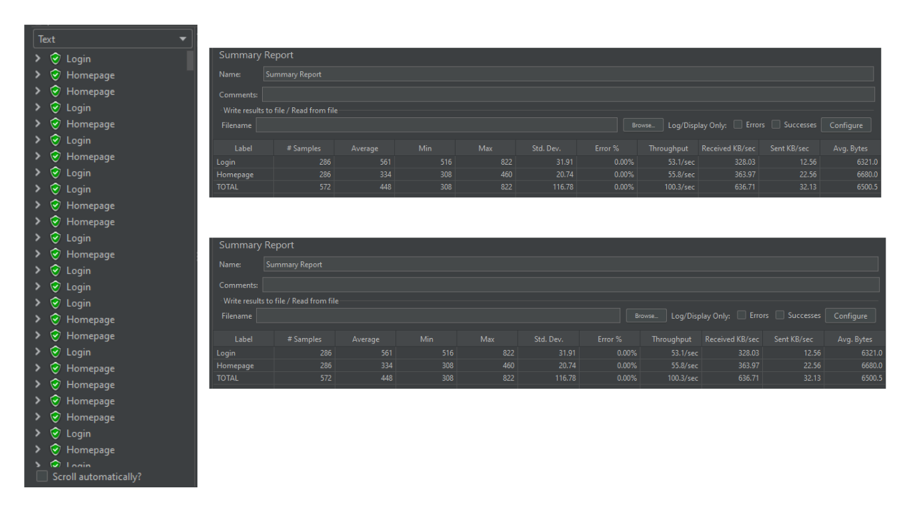

**Figure A-1.** Load Testing Result

The login page and homepage were the pages tested for the load test. A total of 286 user requests were set for the test as it was the sample size for the study with a ramp up time of 5 seconds. The leftmost part of the figure shows that all requests are colored green signifying that all of it has been processed successfully.

In the summary report, the homepage requests were processed faster than those in the login, having a lower maximum response time average. This might be due to more complex backend processes such as authentication causing the slight delay. The high throughput scores signify that the system is stable and is capable of handling the set load having a 0% error rate.

Additionally, the data received and transferred every second provide information about the web portal's network usage. The Login transferred an average of 328 KB/sec received and 12.56 KB/sec sent, while the Homepage operation included significantly more traffic having 364 KB/sec received and 22.56 KB/sec sent. The average response size for Homepage was 6,680 bytes, compared to 6,321 bytes for Login, indicating that Homepage responses are slightly larger, most likely due to more content being submitted.

From these results, it can be inferred that the web portal performed well under the test condition as it showed no errors and a consistent throughput. However, it is important to note that there is room for improvement especially in the login where it was observed that response times was higher.

**Functionality**

The functionality of the web-based portal was evaluated using Selenium IDE. This testing tool ensured that all the functions of the web portal were working as expected through a record-and-playback feature of the demonstration of each action done in the browser. For a better breakdown of the test, test cases were created.

|  |  |  |  |  |  |
| --- | --- | --- | --- | --- | --- |
| **Table A-3.** Functionality Testing Test Cases | | | | | |
| **User** | **Test Case ID** | **Test Case Description** | **Pre-conditions** | **Expected Results** | **Actual Results** |
| All | TC_001 | Verify whether the user can login with correct credentials | An account should be exiting in the database | User should be directed to the homepage | User was directed into their respective portal accounts |
| All | TC_002 | Verify whether the user can login with incorrect credentials | Account credentials should not be in the database | An error message should appear | An error message stating invalid password / user id not found appeared |
| Parent | TC_003 | Verify whether the class schedule is viewable | Schedule should already be uploaded by the Guidance | Class schedule is reflected | Class schedule was shown in the parent portal |
| Parent | TC_004 | Verify whether the e-grades is viewable | E-grades should already be uploaded by the teacher | E-grades is reflected | E-grades was shown in the parent portal |
| Parent | TC_005 | Verify whether the learning materials are downloadable | Material should be uploaded by the teacher and user must have space for download | Material is downloaded | Material is downloaded and found in the downloads folder of the computer |
| Parent | TC_006 | Verify whether the e-certificate is downloadable | E-certificate should be uploaded by the teacher and user must have space for download | E-certificate is downloaded | E-certificate is downloaded and found in the downloads folder of the computer |
| Teacher | TC_007 | Verify if grades can be uploaded | Sample grades in excel file should be ready | Excel file is uploaded and reflected in table form in parent portal | A message prompted that grades were successfully uploaded and is seen on the parent portal. |
| Teacher | TC_008 | Verify if school materials can be uploaded | Sample school material should be ready | School material is uploaded and reflected in the parent portal | A message prompted that materials were successfully uploaded and is seen on the parent portal. |
| Teacher | TC_009 | Verify if e-certificates can be uploaded | Sample e-certificate should be prepared | E-certificate is uploaded and reflected in the parent portal | A message prompted that e-certificate was successfully uploaded and is seen on the parent portal. |
| Teacher | TC_010 | Verify if the records can be turned over | Student records must be existing in the database | The student is promoted to the next grade level | The student is promoted to the next grade level |
| Guidance | TC_011 | Verify if the announcements can be uploaded | Sample announcement with file should be ready | Announcement is reflected across all users | Announcement was seen on the Principal, Guidance, Teacher and Parent portal |
| Guidance | TC_012 | Verify if the enrollment function is working | All fields must be filled up except the files | Student record will be listed on the pending section | Student record was listed on the pending section waiting for LRN |
| Guidance | TC_013 | Verify if the quarterly grades are reflecting on the dashboard | Quarterly grades in excel file must be uploaded by the teacher | The bar graph reflects accurate quarterly grades | The bar graph reflected accurate quarterly grades |
| Guidance | TC_014 | Verify whether the student record is viewable | Student record must be existing in the database | Student records are reflected in table | Student records were reflected |
| Guidance | TC_015 | Verify if schedule can be uploaded | Sample class schedule in excel file should be prepared | Class schedule should be displayed in the parent portal | A message prompted schedule was successfully uploaded and is seen on the parent portal. |
| Principal | TC_016 | Verify if the announcements can be uploaded | Sample announcement with file should be ready | Announcement is reflected across all users | Announcement was seen on the Principal, Guidance, Teacher and Parent portal |
| Principal | TC_017 | Verify if the quarterly grades are reflecting on the dashboard | Quarterly grades in excel file must be uploaded by the teacher | The bar graph reflects accurate quarterly grades | The bar graph reflected accurate quarterly grades |
| PDO | TC_018 | Verify if the announcements can be uploaded | Sample announcement with file should be ready | Announcement is reflected across all users | Announcement was seen on the Principal, Guidance, Teacher and Parent portal |
| PDO | TC_019 | Verify if the student records are reflected | Student record must be existing in the database | Student records are reflected in table | Student records were reflected |
| PDO | TC_020 | Verify if event can be entered on the academic calendar | All fields must be filled up | The event is created an found in the calendar | A message prompted even was successfully created and is seen on the mapped on the calendar |
| All | TC_021 | Verify whether the user can signout | User must be logged in | User will be directed back into the login page | User was logged out of the portal and directed back into the login page |

Table A-1 shows the test cases executed to test the functionality of the web portal. The first column identifies the users who were expected to do the action as the specific function under test is only accessible through their portal. The second column is the test case id, while the third column provides a brief description on what is the test’s objective. The fourth column shows the preliminary conditions that the system must satisfy before proceeding into the testing proper. On the other hand, the fifth column shows the expected result of the testing. Finally, the last column shows the actual result of the conducted test for each test case.

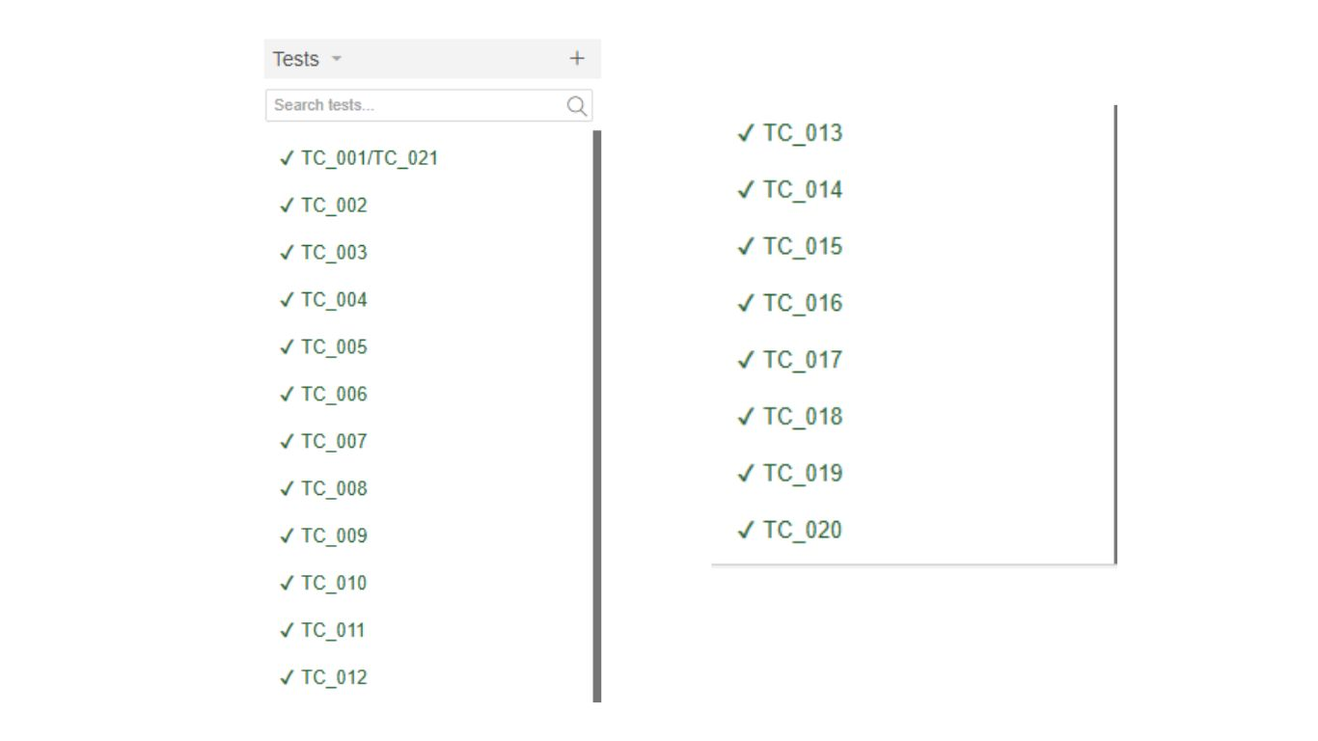

**Figure A-2.** Functionality Testing Result

In Selenium IDE, the test cases were executed by demonstrating the actions step by step. Figure A-2 shows the result of each test cases. TC_001 and TC_002 were joined in a single testing scenario as it only demonstrated the login and sign out of the user. Aside from that, all the test scenarios were isolated from one another for a clearer demonstration and for the point of error to be easily identified.

In summary, all the test cases were successful, signifying that the functions were working accordingly. Green check on the left side of the test case id is a confirmation that there were no errors detected and that the expected outcomes matched the actual results which confirms the reliability of the tested features.

**Flexibility**

Table A-3 below represents the results of the assessment of the flexibility of the Ibaan Central School Web Portal done through the survey to the users.

|  |  |  |
| --- | --- | --- |
| **Table A-4**. Flexibility Testing Results | |  |
| **Flexibility** | **Weighted Mean** | **Verbal Interpretation** |
| How capable was the portal’s interface to fit any screen resolution  How adaptive the portal is to varying devices  How easy it is to switch between different tasks without losing progress  How capable is it in performing multiple tasks at once without delays or errors  How capable is it in providing options for managing data and customizing presentation  **COMPOSITE MEAN** | 3.78  3.70  3.10  3.21  3.10  **3.38** | SA  SA  A  A  A  **SA** |

*Legend: Strongly Disagree (SD) = 1.00 – 1.74, Disagree(D) = 1.75 – 2.49, Agree(A) = 2.50– 3.24, Strongly Agree (SA) = 3.25 – 4.00*

The assessment of the flexibility of the portal had five aspects evaluated. These are resolution flexibility, system adaptability across various devices, task-switching ease, multitasking performance, and data management and customization. Two out of five criteria had fallen into “Strongly Agree” while the rest had a score ranging from 3.20 to 3.10 which equates to “Agree”.

The highest rated aspect among all five was the resolution flexibility which shows that the portal is responsive and it adapts to all screen resolution of different devices well. Similarly, according to the surveyed users, the system was able to adapt to different devices highlighting its compatibility. Nevertheless, the aspects task-switching ease, multitasking performance, and data management and customization scored lower. This indicates that the users’ satisfaction in these aspects is moderate and can be improved in the future. This also implies that the users may have found limitations and in multitasking capabilities of the web portal.

In general, the composite mean is 3.38 which is still considered to be “Strongly Agree”. The overall flexibility of the system is still within acceptable reflecting satisfaction however, there are areas that still have room for improvement for a more seamless and customizable user experience maximizing flexibility.

**Cross Browser Compatibility**

This approach was done to ensure that the web portal remains responsive regardless the platform or browser it was accessed upon.

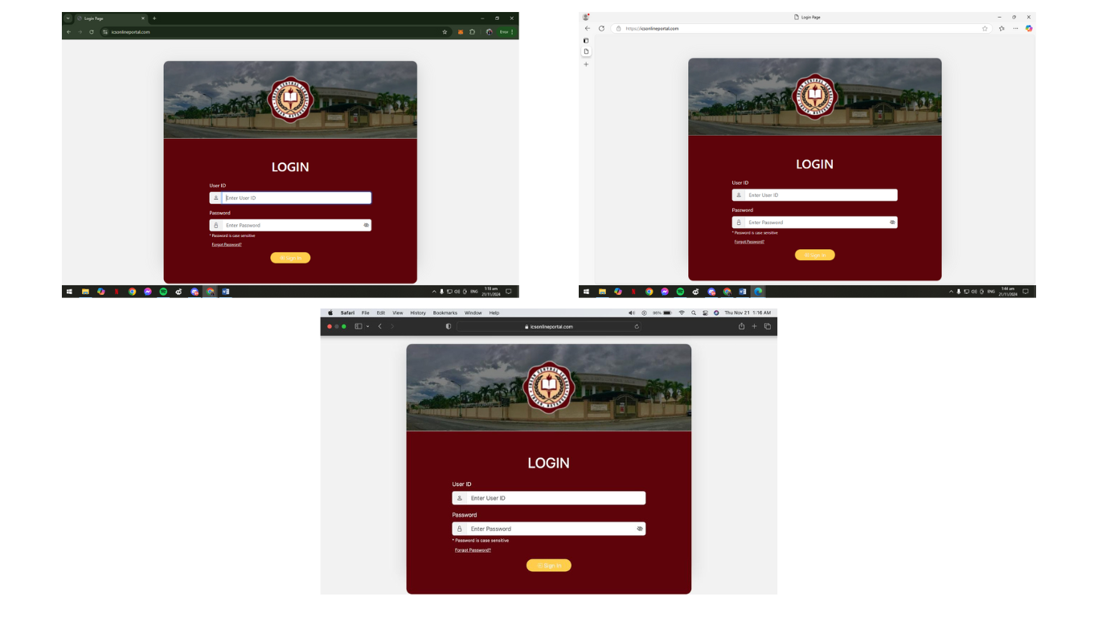

**Figure A-3.** Flexibility Testing Login

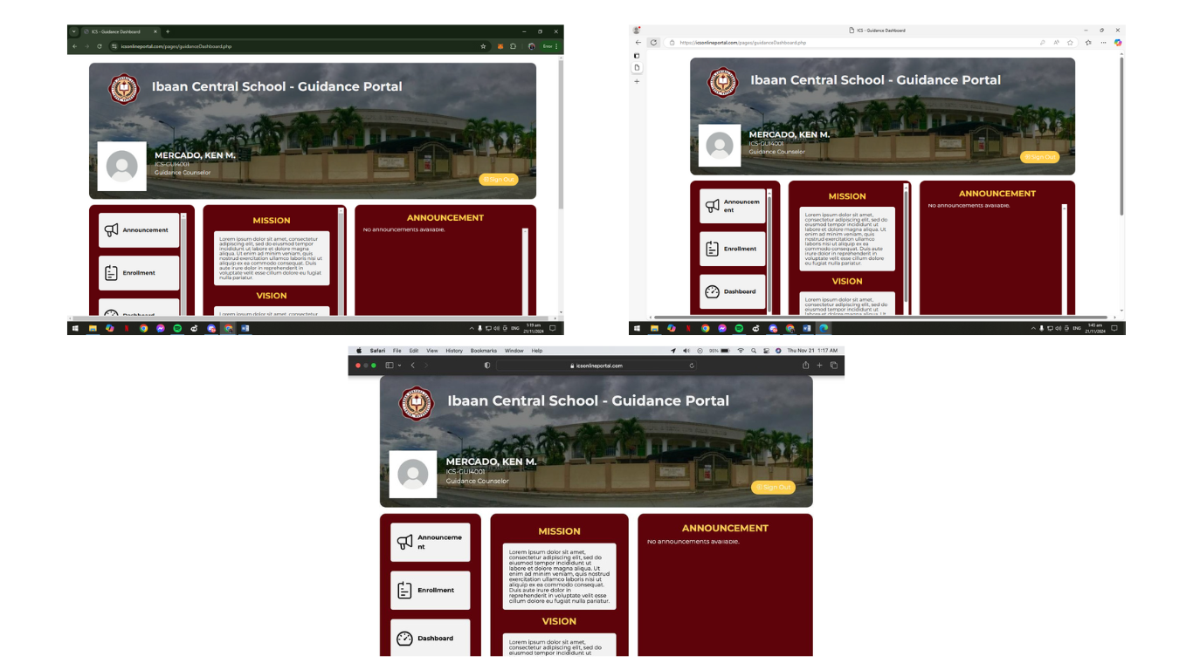Three browsers were used namely, Google Chrome, Microsoft Edge, and Safari. The format of the login page stayed consistent and login was functioning well.

**Figure A-4.** Flexibility Testing Homepage

In the same set of browsers, the flexibility testing proceeded with the homepage wherein the buttons and texts remained in place and all the functions on the left side were operating and the system still accepted input.

## **APPENDIX B: SCHEDULE AND TIMELINE**

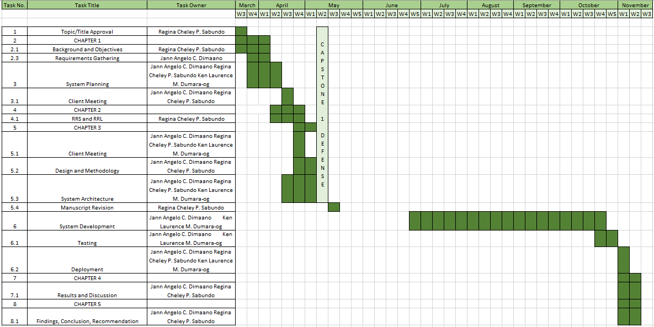The project’s progress is visualized through a Gantt Chart. This maps provides the timeline of the phases of the project detailing the key tasks performed throughout the research as well as their respective durations.

**Figure B-1.** Gantt Chart

Figure B-1 illustrates the start and end date of the conducted study. Each tasks were numbered sequentially paired with the listing of major project activities and sub-tasks grouped under its broad category. The figure also shows the researcher responsible for the given task. The timeline is respectively segmented into weeks from March to November and the areas shaded in green shows the duration the task took to be completed.

## **APPENDIX C: RELEVANT SOURCE CODE**

1. ../modal/enrollmentModal.php

<!-- <link rel="stylesheet" href="../css/modal.css"> -->

<script src="../js/gradeLevel.js"></script>

<script src="../js/getId.js"></script>

<script src="../js/addLrn.js"></script>

<script src="../js/pendingDt.js"></script>

<div class="modal fade modal-xl" id="enrollmentModal" tabindex="-1" aria-labelledby="staticBackdropLabel" aria-hidden="true">

<div class="modal-dialog modal-dialog-centered">

<div class="modal-content" style="height: 700px !important;">

<div class="modal-header justify-content-center" style="border-bottom: none; height: 100px !important; padding: 0 !important;">

<h1 class="modal-title" id="staticBackdropLabel">ENROLLMENT</h1>

<button type="button" class="btn-close position-absolute top-0 end-0" style="top: 25px !important; right: 25px !important;" data-bs-dismiss="modal" aria-label="Close"></button>

</div>

<div class="modal-body">

<!-- Tabs Navigation -->

<ul class="nav nav-tabs mx-3" id="enrollmentTabs" role="tablist">

<li class="nav-item" role="presentation">

<button class="nav-link active" id="enrollment-tab" data-bs-toggle="tab" data-bs-target="#enrollment" type="button" role="tab" aria-controls="enrollment" aria-selected="true">Enrollment</button>

</li>

<li class="nav-item" role="presentation">

<button class="nav-link" id="pending-tab" data-bs-toggle="tab" data-bs-target="#pending" type="button" role="tab" aria-controls="pending" aria-selected="false">Pending</button>

</li>

</ul>

<div class="tab-content" id="enrollmentTabContent">

<!-- Enrollment Tab -->

<div class="tab-pane fade show active overflow-y-scroll" id="enrollment" role="tabpanel" aria-labelledby="enrollment-tab" style="height: 500px;">

<div class="form-container">

<!-- Your existing form starts here -->

<div class="form-container m-3">

<form id="enrollmentForm" action="../function/processEnrollment.php" method="POST" enctype="multipart/form-data">

<div class="row mb-3">

<div class="col">

<label for="firstName" class="form-label">Student's First Name</label>

<input type="text" class="form-control" id="firstName" name="first_name" required>

</div>

<div class="col">

<label for="middleName" class="form-label">Student's Middle Name</label>

<input type="text" class="form-control" id="middleName" name="middle_name">

</div>

<div class="col">

<label for="lastName" class="form-label">Student's Last Name</label>

<input type="text" class="form-control" id="lastName" name="last_name" required>

</div>

</div>

<div class="mb-3">

<label for="sex" class="form-label">Sex</label>

<select class="form-select" id="sex" name="sex" required>

<option selected disabled>Select</option>

<option value="male">Male</option>

<option value="female">Female</option>

</select>

</div>

<div class="mb-3">

<label for="dateOfBirth" class="form-label">Birth Date</label>

<input type="date" class="form-control" id="dateOfBirth" name="date_of_birth" required>

</div>

<div class="mb-3">

<label for="address" class="form-label">Address</label>

<input type="text" class="form-control" id="address" name="address" required>

</div>

<div class="row mb-3">

<div class="col">

<label for="parentFirstName" class="form-label">Parent's First Name</label>

<input type="text" class="form-control" id="parentFirstName" name="parent_first_name" required>

</div>

<div class="col">

<label for="parentMiddleName" class="form-label">Parent's Middle Name</label>

<input type="text" class="form-control" id="parentMiddleName" name="parent_middle_name">

</div>

<div class="col">

<label for="parentLastName" class="form-label">Parent's Last Name</label>

<input type="text" class="form-control" id="parentLastName" name="parent_last_name" required>

</div>

</div>

<div class="mb-3">

<label for="parentEmail" class="form-label">Parent's Email</label>

<input type="email" class="form-control" id="parentEmail" name="parent_email" required>

</div>

<div class="mb-3">

<label for="parentContact" class="form-label">Parent's Contact Number</label>

<input type="tel" class="form-control" id="parentContact" name="parent_contact" required>

</div>

<div class="mb-3">

<label for="civilStatus" class="form-label">Civil Status</label>

<select class="form-select" id="civilStatus" name="civil_status" required>

<option selected disabled>Select</option>

<option value="single">Single</option>

<option value="married">Married</option>

<option value="widowed">Widowed</option>

<option value="separated">Separated</option>

</select>

</div>

<div class="row mb-3">

<div class="col">

<label for="gradeLevel" class="form-label">Grade Level</label>

<select class="form-select" id="gradeLevel" name="grade_level" required>

<option selected disabled>Select</option>

</select>

</div>

<div class="col">

<label for="section" class="form-label">Section</label>

<select class="form-select" id="section" name="section" required>

<option selected disabled>Select</option>

</select>

</div>

</div>

<div class="mb-3">

<label for="studentPicture" class="form-label">Student's Picture</label>

<input class="form-control" type="file" id="studentPicture" name="student_picture" required>

</div>

<div class="mb-3">

<label for="psaBirthCertificate" class="form-label">PSA - Birth Certificate</label>

<input class="form-control" type="file" id="psaBirthCertificate" name="psa_birth_certificate" required>

</div>

<div class="mb-3">

<label for="progressReportCard" class="form-label">Progress Report Card</label>

<input class="form-control" type="file" id="progressReportCard" name="progress_report_card" required>

</div>

<div class="mb-3">

<label for="medicalAssessment" class="form-label">Medical Assessment</label>

<input class="form-control" type="file" id="medicalAssessment" name="medical_assessment" required>

</div>

<button type="submit" class="btn btn-primary w-100">Enroll</button>

</form>

</div>

</div>

</div>

<!-- Pending Tab -->

<div class="tab-pane fade" id="pending" role="tabpanel" aria-labelledby="pending-tab">

<div class="table-responsive m-2">

<table id="pendingTable" class="table">

<thead>

<tr>

<th>Name</th>

<th>Grade Level</th>

<th>Section</th>

<th>LRN</th>

<th>Password</th>

<th>Confirm Password</th>

<th>Actions</th>

</tr>

</thead>

<tbody id="tableBody" id="dataTable" style="max-height: 400px;">

<?php

include "../connectDb.php";

// Initialize query with base SQL

$query = "SELECT CONCAT(s.first_name, ' ', s.middle_name, ' ', s.last_name) AS full_name,

gl.grade_level AS grade_level,

sec.section_name AS section_name,

s.student_id AS student_id

FROM student s

LEFT JOIN section sec ON s.section_id = sec.section_id

LEFT JOIN grade_level gl ON sec.grade_level_id = gl.grade_level_id

WHERE s.lrn IS NULL";

$result = mysqli_query($conn, $query);

if (mysqli_num_rows($result) > 0) {

while ($row = mysqli_fetch_assoc($result)) { ?>

<tr>

<td class="fw-bold"> <?php echo htmlspecialchars($row['full_name'])?></td>

<td class="fw-bold"> <?php echo htmlspecialchars($row['grade_level']) ?> </td>

<td class="fw-bold"> <?php echo htmlspecialchars($row['section_name']) ?> </td>

<td class="fw-bold">

<div class="col">

<input type="hidden" name="get_student_id" value="">

<input type="number" class="form-control" id="studentLrn" name="student_lrn"

pattern="^\d{12}$"

required title="LRN must be exactly 12 digits"

maxlength="12"

oninput="this.value = this.value.replace(/[^0-9]/g, '');">

</div>

</td>

<td>

<div class="col">

<input type="password" class="form-control" id="studentPassword" name="password" required minlength="8" title="Password must be at least 8 characters long">

</div>

</td>

<td>

<div class="col">

<input type="password" class="form-control" id="confirmPassword" name="confirm_password" required>

</div>

</td>

<td>

<button class="btn btn-primary add-lrn-btn"

onclick="addLrn(this)" data-lrn-id="<?php echo htmlspecialchars($row['student_id']); ?>">

Add LRN

</button>

</td>

</tr>

<?php

}

} else { ?>

<tr>

<td></td>

<td></td>

<td></td>

<td class=" text-center" style="width: 120px;" colspan="2">No records found.

</td>

<td></td>

<td></td>

<td></td>

</tr> <?php

}

?>

</tbody>

</table>

</div>

</div>

</div>

</div>

</div>

</div>

</div>

../js/addLrn.js

function addLrn(button) {

// Find the closest row and its inputs

var row = button.closest("tr");

var getStudentId = button.getAttribute("data-lrn-id");

var studentLrn = document.getElementById("studentLrn").value;

var studentPassword = document.getElementById("studentPassword").value;

var confirmPassword = document.getElementById("confirmPassword").value;

// Validate the inputs

if (!studentLrn || !studentPassword || !confirmPassword) {

Swal.fire("Error!", "Please fill in all fields.", "error");

return;

}

if (studentLrn.length !== 12 || !/^\d{12}$/.test(studentLrn)) {

Swal.fire("Error!", "LRN must be exactly 12 digits.", "error");

return;

}

if (studentPassword.length < 8) {

Swal.fire("Error!", "Password must be at least 8 characters long.", "error");

return;

}

if (studentPassword !== confirmPassword) {

Swal.fire("Error!", "Passwords do not match.", "error");

return;

}

// SweetAlert2 confirmation

Swal.fire({

title: "Create account?",

text: "Press YES to confirm.",

icon: "warning",

showCancelButton: true,

confirmButtonColor: "#3085d6",

cancelButtonColor: "#d33",

confirmButtonText: "YES",

}).then((result) => {

if (result.isConfirmed) {

// AJAX request to send the data

var xhr = new XMLHttpRequest();

xhr.open("POST", "../function/addStudentAccount.php", true);

xhr.setRequestHeader("Content-Type", "application/x-www-form-urlencoded");

xhr.onload = function () {

if (xhr.status === 200) {

// On success, remove the row

row.remove();

Swal.fire("Success!", "Student account created successfully.", "success");

} else {

Swal.fire("Error!", "There was an issue creating the account.", "error");

}

};

xhr.send(

"get_lrn_student_id=" + getStudentId +

"&student_lrn=" + studentLrn +

"&password=" + studentPassword +

"&confirm_password=" + confirmPassword

);

}

});

}

../js/gradeLevel.js

$(document).ready(function () {

// Fetch grade levels on page load

$.ajax({

url: "../function/fetchGradeLevels.php", // Path to your PHP file for grade levels

type: "GET",

dataType: "json",

success: function (response) {

$.each(response, function (index, grade) {

$("#gradeLevel").append(

'<option value="' +

grade.grade_level_id +

'">' +

grade.grade_level +

"</option>"

);

});

},

error: function (xhr, status, error) {// Log the error

alert("Failed to retrieve grade levels.");

},

});

// Fetch sections based on selected grade level

$("#gradeLevel").change(function () {

var gradeLevelId = $(this).val(); // Debugging line

$.ajax({

url: "../function/fetchSections.php", // Path to your PHP file for sections

type: "POST",

data: { grade_level_id: gradeLevelId },

dataType: "json",

success: function (response) { // Debugging line

$("#section").empty(); // Clear previous options

$("#section").append("<option selected>Select</option>");

$.each(response, function (index, section) {

// Ensure the correct syntax here

$("#section").append(

'<option value="' +

section.section_id +

'">' +

section.section_name +

"</option>" // Use section_id for value

);

});

},

error: function (xhr, status, error) { // Log the error

alert("Failed to retrieve sections.");

},

});

});

});

$(document).ready(function () {

// Fetch grade levels on page load

$.ajax({

url: "../function/fetchGradeLevels.php", // Path to your PHP file for grade levels

type: "GET",

dataType: "json",

success: function (response) {

$.each(response, function (index, grade) {

$("#gradeLevel").append(

'<option value="' +

grade.grade_level_id +

'">' +

grade.grade_level +

"</option>"

);

});

},

error: function (xhr, status, error) {// Log the error

alert("Failed to retrieve grade levels.");

},

});

// Fetch sections based on selected grade level

$("#gradeLevel").change(function () {

var gradeLevelId = $(this).val(); // Debugging line

$.ajax({

url: "../function/fetchSections.php", // Path to your PHP file for sections

type: "POST",

data: { grade_level_id: gradeLevelId },

dataType: "json",

success: function (response) { // Debugging line

$("#section").empty(); // Clear previous options

$("#section").append("<option selected>Select</option>");

$.each(response, function (index, section) {

// Ensure the correct syntax here

$("#section").append(

'<option value="' +

section.section_id +

'">' +

section.section_name +

"</option>" // Use section_id for value

);

});

},

error: function (xhr, status, error) { // Log the error

alert("Failed to retrieve sections.");

},

});

});

});

../function/processEnrollment.php

<?php

// Start the session

session_start();

// Database connection

include "../connectDb.php";

if ($_SERVER["REQUEST_METHOD"] == "POST") {

$year = (int)date("Y");

$academic_year = date("Y") . "-" . ($year + 1);

// Sanitize input

$first_name = $conn->real_escape_string($_POST['first_name_enrollment']);

$middle_name = $conn->real_escape_string($_POST['middle_name_enrollment']);

$last_name = $conn->real_escape_string($_POST['last_name_enrollment']);

$sex = ucfirst($conn->real_escape_string($_POST['sex_enrollment']));

$date_of_birth = $conn->real_escape_string($_POST['date_of_birth_enrollment']);

$address = $conn->real_escape_string($_POST['address_enrollment']);

$parent_first_name = $conn->real_escape_string($_POST['parent_first_name_enrollment']);

$parent_last_name = $conn->real_escape_string($_POST['parent_last_name_enrollment']);

$parent_email = $conn->real_escape_string($_POST['parent_email_enrollment']);

$parent_contact = $conn->real_escape_string($_POST['parent_contact_enrollment']);

$civil_status = $conn->real_escape_string($_POST['civil_status_enrollment']);

$grade_level = $conn->real_escape_string($_POST['grade_level_enrollment']);

$section = $conn->real_escape_string($_POST['section_enrollment']);

// Handle file uploads

$upload_dir = '../uploads/'; // Ensure this directory exists and is writable

$student_picture = $upload_dir . basename($_FILES['student_picture']['name']);

$psa_birth_certificate = $upload_dir . basename($_FILES['psa_birth_certificate']['name']);

$progress_report_card = $upload_dir . basename($_FILES['progress_report_card']['name']);

$medical_assessment = $upload_dir . basename($_FILES['medical_assessment']['name']);

// Insert into parent table

$parent_sql = "INSERT INTO parent (first_name, last_name, email, phone_number, address, role_id) VALUES ('$parent_first_name', '$parent_last_name', '$parent_email', $parent_contact, '$address', 2)";

if ($conn->query($parent_sql) === TRUE) {

$parent_id = $conn->insert_id; // Get the last inserted parent ID

// Insert into student table

$student_sql = "INSERT INTO student (first_name, middle_name, last_name, sex, date_of_birth, current_status, academic_year, parent_id, grade_level_id, section_id, role_id) VALUES ('$first_name', '$middle_name', '$last_name', '$sex', '$date_of_birth', 'Enrolled', '$academic_year', $parent_id, $grade_level, $section, 1)";

if ($conn->query($student_sql) === TRUE) {

$student_id = $conn->insert_id; // Get the last inserted student ID

// Insert into student_file table

$student_file_sql = "INSERT INTO student_file (student_picture, psa_birth_certificate, progress_report_card, medical_assessment, student_id) VALUES ('$student_picture', '$psa_birth_certificate', '$progress_report_card', '$medical_assessment', $student_id)";

if ($conn->query($student_file_sql) === TRUE) {

echo "<script>

window.location.href = '../pages/guidanceDashboard.php';

</script>";

} else {

echo "Error inserting student file record: " . $conn->error;

}

} else {

echo "Error inserting student record: " . $conn->error;

}

} else {

echo "Error inserting parent record: " . $conn->error;

}

} else {

echo "Invalid request method.";

}

// Close connection

$conn->close();

?>

../function/addStudentAccount.php

<?php

session_start();

include "../connectDb.php";

// Check if the form is submitted

if ($_SERVER['REQUEST_METHOD'] == 'POST') {

// Sanitize input to prevent SQL injection

$lrn = $conn->real_escape_string($_POST['student_lrn']);

$password = $conn->real_escape_string($_POST['password']);

$confirm_password = $conn->real_escape_string($_POST['confirm_password']);

$student_id = $_POST['get_student_id'];

// Validate if the passwords match

if ($password !== $confirm_password) {

$_SESSION['error_message'] = "Passwords do not match.";

header("Location: ../pages/guidanceDashboard");

}

// Validate if the LRN is exactly 12 digits

if (!preg_match('/^\d{12}$/', $lrn)) {

$_SESSION['error_message'] = "Invalid LRN. LRN must be exactly 12 digits.";

header("Location: ../pages/guidanceDashboard");

}

// Hash the password for security

$hashedPassword = password_hash($password, PASSWORD_DEFAULT);

// Begin transaction to ensure data integrity

$conn->begin_transaction();

try {

// Update the student's LRN in the student table

$update_lrn_sql = "UPDATE student SET lrn = $lrn WHERE student_id = $student_id";

if ($conn->query($update_lrn_sql) !== TRUE) {

throw new Exception("Error updating student LRN: " . $conn->error);

}

// Insert the LRN and hashed password into the student_credential table

$insert_credential_sql = "INSERT INTO account (user_id, user_password, role_id) VALUES ($lrn, '$hashedPassword', 1)";

if ($conn->query($insert_credential_sql) !== TRUE) {

throw new Exception("Error inserting into student_credential: " . $conn->error);

}

// If everything is successful, commit the transaction

$conn->commit();

header("Location: ../pages/guidanceDashboard");

} catch (Exception $e) {

// If there is an error, rollback the transaction

$conn->rollback();

header("Location: ../pages/guidanceDashboard");

}

} else {

header("Location: ../pages/guidanceDashboard");

}

// Close the connection

$conn->close();

?>

2.1 ../modal/announcementModal.php

<link rel="stylesheet" href="../css/modal.css">

<!-- Modal -->

<div class="modal fade modal-xl" id="announcementModal" tabindex="-1" aria-labelledby="staticBackdropLabel" aria-hidden="true">

<div class="modal-dialog modal-dialog-centered">

<div class="modal-content" style="height: 600px !important;">

<div class="modal-header justify-content-center" style="border-bottom: none; height: 100px !important; padding: 0 !important;">

<h1 class="modal-title" id="staticBackdropLabel">ANNOUNCEMENT</h1>

<button type="button" class="btn-close position-absolute top-0 end-0" style="top: 25px !important; right: 25px !important;" data-bs-dismiss="modal" aria-label="Close"></button>

</div>

<div class="modal-body" style="padding: 0;">

<div class="announcement-card px-4">

<div class="d-flex align-items-center mb-3">

<div class="profile-icon" style="width: 100px;">

<img class="img-fluid" src="../img/avatar.jpg" alt="profilePicture" style="width: 100px;">

</div>

<div>

<?php

$full_name = $_SESSION['full_name'];

$rank_name = $_SESSION['rank_name'];

?>

<strong class="text-uppercase"><?php echo "$full_name"; ?></strong><br>

<span><?php echo "$rank_name"; ?></span>

</div>

</div>

<div class="mb-3">

<form action="../function/createAnnouncement.php" method="POST" enctype="multipart/form-data">

<div class="mb-3">

<input type="text" class="form-control" id="announcementTitle" placeholder="Title" name="announcement_title" required>

</div>

<div class="mb-3">

<textarea type="text" class="form-control" id="announcementText"

placeholder="Type Text" name="announcement_text"

style="height: 200px;" required></textarea>

</div>

<div class="mb-3">

<input class="form-control" type="file" id="announcementFile" name="announcement_file">

</div>

<div class="mb-3">

<button type="submit" class="btn btn-primary">Submit</button>

</div>

</form>

</div>

</div>

</div>

</div>

</div>

</div>

../function/createAnnouncement.php

<?php

session_start();

include "../connectDb.php";

// Check if the form is submitted

if ($_SERVER['REQUEST_METHOD'] == 'POST') {

$full_name = $conn->real_escape_string($_SESSION['full_name']);

$rank_name = $conn->real_escape_string($_SESSION['rank_name']);

// Sanitize input to prevent SQL injection

$announcement_title = $conn->real_escape_string($_POST['announcement_title']);

$announcement_text = $conn->real_escape_string($_POST['announcement_text']);

$upload_dir = './announcement/'; // Ensure this directory exists and is writable

$announcement_file = $upload_dir . basename($_FILES['announcement_file']['name']);

// Begin transaction to ensure data integrity

$conn->begin_transaction();

try {

$insert_announcement_sql = "INSERT INTO announcements (title, announcement_text, announcement_file, full_name, rank_name)

VALUES ('$announcement_title', '$announcement_text', '$announcement_file', '$full_name', '$rank_name')";

if ($conn->query($insert_announcement_sql) !== TRUE) {

throw new Exception("Error inserting into announcements: " . $conn->error);

}

$conn->commit();

$_SESSION['swal_message'] = [

'type' => 'success',

'title' => 'Announcement uploaded!',

];

} catch (Exception $e) {

// If there is an error, rollback the transaction

$conn->rollback();

$_SESSION['swal_message'] = [

'type' => 'error',

'title' => $e->getMessage(),

];

}

header("Location: ../pages/guidanceDashboard.php");

}

// Close the connection

$conn->close();

?>

../modal/viewAnnouncementsModal.php

<script src="../js/getId.js"></script>

<!-- Modal -->

<div class="modal fade modal-xl" id="viewAnnouncementModal" tabindex="-1" aria-labelledby="staticBackdropLabel" aria-hidden="true">

<div class="modal-dialog modal-dialog-centered">

<div class="modal-content" style="height:850px !important;">

<div class="modal-header justify-content-center" style="border-bottom: none; height: 100px !important;">

<h1 class="modal-title" id="staticBackdropLabel">ANNOUNCEMENT</h1>

<button type="button" class="btn-close position-absolute top-0 end-0" style="top: 25px !important; right: 25px !important;" data-bs-dismiss="modal" aria-label="Close"></button>

</div>

<div class="modal-body">

<div class="announcement-container overflow-y-scroll" id="announcementContainer" style="height: 680px;">

<?php

include "../connectDb.php";

// Initialize query with base SQL

$query = "SELECT * FROM announcements ORDER BY created_at DESC";

$result = mysqli_query($conn, $query);

if (mysqli_num_rows($result) > 0) {

while ($row = mysqli_fetch_assoc($result)) {

?>

<div class="row shadow mx-2 mb-5 rounded-3">

<div class="col-md-12">

<div class="row align-items-center">

<div class="col-6" style="width: 100px;">

<img src="../img/avatar.jpg" alt="profilePic" style="width: 100px;">

</div>

<div class="col-6">

<strong class="text-uppercase"><?php echo htmlspecialchars($row['full_name']); ?></strong><br>

<span><?php echo htmlspecialchars($row['rank_name']); ?></span><br>

<span class="fst-italic"><?php echo htmlspecialchars($row['created_at']); ?></span>

</div>

</div>

<div class="row px-5 pt-2">

<p class="fw-bold lh-base" style="color: black;"><?php echo htmlspecialchars($row['title']); ?></p>

<p class="lh-base" style="color: black; white-space: pre-wrap;"><?php echo htmlspecialchars($row['announcement_text']); ?></p>

</div>

<div class="row px-5 pb-4 justify-content-center">

<?php

$file_path = htmlspecialchars($row['announcement_file']);

// Check if the file path is not null and not the empty directory path

if (!is_null($file_path) && $file_path !== '../announcement/') {

if (file_exists($file_path)) {

?>

<img class="img-fluid img-thumbnail" src="<?php echo htmlspecialchars($row['announcement_file']); ?>" alt="announcementFile" style="width: 400px !important;">

<?php

} else {

?>

<p>File not found: <?php echo $file_path; ?></p>'

<?php

}

}

?>

</div>

</div>

</div>

<?php

}

} else {

echo "<p>No announcements available.</p>";

}

?>

</div>

</div>

</div>

</div>

</div>

2.2 ../modal/learningMaterialsModal.php

<!-- Modal -->

<?php

include '../connectDb.php';

?>

<link rel="stylesheet" href="../css/modal.css">

<script src="../js/getSectionMaterials.js"></script>

<script src="../js/filterSectionMaterials.js"></script>

<div class="modal fade modal-xl" id="teacherMaterialsModal" tabindex="-1" aria-labelledby="staticBackdropLabel" aria-hidden="true">

<div class="modal-dialog modal-dialog-centered">

<div class="modal-content">

<div class="modal-header justify-content-center" style="border-bottom: none; height: 100px !important; padding: 0 !important;">

<h1 class="modal-title" id="staticBackdropLabel">SCHOOL MATERIALS</h1>

<button type="button" class="btn-close position-absolute top-0 end-0" style="top: 25px !important; right: 25px !important;" data-bs-dismiss="modal" aria-label="Close"></button>

</div>

<div class="modal-body">

<ul class="nav nav-tabs mx-3" id="uploadTabs" role="tablist">

<li class="nav-item" role="presentation">

<button class="nav-link active" id="post-tab" data-bs-toggle="tab" data-bs-target="#post" type="button" role="tab" aria-controls="post" aria-selected="true">Post</button>

</li>

<li class="nav-item" role="presentation">

<button class="nav-link" id="uploaded-tab" data-bs-toggle="tab" data-bs-target="#uploaded" type="button" role="tab" aria-controls="uploaded" aria-selected="false">Uploaded</button>

</li>

</ul>

<div class="tab-content" id="postTabContent">

<div class="tab-pane fade show active" id="post" role="tabpanel" aria-labelledby="post-tab" style="height: 400px;">

<!-- Upload Section -->

<div class="card m-3">

<div class="card-body" style="height: 358px;">

<h5 class="card-title">Post</h5>

<form action="../function/uploadSchoolMaterial.php" id="uploadForm" method="POST" enctype="multipart/form-data">

<div class="mb-3">

<label for="sectionMaterials" class="form-label">Section</label>

<select id="sectionMaterials" class="form-select" name="section_name">

<option selected disabled>Section</option>

</select>

</div>

<div class="mb-3">

<label for="fileInput" class="form-label">Upload File</label>

<input type="file" class="form-control" id="fileInput" name="school_materials">

</div>

<button type="submit" class="btn btn-primary">Post</button>

</form>

</div>

</div>

</div>

<div class="tab-pane fade" id="uploaded" role="tabpanel" aria-labelledby="uploaded-tab" style="height: 400px;">

<!-- Uploaded Section -->

<div class="card m-3 overflow-y-auto" style="height: 360px;">

<div class="card-body">

<div class="row position-relative">

<div class="col-md-8">

<h5 class="card-title">Uploaded</h5>

</div>

<div class="col-md-4">

<div class="position-absolute top-50 end-0 translate-middle-y pe-2">

<select class="form-select" id="sectionFilter" name="section_filter">

<option selected>Select</option>

</select>

</div>

</div>

</div>

<div class="overflow-y" id="uploadedFiles" style="max-height: 295px;">

<!-- List of Certificates -->

<p class="text-center pt-5" style="color: gray;">Select a section.</p>

</div>

</div>

</div>

</div>

</div>

</div>

</div>

</div>

</div>

../js/getSectionMaterials.js

function loadSections() {

$.ajax({

url: '../function/fetchSectionMaterials.php', // Path to the external PHP file

type: 'GET',

success: function(response) {

const sections = JSON.parse(response);

const sectionSelect = $('#sectionMaterials');

sectionSelect.empty(); // Clear existing options

if (sections.length > 0) {

sectionSelect.append('<option selected disabled>Section</option>');

sections.forEach(section => {

sectionSelect.append('<option value="' + section.section_id + '">' + section.section_name + '</option>');

});

} else {

sectionSelect.append('<option>No sections available</option>');

}

},

error: function() {

alert("Error fetching sections.");

}

});

}

$(document).ready(function() {

loadSections(); // Call loadSections on page load

});

../js/filterSectionMaterials.js

function loadFilterSections() {

$.ajax({

url: '../function/fetchSectionMaterials.php', // Path to the PHP file to get sections

type: 'GET',

success: function(response) {

const sections = JSON.parse(response);

const sectionFilter = $('#sectionFilter');

sectionFilter.empty();

if (sections.length > 0) {

sectionFilter.append('<option selected disabled>Section</option>');

sections.forEach(section => {

sectionFilter.append('<option value="' + section.section_id + '">' + section.section_name + '</option>');

});

} else {

sectionFilter.append('<option>No sections available</option>');

}

},

error: function() {

alert("Error fetching sections.");

}

});

$('#sectionFilter').on('change', function() {

const sectionId = $(this).val();

fetchFilteredMaterials(sectionId);

});

}

function fetchFilteredMaterials(sectionId) {

$.ajax({

url: '../function/fetchMaterialList.php', // Path to PHP file for filtering materials

type: 'POST',

data: { section_filter: sectionId },

success: function(data) {

$('#uploadedFiles').html(data);

},

error: function() {

alert("Error fetching materials.");

}

});

}

$(document).ready(function() {

loadFilterSections(); // Call loadSections on page load

});

../function/fetchSectionMaterials.php

<?php

require "../connectDb.php";

session_start(); // Ensure the session is started to access session variables

// Retrieve teacher_id from session

if (isset($_SESSION['get_user_id'])) {

$teacher_id = $_SESSION['get_user_id'];

// Query to get sections based on teacher_id

$sql = "SELECT s.section_id AS section_id, s.section_name AS section_name

FROM section s

JOIN teacher_section ts ON ts.section_id = s.section_id

WHERE ts.teacher_id = $teacher_id";

$result = mysqli_query($conn, $sql);

// Prepare an array to hold the results

$sections = [];

if ($result && mysqli_num_rows($result) > 0) {

while ($row = mysqli_fetch_assoc($result)) {

$sections[] = [

'section_id' => $row['section_id'],

'section_name' => $row['section_name']

];

}

}

// Return the sections as a JSON response

echo json_encode($sections);

} else {

echo json_encode([]); // Return empty array if teacher_id is not set

}

?>

../function/fetchMaterialList.php

<script src="../js/deleteMaterial.js"></script>

<?php

include '../connectDb.php';

// Get section filter from POST request

$sectionFilter = isset($_POST['section_filter']) ? intval($_POST['section_filter']) : 0;

// Query the database based on the selected section ID

$query = "SELECT school_materials, school_materials_id FROM school_materials WHERE section_id = ?";

$stmt = $conn->prepare($query);

$stmt->bind_param('i', $sectionFilter);

$stmt->execute();

$result = $stmt->get_result();

// Output results

if ($result->num_rows > 0) {

while ($row = $result->fetch_assoc()) {

// Get the full path of the file

$file_path = $row['school_materials'];

// Remove the "../school_materials/" part from the file name for display purposes

$file_name = str_replace('../school_materials/', '', $file_path);

?>

<div class="row column-gap-5 mt-3 mx-1 align-content-center position-relative rounded-3 border border-1" style="height: 40px;">

<input type="hidden" name="material_id" value="">

<div class="col-md-8 ms-2 fw-bold"><?php echo htmlspecialchars($file_name); ?></div>

<div class="col-md-2">

<a class="btn btn-secondary position-absolute top-50 end-0 translate-middle-y border border-0 me-5" style="height: 40px; width: 50px; background-color: transparent;" href="<?php echo htmlspecialchars($row['school_materials']); ?>" download>

<iconify-icon class="pt-1" icon="tabler:download" style="font-size: 20px; color: black;"></iconify-icon>

</a>

</div>

<div class="col-md-2">

<button class="btn btn-secondary position-absolute top-50 end-0 translate-middle-y border border-0 delete-file" onclick="deleteMaterial(this)" data-material-id="<?php echo htmlspecialchars($row['school_materials_id']); ?>" style="height: 40px; width: 50px; background-color: transparent;">

<iconify-icon class="pt-1" icon="mingcute:delete-line" style="font-size: 20px; color: black;"></iconify-icon>

</button>

</div>

</div>

<?php

}

} else { ?>

<p class="text-center pt-5" style="color: gray;">No uploaded school materials.</p>

<?php }

$stmt->close();

$conn->close();

?>

../modal/uploadScheduleModal.php

<link rel="stylesheet" href="../css/modal.css">

<script src="../js/gradeLevelSchedule.js"></script>

<!-- Modal -->

<div class="modal fade" id="uploadSchedule" tabindex="-1" aria-labelledby="staticBackdropLabel" aria-hidden="true">

<div class="modal-dialog modal-dialog-centered modal-lg">

<div class="modal-content" style="height: 450px !important;">

<div class="modal-header justify-content-center" style="border-bottom: none; height: 100px !important;">

<h1 class="modal-title" id="staticBackdropLabel">UPLOAD SCHEDULE</h1>

<button type="button" class="btn-close position-absolute top-0 end-0" style="top: 25px !important; right: 25px !important;" data-bs-dismiss="modal" aria-label="Close"></button>

</div>

<div class="modal-body">

<div class="form-container">

<form id="uploadScheduleForm" action="../function/uploadSchedule.php" method="POST" enctype="multipart/form-data">

<div class="mb-3">

<label for="gradeLevelSchedule" class="form-label">Grade Level</label>

<select class="form-select" id="gradeLevelSchedule" name="grade_level_schedule" required>

<option selected disabled>Select</option>

</select>

</div>

<div class="mb-3">

<label for="sectionSchedule" class="form-label">Section</label>

<select class="form-select" id="sectionSchedule" name="section_schedule" required>

<option selected disabled>Select</option>

</select>

</div>

<div class="mb-3">

<label for="section" class="form-label">Schedule</label>

<input class="form-control" type="file" id="uploadSchedule" name="upload_schedule" accept=".xls, .xlsx" required>

</div>

<button type="submit" class="btn btn-primary w-100">Submit</button>

</form>

</div>

</div>

</div>

</div>

</div>

../function/uploadSchedule.php

<?php

require '../vendor/autoload.php'; // Adjust the path to your autoload.php

use PhpOffice\PhpSpreadsheet\IOFactory;

function uploadSchedule($file) {

// Database connection parameters

$host = 'localhost: 3308';

$username = 'root';

$password = '';

$dbname = 'ics_db';

try {

// Create a new PDO instance

$pdo = new PDO("mysql:host=$host;dbname=$dbname;charset=utf8", $username, $password);

$pdo->setAttribute(PDO::ATTR_ERRMODE, PDO::ERRMODE_EXCEPTION);

// Get the selected section ID from the form

$section_id = $_POST['section_schedule']; // Assuming this is passed in the form

// Step 1: Archive existing schedules

$archiveStmt = $pdo->prepare("INSERT INTO class_schedule_archive (class_time, subject_name, weekday, section_id) SELECT class_time, subject_name, weekday, section_id FROM class_schedule WHERE section_id = ?");

$archiveStmt->execute([$section_id]);

// Step 2: Delete existing schedules for the section

$deleteStmt = $pdo->prepare("DELETE FROM class_schedule WHERE section_id = ?");

$deleteStmt->execute([$section_id]);

// Step 3: Load the Excel file

$spreadsheet = IOFactory::load($file['tmp_name']);

$sheet = $spreadsheet->getActiveSheet();

$rows = $sheet->toArray(null, true, true, true); // Load data as an associative array

// Prepare the SQL statement for new schedule insertion

$insertStmt = $pdo->prepare("INSERT INTO class_schedule (class_time, subject_name, weekday, section_id) VALUES (?, ?, ?, ?)");

// Define weekdays as keys

$weekdays = ['Monday', 'Tuesday', 'Wednesday', 'Thursday', 'Friday'];

// Loop through the rows of the spreadsheet starting from the second row (data starts here)

foreach ($rows as $rowIndex => $row) {

if ($rowIndex == 1) continue; // Skip header row

$time = $row['A']; // Assuming 'Time' is in column A

// Loop through each weekday column (columns B to F)

foreach ($weekdays as $i => $weekday) {

$subject_name = $row[chr(66 + $i)]; // 'B' is 66 in ASCII, then increment for each weekday

// Insert into the database if there's a subject name

if (!empty($subject_name)) {

$insertStmt->execute([$time, $subject_name, $weekday, $section_id]);

}

}

}

// Optional: Display success message

$_SESSION['swal_message'] = [

'type' => 'success',

'title' => "Schedule uploaded successfully. Existing schedules archived.",

];

} catch (Exception $e) {

echo "Error: " . $e->getMessage();

}

}

// Handle the form submission

if ($_SERVER['REQUEST_METHOD'] === 'POST' && isset($_FILES['upload_schedule'])) {

uploadSchedule($_FILES['upload_schedule']);

}

?>

../modal/classScheduleModal.php

<link rel="stylesheet" href="../css/modal.css">

<!-- Modal -->

<div class="modal fade modal-xl" id="classScheduleModal" tabindex="-1" aria-labelledby="staticBackdropLabel" aria-hidden="true">

<div class="modal-dialog modal-dialog-centered">

<div class="modal-content px-3" style="height: 650px !important;">

<div class="modal-header justify-content-center" style="border-bottom: none; height: 100px !important; padding: 0 !important;">

<h1 class="modal-title" id="staticBackdropLabel">CLASS SCHEDULE</h1>

<button type="button" class="btn-close position-absolute top-0 end-0" style="top: 25px !important; right: 25px !important;" data-bs-dismiss="modal" aria-label="Close"></button>

</div>

<div class="modal-body">

<!-- Table -->

<table class="table table-bordered text-center" style="height: 500px;">

<thead style="background-color: var(--gold);">

<tr>

<th>Time</th>

<th>Monday</th>

<th>Tuesday</th>

<th>Wednesday</th>

<th>Thursday</th>

<th>Friday</th>

</tr>

</thead>

<tbody>

<?php

include "../connectDb.php"; // Ensure this file sets up $conn properly

$section_id = $_SESSION['section_id'] ?? 1;

$query = "SELECT

cs.class_time,

MAX(CASE WHEN cs.weekday = 'Monday' THEN cs.subject_name ELSE '' END) AS Monday,

MAX(CASE WHEN cs.weekday = 'Tuesday' THEN cs.subject_name ELSE '' END) AS Tuesday,

MAX(CASE WHEN cs.weekday = 'Wednesday' THEN cs.subject_name ELSE '' END) AS Wednesday,

MAX(CASE WHEN cs.weekday = 'Thursday' THEN cs.subject_name ELSE '' END) AS Thursday,

MAX(CASE WHEN cs.weekday = 'Friday' THEN cs.subject_name ELSE '' END) AS Friday

FROM class_schedule cs

JOIN section s ON cs.section_id = s.section_id

WHERE cs.section_id = ?

GROUP BY cs.class_time

ORDER BY STR_TO_DATE(cs.class_time, '%h:%i %p')";

// Prepare the SQL statement

$stmt = $conn->prepare($query);

if (!$stmt) {

die('Prepare failed: ' . $conn->error);

}

// Bind the section_id to the query

$stmt->bind_param('i', $_SESSION['section_id']);

// Execute the query

$stmt->execute();

// Get the result

$result = $stmt->get_result();

// Check if there are any results

if ($result->num_rows > 0) {

while ($row = $result->fetch_assoc()) { ?>

<tr>

<td><?php echo htmlspecialchars($row['class_time']); ?></td>

<td><?php echo htmlspecialchars($row['Monday']); ?></td>

<td><?php echo htmlspecialchars($row['Tuesday']); ?></td>

<td><?php echo htmlspecialchars($row['Wednesday']); ?></td>

<td><?php echo htmlspecialchars($row['Thursday']); ?></td>

<td><?php echo htmlspecialchars($row['Friday']); ?></td>

</tr>

<?php }

} else { ?>

<tr>

<td colspan="6">No classes scheduled.</td>

</tr>

<?php }

// Close the statement and connection

$stmt->close();

$conn->close();

?>

</tbody>

</table>

</div>

</div>

</div>

</div>

../modal/inputGradesModal.php

<!DOCTYPE html>

<html lang="en">

<head>

<meta charset="UTF-8">

<meta name="viewport" content="width=device-width, initial-scale=1.0">

<title>Input Grades - ICS Teacher Portal</title>

<link rel="stylesheet" href="../css/modal.css">

<script src="../js/gradeLevelSelect.js"></script>

<script src="../js/subjectSelect.js"></script>

</head>

<body>

<div class="modal fade modal-lg" id="inputGradesModal" tabindex="-1" aria-labelledby="staticBackdropLabel" aria-hidden="true">

<div class="modal-dialog modal-dialog-centered">

<div class="modal-content">

<div class="modal-header justify-content-center" style="border-bottom: none; height: 100px !important; padding: 0 !important;">

<h1 class="modal-title" id="staticBackdropLabel">INPUT GRADES</h1>

<button type="button" class="btn-close position-absolute top-0 end-0" style="top: 25px !important; right: 25px !important;" data-bs-dismiss="modal" aria-label="Close"></button>

</div>

<div class="modal-body">

<div class="form-container">

<form id="uploadScheduleForm" action="../function/uploadGrades.php" method="POST" enctype="multipart/form-data">

<div class="mb-3">

<?php $teacher_id = $_SESSION['get_user_id']; ?>

<input type="hidden" name="teacher_id_input_grades" value="<?php echo $teacher_id ?>">

<label for="sectionInputGrades" class="form-label">Section</label>

<select class="form-select" id="sectionInputGrades" name="section_input_grades" required>

<option selected disabled>Select</option>

</select>

</div>

<div class="mb-3">

<label for="subjectInputGrades" class="form-label">Subject</label>

<select class="form-select" id="subjectInputGrades" name="subject_input_grades" required>

<option selected disabled>Select</option>

</select>

</div>

<div class="mb-3">

<label for="section" class="form-label">Upload Grades</label>

<input class="form-control" type="file" id="uploadInputGrades" name="upload_input_grades" accept=".xls, .xlsx" required>

</div>

<button type="submit" class="btn btn-primary w-100">Submit</button>

</form>

</div>

</div>

</div>

</div>

</div>

</body>

</html>

../js/gradeLevelSelect.js

function loadGradeSections() {

$.ajax({

url: '../function/fetchSectionMaterials.php', // Path to the external PHP file

type: 'GET',

success: function(response) {

const sections = JSON.parse(response);

const sectionSelect = $('#sectionInputGrades');

sectionSelect.empty(); // Clear existing options

if (sections.length > 0) {

sectionSelect.append('<option selected disabled>Section</option>');

sections.forEach(section => {

sectionSelect.append('<option value="' + section.section_id + '">' + section.section_name + '</option>');

});

} else {

sectionSelect.append('<option>No sections available</option>');

}

},

error: function() {

alert("Error fetching sections.");

}

});

}

$(document).ready(function() {

loadGradeSections(); // Call loadSections on page load

});

../js/subjectSelect.js

function loadGradesubjects() {

$.ajax({

url: '../function/fetchSubjectId.php', // Path to the external PHP file

type: 'GET',

success: function(response) {

const subjects = JSON.parse(response);

const subjectSelect = $('#subjectInputGrades');

subjectSelect.empty(); // Clear existing options

if (subjects.length > 0) {

subjectSelect.append('<option selected disabled>Subject</option>');

subjects.forEach(subjects => {

subjectSelect.append('<option value="' + subjects.subject_id + '">' + subjects.subject_name + '</option>');

});

} else {

subjectSelect.append('<option>No subjects available</option>');

}

},

error: function() {

alert("Error fetching subjects.");

}

});

}

$(document).ready(function() {

loadGradesubjects();

});

../function/fetchSubjectId.ph

<?php

require "../connectDb.php";

session_start(); // Ensure the session is started to access session variables

// Retrieve teacher_id from session

if (isset($_SESSION['get_user_id'])) {

$teacher_id = $_SESSION['get_user_id'];

$sql = "SELECT sub.subject_id AS subject_id, sub.subject_name AS subject_name

FROM subject sub

JOIN teacher_subject tsub ON tsub.subject_id = sub.subject_id

WHERE tsub.teacher_id = $teacher_id";

$result = mysqli_query($conn, $sql);

// Prepare an array to hold the results

$subjects = [];

if ($result && mysqli_num_rows($result) > 0) {

while ($row = mysqli_fetch_assoc($result)) {

$subjects[] = [

'subject_id' => $row['subject_id'],

'subject_name' => $row['subject_name']

];

}

}

// Return the sections as a JSON response

echo json_encode($subjects);

} else {

echo json_encode([]);

}

?>

../function/uploadGrades.php

<?php

session_start();

require '../vendor/autoload.php'; // Adjust the path to your autoload.php

use PhpOffice\PhpSpreadsheet\IOFactory;

// Database connection

$db_host = 'localhost: 3308'; // Change to your DB host

$db_name = 'ics_db'; // Change to your DB name

$db_user = 'root'; // Change to your DB username

$db_pass = ''; // Change to your DB password

$conn = new mysqli($db_host, $db_user, $db_pass, $db_name);

if ($conn->connect_error) {

die("Connection failed: " . $conn->connect_error);

}

// Check if a file was uploaded

if ($_SERVER['REQUEST_METHOD'] === 'POST' && isset($_FILES['upload_input_grades'])) {

$upload_dir = '../uploaded_grades/';

$file_name = basename($_FILES['upload_input_grades']['name']);

$upload_path = $upload_dir . $file_name;

$section_id = $_POST['section_input_grades']; // Set section_id

$subject_id = $_POST['subject_input_grades']; // Set subject_id

$teacher_id = $_POST['teacher_id_input_grades']; // Set teacher_id

// Move the uploaded file to the server

if (move_uploaded_file($_FILES['upload_input_grades']['tmp_name'], $upload_path)) {

// Load the Excel file

$spreadsheet = IOFactory::load($upload_path);

$sheet = $spreadsheet->getActiveSheet();

$data = $sheet->toArray(null, true, true, true);

// Process Excel data

foreach ($data as $index => $row) {

if ($index === 1) continue; // Skip header row

$lrn = $row['A']; // Assuming LRN is in column A

$first_quarter = $row['B'];

$second_quarter = $row['C'];

$third_quarter = $row['D'];

$fourth_quarter = $row['E'];

// Get student_id and academic_year based on LRN

$student_query = $conn->prepare("SELECT student_id, academic_year FROM student WHERE lrn = ?");

$student_query->bind_param("s", $lrn);

$student_query->execute();

$result = $student_query->get_result();

if ($result->num_rows > 0) {

$student = $result->fetch_assoc();

$student_id = $student['student_id'];

$academic_year = $student['academic_year'];

// Insert grades

$insert_query = $conn->prepare("INSERT INTO grade (student_id, subject_id, section_id, teacher_id, academic_year, first_quarter, second_quarter, third_quarter, fourth_quarter)

VALUES (?, ?, ?, ?, ?, ?, ?, ?, ?)");

$insert_query->bind_param(

"iiiisiiii",

$student_id,

$subject_id,

$section_id,

$teacher_id,

$academic_year,

$first_quarter,

$second_quarter,

$third_quarter,

$fourth_quarter

);

if ($insert_query->execute()) {

$_SESSION['swal_message'] = [

'type' => 'success',

'title' => "Grades uploaded successfully!",

];

} else {

$_SESSION['swal_message'] = [

'type' => 'error',

'title' => "Failed to upload grades for LRN: $lrn.",

];

}

} else {

$_SESSION['swal_message'] = [

'type' => 'error',

'title' => "No student found for LRN: $lrn.",

];

}

}

} else {

$_SESSION['swal_message'] = [

'type' => 'error',

'title' => 'Failed to upload file.',

];

}

} else {

$_SESSION['swal_message'] = [

'type' => 'error',

'title' => 'No file uploaded.',

];

}

$conn->close();

// Redirect to teacher dashboard

header("Location: ../pages/teacherDashboard");

exit();

../modal/gradesModal.php

<?php

include '../connectDb.php'; // Modify this with your database connection file

// Function to fetch grades based on student ID

function fetchGrades($conn, $studentId)

{

$query = "SELECT g.first_quarter, g.second_quarter, g.third_quarter, g.fourth_quarter,

s.subject_name,

CONCAT(t.first_name, ' ', t.last_name) AS teacher_name

FROM grade g

JOIN subject s ON g.subject_id = s.subject_id

JOIN teacher t ON g.teacher_id = t.teacher_id

WHERE g.student_id = ?

";

$stmt = $conn->prepare($query);

$stmt->bind_param("i", $studentId);

$stmt->execute();

$result = $stmt->get_result();

if ($result->num_rows > 0) {

return $result;

} else {

return false;

}

}

$studentId = isset($_SESSION['user_id']) ? $_SESSION['user_id'] : null;

$grades = [];

if ($studentId) {

$query = "SELECT student_id

FROM student

WHERE student.lrn = ?

";

$stmt = $conn->prepare($query);

$stmt->bind_param("i", $studentId);

$stmt->execute();

$result = $stmt->get_result();

if ($result->num_rows > 0) {

$row = $result->fetch_assoc();

$studentRecord = $row['student_id'];

} else

return false;

$grades = fetchGrades($conn, $studentRecord);

}

?>

<!DOCTYPE html>

<html lang="en">

<head>

<meta charset="UTF-8">

<meta name="viewport" content="width=device-width, initial-scale=1.0">

<title>Grades - ICS Parent Portal</title>

<link rel="stylesheet" href="../css/modal.css">

</head>

<body>

<!-- Modal -->

<div class="modal fade modal-xl" id="gradesModal" tabindex="-1" aria-labelledby="staticBackdropLabel" aria-hidden="true">

<div class="modal-dialog modal-dialog-centered">

<div class="modal-content" style="max-height: 600px; height: 600px;">

<div class="modal-header justify-content-center" style="border-bottom: none; height: 100px !important; padding: 0 !important;">

<h1 class="modal-title" id="staticBackdropLabel">GRADES</h1>

<button type="button" class="btn-close position-absolute top-0 end-0" style="top: 25px !important; right: 25px !important;" data-bs-dismiss="modal" aria-label="Close"></button>

</div>

<div class="modal-body">

<!-- Table -->

<table class="table table-bordered rounded">

<thead>

<tr>

<th>Subject</th>

<th>First</th>

<th>Second</th>

<th>Third</th>

<th>Fourth</th>

<th>Teacher</th>

</tr>

</thead>

<tbody>

<?php if ($grades): ?>

<?php while ($row = $grades->fetch_assoc()): ?>

<tr>

<th><?php echo htmlspecialchars($row['subject_name']); ?></th>

<td><?php echo htmlspecialchars($row['first_quarter']); ?></td>

<td><?php echo htmlspecialchars($row['second_quarter']); ?></td>

<td><?php echo htmlspecialchars($row['third_quarter']); ?></td>

<td><?php echo htmlspecialchars($row['fourth_quarter']); ?></td>

<td><?php echo htmlspecialchars($row['teacher_name']); ?></td>

</tr>

<?php endwhile; ?>

<?php else: ?>

<tr>

<td colspan="6">No grades available.</td>

</tr>

<?php endif; ?>

</tbody>

</table>

</div>

</div>

</div>

</div>

</body>

</html>

../modal/eCertModal.php

<link rel="stylesheet" href="../css/modal.css">

<!-- Modal -->

<div class="modal fade modal-xl" id="eCertModal" tabindex="-1" aria-labelledby="staticBackdropLabel" aria-hidden="true">

<div class="modal-dialog modal-dialog-centered">

<div class="modal-content" style="height: 600px !important;">

<div class="modal-header justify-content-center" style="border-bottom: none; height: 100px !important; padding: 0 !important;">

<h1 class="modal-title" id="staticBackdropLabel">E-CERTIFICATE</h1>

<button type="button" class="btn-close position-absolute top-0 end-0" style="top: 25px !important; right: 25px !important;" data-bs-dismiss="modal" aria-label="Close"></button>

</div>

<div class="modal-body" style="padding: 0;">

<ul class="nav nav-tabs mx-3" id="uploadTabs" role="tablist">

<li class="nav-item" role="presentation">

<button class="nav-link active" id="post-tab-cert" data-bs-toggle="tab" data-bs-target="#postCert" type="button" role="tab" aria-controls="post" aria-selected="true">Post</button>

</li>

<li class="nav-item" role="presentation">

<button class="nav-link" id="uploaded-tab-cert" data-bs-toggle="tab" data-bs-target="#uploadedCert" type="button" role="tab" aria-controls="uploaded" aria-selected="false">Uploaded</button>

</li>

</ul>

<div class="tab-content" id="postTabContent">

<div class="tab-pane fade show active" id="postCert" role="tabpanel" aria-labelledby="post-tab-cert" style="height: 400px;">

<!-- Upload Section -->

<div class="card m-3">

<div class="card-body" style="height: 358px;">

<h5 class="card-title">Post</h5>

<form action="../function/uploadCertificate.php" id="uploadCertificate" method="POST" enctype="multipart/form-data">

<div class="mb-3">

<label for="sectionCertificate" class="form-label">Section</label>

<select id="sectionCertificate" class="form-select" name="section_cert">

<option selected disabled>Section</option>

</select>

</div>

<div class="mb-3">

<label for="studentCertificate" class="form-label">Student Name</label>

<select id="studentCertificate" class="form-select" name="student_cert">

<option selected disabled>Select Student</option>

</select>

</div>

<div class="mb-3">

<label for="certInput" class="form-label">Upload Certificate</label>

<input type="file" accept=".jpg, .png" class="form-control" id="certInput" name="student_certificate" required>

</div>

<input type="hidden" name="full_name" id="fullName">

<button type="submit" class="btn btn-primary">Post</button>

</form>

</div>

</div>

</div>

<div class="tab-pane fade" id="uploadedCert" role="tabpanel" aria-labelledby="uploaded-tab-cert" style="height: 400px;">

<!-- Uploaded Section -->

<div class="card m-3 overflow-y-auto pb-2" style="height: 360px;">

<div class="card-body">

<div class="row position-relative">

<div class="col-md-8">

<h5 class="card-title">Uploaded</h5>

</div>

<div class="col-md-4">

<div class="position-absolute top-50 end-0 translate-middle-y pe-2">

<select class="form-select" id="sectionCertificateFilter" name="section_certificate_filter">

<option selected>Select</option>

</select>

</div>

</div>

</div>

<div class="overflow-y" id="uploadedCertificate" style="max-height: 295px;">

<!-- List of Uploaded Certificate by Section -->

<?php

include '../connectDb.php';

if (isset($_SESSION['get_user_id'])) {

$teacher_id = $_SESSION['get_user_id'];

// Query the database based on the selected section ID

$query = "SELECT e_certificate, full_name, e_certificate_id FROM e_certificate

WHERE teacher_id = ?";

$stmt = $conn->prepare($query);

$stmt->bind_param('i', $teacher_id);

$stmt->execute();

$result = $stmt->get_result();

// Output results

if ($result->num_rows > 0) {

while ($row = $result->fetch_assoc()) {

?>

<div class="row column-gap-4 mt-3 mx-1 align-content-center position-relative rounded-3 border border-1" style="height: 80px;">

<input type="hidden" name="certificate_id" value="">

<div class="col-md-1 ms-2">

<img class="img_fluid" src="<?php echo htmlspecialchars($row['e_certificate']); ?>" alt="e_certificate"

style="height: 60px;">

</div>

<div class="col-md-9">

<p class="text-start fw-bold pt-4 me-5" style="font-size: 18px; color: black;"><?php echo htmlspecialchars($row['full_name']); ?></p>

</div>

<div class="col-md-2">

<button class="btn btn-secondary position-absolute top-50 end-0 translate-middle-y border border-0 delete-file me-3" onclick="deleteCertificate(this)" data-certificate-id="<?php echo htmlspecialchars($row['e_certificate_id']); ?>" style="height: 40px; width: 50px; background-color: transparent;">

<iconify-icon class="pt-1" icon="mingcute:delete-line" style="font-size: 20px; color: black;"></iconify-icon>

</button>

</div>

</div>

<?php

}

} else { ?>

<p class="text-center pt-5" style="color: gray;">No uploaded certificate.</p>

<?php }

$stmt->close();

$conn->close();

}

?>

</div>

</div>

</div>

</div>

</div>

</div>

</div>

</div>

</div>

../function/uploadCertificate.php

<?php

session_start();

include '../connectDb.php';

if ($_SERVER['REQUEST_METHOD'] == 'POST') {

// Check if the file was uploaded without errors

if (isset($_FILES['student_certificate']) && $_FILES['student_certificate']['error'] == 0) {

$teacher_id = $_SESSION['get_user_id'];

$section_id = $_POST['section_cert'];

$student_id = $_POST['student_cert'];

$full_name = $_POST['full_name'];

// Define the file variables

$file_name = $_FILES['student_certificate']['name'];

$file_tmp = $_FILES['student_certificate']['tmp_name'];

$file_size = $_FILES['student_certificate']['size'];

$file_type = $_FILES['student_certificate']['type'];

// Specify the directory where the file will be saved

$upload_directory = '../student_certificate/';

$file_destination = $upload_directory . basename($file_name);

// Move the file to the specified directory

if (move_uploaded_file($file_tmp, $file_destination)) {

// Insert file details into the database

$query = "INSERT INTO e_certificate (e_certificate, full_name, student_id, teacher_id, section_id)

VALUES (?, ?, ?, ?, ?)";

$stmt = $conn->prepare($query);

$stmt->bind_param('ssiii', $file_destination, $full_name, $student_id, $teacher_id, $section_id);

if ($stmt->execute()) {

$_SESSION['swal_message'] = [

'type' => 'success',

'title' => 'Certificate uploaded successfully!',

];

} else {

$_SESSION['swal_message'] = [

'type' => 'error',

'title' => 'Failed to upload certificate to the database.',

];

}

} else {

$_SESSION['swal_message'] = [

'type' => 'error',

'title' => 'Failed to move the certificate.',

];

}

} else {

$_SESSION['swal_message'] = [

'type' => 'error',

'title' => 'No certificate uploaded or there was an error uploading the certificate.',

];

}

// Redirect to teacher dashboard

header("Location: ../pages/teacherDashboard");

exit(); // Ensure the script stops after redirect

}

../modal/viewCertificateModal.php

<link rel="stylesheet" href="../css/modal.css">

<div class="modal fade modal-xl" id="viewCertModal" tabindex="-1" aria-labelledby="staticBackdropLabel" aria-hidden="true">

<div class="modal-dialog modal-dialog-centered">

<div class="modal-content" style="height: 600px !important;">

<div class="modal-header justify-content-center" style="border-bottom: none; height: 100px !important; padding: 0 !important;">

<h1 class="modal-title" id="staticBackdropLabel">E-CERTIFICATE</h1>

<button type="button" class="btn-close position-absolute top-0 end-0" style="top: 25px !important; right: 25px !important;" data-bs-dismiss="modal" aria-label="Close"></button>

</div>

<div class="modal-body">

<div class="overflow-y" id="uploadedCertificate" style="max-height: 295px;">

<!-- List of Uploaded Certificate by Section -->

<?php

include '../connectDb.php';

$student_id = $_SESSION['student_id'];

// Query the database based on the selected section ID

$query = "SELECT e_certificate, full_name, e_certificate_id FROM e_certificate

WHERE student_id = ?";

$stmt = $conn->prepare($query);

$stmt->bind_param('i', $student_id);

$stmt->execute();

$result = $stmt->get_result();

// Output results

if ($result->num_rows > 0) {

while ($row = $result->fetch_assoc()) {

?>

<div class="row column-gap-4 mt-3 mx-1 align-content-center position-relative rounded-3 border border-1" style="height: 80px;">

<input type="hidden" name="certificate_id" value="">

<div class="col-md-1 ms-2">

<img class="img_fluid" src="<?php echo htmlspecialchars($row['e_certificate']); ?>" alt="e_certificate"

style="height: 60px;">

</div>

<div class="col-md-9">

<p class="text-start fw-bold pt-4 me-5" style="font-size: 18px; color: black;"><?php echo htmlspecialchars($row['full_name']); ?></p>

</div>

<div class="col-md-2">

<a class="btn btn-secondary position-absolute top-50 end-0 translate-middle-y border border-0 me-3" style="height: 40px; width: 50px; background-color: transparent;" href="<?php echo htmlspecialchars($row['e_certificate']); ?>" download>

<iconify-icon class="pt-1" icon="tabler:download" style="font-size: 20px; color: black;"></iconify-icon>

</a>

</div>

</div>

<?php

}

} else { ?>

<p class="text-center pt-5" style="color: gray;">No certificate.</p>

<?php }

$stmt->close();

$conn->close();

?>

</div>

</div>

</div>

</div>

</div>

## **APPENDIX D: PROJECT ROLES AND RESPONSIBILITIES**

This section of the appendix clearly defines the roles and responsibilities of each researcher towards the project’s completion. This ensures that all members fulfilled their duties and did their contributions which aligns to their role for the guaranteed success of the project.

|  |  |
| --- | --- |
| **Table D-1**. Roles and Responsibilities |  |
| **Researcher** | **Responsibilities** |
| Jann Angelo C. Dimaano  Ken Laurence M. Dumara-og  Regina Cheley P. Sabundo | Lead Programmer, Full Stack Developer, UI/UX Designer, Quality Assurance Tester  Programmer, Database Administrator  Project Manager, System Analyst, Documentation Head, Quality Assurance Tester |

Mr. Dimaano took the lead in developing the majority of the web portal. He ensured that the design of the UI/UX is user-friendly and visually appealing while not compromising the quality of the system. Dimaano also did the coding of both frontend and backend of the system. He also participated in the testing of the web portal and solved bugs ensuring the functionality and quality before deployment.

Mr. Dumara-og provided assistance in the development of the system, mostly in the backend, connection and maintenance of the database, and analytics implementation.

Ms. Sabundo headed the conceptualization of the project. She assigned the tasks to each members. Most importantly, Sabundo oversaw all key documents, revised the manuscript, and communicated with the client to ensure the project meets the requirements. She also participated in the quality assurance of the web portal.

With this distribution of workload which was based on the skill of the respective members, clear division of duties throughout the span of the project was ensured. The structured allocation of the responsibilities promoted a collaborative effort to achieve an efficient workflow and success of the project.

## **APPENDIX E: BIONOTE**



Jann Angelo C. Dimaano, born on July 10, 2003, currently resides in C. Tirona St., Barangay 10, Batangas City, Batangas. He formerly studied in Batangas City East Elementary School, moved to New Era University - Lipa Branch for junior high school, and finished his senior high school in University of Batangas. Currently, Dimaano is studying in Batangas State University – The National Engineering University and is pursuing Bachelor of Science in Information Technology, majoring in Business Analytics. Dimaano’s specialty is frontend development as he is proficient in HTML, CSS, and Python programming language. His personal skills include analytical thinking and adaptability to different programming languages. In the future, Dimaano aims to be a web developer and professional UI/UX designer.



Ken Laurence M. Dumara-og, born on August 13,2002, currently resides in Aguila, San Jose, Batangas. He graduated in BEDIMES for his elementary studies and finished his junior high school at NAVERA. He continued to study in ACLC for senior high school. Currently, he is studying in Batangas State University – The National Engineering University and is pursuing Bachelor of Science in Information Technology, majoring in Business Analytics. Dumara-og specializes in basic programming and backend programming. His future endeavors include working freelance as a web developer or web3 service developer.



Regina Cheley P. Sabundo, born on June 19, 2003, currently resides in Calamias, Ibaan, Batangas. She formerly studied in Tulay Elementary School and finished his junior and senior high school in Ibaan Saint James Academy Incorporated. Currently, Sabundo is studying in Batangas State University – The National Engineering University and is pursuing Bachelor of Science in Information Technology, majoring in Business Analytics. Sabundo’s specializes in analyzing data and generating an interpretation. She possesses good leadership quality and is skilled in public speaking. In the future, Sabundo’s goal is to strive in being a Data Analyst and Marketing Analyst to fully utilize her knowledge obtained upon taking business analytics major while expanding her skills in other fields that might fit her interest.